The 5781/2020 Anthology
For the Jewish New Year

Compiled by Daniel Keren
An illustration of a Jew blowing a shofar to the heavens

SHANAH TOVAH
May the coming Jewish New Year of 5781 be a sweet one overflowing with brochos (blessings) in both ruchnius and gashmius for all our readers and all Klal Yisroel.

May 5781 also be a year of safety for everyone and may the dreaded Coronavirus pandemic disappear and may those who lost jobs as a result of the quarantine be blessed with a new year of economic security.

This Rosh Hashanah begins our 12th year of publishing the Shabbos Stories for the Parsha and the fifth year of publishing the Brooklyn Torah Gazette. We have over the past year also created a website ShabbosStories.com where almost 800 past emails of both our Shabbos Stories and Brooklyn Torah Gazette for the Parsha are posted and which can be accessed by readers from around the world.

In the beginning, we were emailing the Shabbos Stories for the Parsha to 40 people we knew. From word of mouth and from plugs from other parsha emails, we today have more than 1,000 subscribers who enjoy our free emails. If you know anyone who might enjoy these emails, please feel free to let them know of these weekly stories and articles. They can email their requests to keren18@juno.com

We hope that you enjoy the stories and articles in this year’s anthology. And may this be the year that Hashem will hear our prayers for the coming of the geulah (redemption from this long and bitter exile,) and send us soon Moshiach and return us all of the Promised Land and restore to us the Beis Hamikdosh (the Holy Temple in Yerushalayim/Jerusalem) that we pray for every day.

Daniel Keren
(18 day of Elul, September 7, 2020)

The 5781 jewish new year anthology
Printed L’illuy nishmas Nechama bas R’ Noach, a”h

Compiled by
Daniel Keren

Shabbos Stories for Rosh Hashanah 5781………………………………..Page 4
Brooklyn Torah Gazette for Rosh Hashanah 5781………………….....Page...24
Supplemental Stories for Rosh Hashanah 5781…………………….…..Page...45
Shabbos Stories for
Rosh hashanah 5781
Volume 12, Issue 1 1-2 Tishrei/ Sept. 19-20, 2020
Printed L’illuy nishmas Nechama bas R’ Noach, a”h

For a free subscription, please forward your request to keren18@juno.com

How I Will Celebrate
Rosh Hashanah Alone
By Karen Kaplan

I love the High Holidays—the month when we turn our full attention to G-d, reflect upon our renewed commitment to becoming our best selves, and spend time with our family and friends.
Except this year. This year is different. This year there is the pandemic.
I’m an older woman, living alone, with health issues, and for those like me, this year will be unlike any before. I'll be observing the holidays at home, by myself.
I’m used to davening at my local Chabad center, listening as the chazzan (cantor) does the “heavy lifting” of reciting the prayers, allowing my mind to wander at will, letting the rabbi make the service meaningful with his commentary, listening as the shofar is blown.
During services, I was more like a passenger than a driver. I got to look out the window and enjoy the scenery because I didn't have to drive the car. This year everything will be different.

Does Different Have to Mean Bad?
But does different have to mean bad? Can’t something be different and good? I like to eat coffee ice cream every day, but if there’s none in the freezer, I'll eat vanilla instead. And maybe that vanilla will be a delicious change.
So, I decided to look for new ways to make this year fresh and exciting. And truly, shouldn’t we be doing this every year? Each year we stand before G-d, asking Him to forgive our shortcomings, asking Him to view us favorably, asking Him to give us another year to grow and improve. Should this ever be done on autopilot?
It’s true, we are living in difficult times. But Chassidic tradition teaches that all experiences - even the difficult ones - are opportunities to reveal the goodness that exists within everything. G-d put goodness in all His creations, but we have to choose to look for it. Sometimes it’s easy, sometimes it’s hard, but it’s always our choice.
This year I’ve been forced out of my comfort zone by circumstances I can’t control. Even if I wanted to, I can’t go on autopilot. I can’t sit back, enjoy the ride, and let someone else drive the car. I’m behind the wheel. But being the driver means that I’ll be in control of the journey. And that, I believe, is where the goodness lies within this very different holiday season. I will control the journey, and I am choosing to take the scenic route.

Slow Down and Sing
When I’m in shul, I have to rush through the prayers just to keep up. I’m looking forward to going at my own pace and taking time to think about what I’m reading. I’ve also started listening to musical renditions of the prayers we sing (you can find excellent ones on Chabad.org) to learn the melodies.
I’ve called my local Judaica store and bought a shofar. My very own shofar! Blowing it is not as hard as I'd thought and I have the entire month of Elul to practice. By Rosh Hashanah, I'll be ready to crown the King!
It will be hard not being with my friends during the festive meals, and nothing can replace that, but I'll make sure I have good company in the form of uplifting Jewish books. I've collected many excellent ones over the years, and my bookcases make me feel like the greatest Jewish minds in history are in the room with me, ready to teach and converse. The Lubavitcher Rebbe may join me for lunch, Maimonides for dinner, and the Baal Shem Tov (founder of Chassidism) for coffee the next morning. And of course, I'll have books of Chassidic stories to spice up the meal. With guests like these, I'll naturally want to put on nice clothes and set the table with my best things.
Yes, this year will be different. I’ve been given my driver’s license and handed the car keys. I can't wait to get out on the road, open the windows, and enjoy the ride. May your own journey this season be healthy, smooth, and meaningful.

Weekly Chasidic Story #1082
Foiling the Third Decree
From the desk of Yerachmiel Tilles

In the little town of Lubavitch, the month of Elul was drawing to a close. The wind of teshuva had blown through the village for thirty days, aiding everyone in perfecting their spiritual service. More Tehillim (reciting Psalms), more Tzedakah (charity), more Torah study. The frenzied preparation reached its climax.
The setting sun signaled the beginning of a new year when the Creator sits in judgment and decides the affairs of every individual. Many thousands of chasidim poured into the village, eager to spend Rosh HaShana with the Tzemach Tzedek. They crammed into the Rebbe's shul, filling the huge interior until nary an empty inch remained.

A Hush Fell on the Room
A hush fell on the room as the Tzemach Tzedek entered. A path miraculously appeared. The Rebbe made his way to his place, and Rosh Hashana evening prayer began.
It was an unusual Maariv. The Tzemach Tzedek appeared drawn, worried. His prayers were imbued with extraordinary fervor, as though - if it were possible - they were more fervent than an ordinary Rosh HaShana.
Fear and dread gripped every heart. This is the time when "the angels tremble, terror seizes them, and they exclaim: 'The Day of Judgment is here.'" The chasidim redoubled their concentration, desperately trying to arouse divine mercy. Everyone felt that something unusual was in the air.
That night after the prayers, the Rebbe joined his family for the holiday meal. Though the Lubavitch Rebbes generally minimized all talk on Rosh HaShana, the Tzemach Tzedek distinctively made it a point to speak during the meal every Rosh HaShana. He discussed current events in the capital, the names and ranks of different ministers and the political situation in general. Reb Yehuda-Leib, one of the Rebbe's sons, would remark, "He is performing Baalshem'ske (Baal Shem Tov style) wonders in Petersburg right now."

This Year Was No Different
This year was no different. The Tzemach Tzedek related all the goings-on in the capital and focused on certain ministers and their roles. In fact, he seemed more specific, more detailed, than in other years. His sons listened quietly, as they always did, taking notice of the Rebbe's particular emphasis in the discussion.
The day of Rosh HaShana dawned and throngs of Chassidim streamed toward the Rebbe's shul. Again the Rebbe's prayers were permeated with emotion. After the morning prayer was completed and the Torah reading was finished, everyone prepared themselves for the great mitzvah of shofar.
A feeling of awe enveloped the large synagogue as the seven sons of the Tzemach Tzedek took their places around the platform, each in his designated place. The Tzemach Tzedek himself finished his preparations, readying himself to blow the thirty notes. His face burned brightly as he sang softly to himself, his eyes closed in deep concentration. Suddenly his voice resonated throughout the shul, "Ay, sertzeh, LaMnatzei'ach…" ("Woe! My heart! A Psalm…").

Panic Gripped the Congregation
Panic gripped the congregation and tears flowed from every eye. Some evil decree prompted the Rebbe's unusual outburst, no doubt, and a great wailing filled the shul. Everyone's heart was open, raw and receptive. The congregation recited Psalm 47 seven times as required and the Rebbe began the required sounds.

* * *
Minister Suvorin, governor of Petersburg, the capital, studied his reflection in the ornate mirror gracing the walls of the czar's antechamber. He was waiting somewhat impatiently for his scheduled appointment with His Majesty. In his hand lay the document in which he had invested so much work. It concerned the so-called great rabbi, M. M. Schneersohn, the one they called "Tzemach Tzedek."
A flicker of annoyance crossed his face. It was intolerable that a rabbi should have all that power, what with all his followers and students spread across White Russia. His seat of power lay in his choice of residence, a small village far away from prying eyes and government informers.

Forced to Move to Either Petersburg or Kiev
No more. The rabbi would now be forced to move to either Petersburg or Kiev. His followers would think twice before visiting their rabbi in such a large city. They would be too easily followed, easily questioned, easily inspected. He had the official document in his hand now: all it needed was the czar's signature.
Suvorin crossed the magnificent antechamber and stared pensively out the window. A fair portion of Petersburg was visible from here. There had been some trouble lately - anger was brewing among the populace, and he knew he was mostly to blame. His two new decrees had raised the ire of Petersburg's residents, but they were just a mob of common folk anyway. After all, his intentions had been pure.
He turned from the window and paced the room, smiling as he recalled the new decrees. No smoking was allowed on city streets. It was untidy; too many cigarette butts were allowed to litter the city. No more meat would be sold within the city. Whoever wanted meat would have to go out of the city and buy it there. No longer would the beautiful capital carry the smell of rotting flesh. With these two decrees, he, Minister Suvorin, had launched his campaign to make Petersburg the most beautiful capital in the world.

“His Majesty Will See You Now”
A liveried servant entered the antechamber and bowed. "Minister Suvorin," he said. "His Majesty will see you now."
Suvorin straightened his uniform and followed the servant, beads of perspiration forming on his forehead. He entered the dazzling audience chamber and bowed low before the czar.
The czar was in a foul mood. "What is news in the city?" he asked.
"No news," responded Suvorin. "All is well."
The czar stared at him savagely, and then at the document in his hand. "I know some news," he finally said. "You passed two decrees, banning both the sale of meat and outside use of cigarettes. The population is angry; the decrees are intolerable."
B-But I did it for the good of the city," stammered the minister. "Our streets will not be dirtied by cigarette butts and the smell of meat will not…"
"Idiot!" roared the czar. He tore the document out of the minister's hand and hurled it angrily on the floor. Suvorin turned white with fear, bowed low and quickly left the audience chamber.
The minister stood once again in the antechamber, his mind whirling with confused thoughts. His dream had been shattered. Gone was his goal of restraining the influential rabbi. For such was the accepted law: any document that had been thrown away by the czar was automatically negated and it was illegal to present the request again. His plan had been shattered; the rabbi would stay in the village of Lubavitch after all.
* * *

Far, far away in the village of Lubavitch, the Tzemach Tzedek finished blowing the shofar. He returned to his place and the congregation began the special Musaf (Additional) prayer of Rosh Hashana.
~~~~~~~~
Source: Adapted by Yerachmiel Tilles from the well-written translation of E. Lesches in "Beis Moshiach Magazine" #295 (which is based on HaMelech B'M'sibop.143; Seifer HaSichos 5704, p. 4.)
Biographical notes: Rabbi Menachem-Mendel Schneersohn [of blessed memory: 29 Elul 5549 - 13 Nissan 5626 (Sept. 1789 - April 1866)], the third Rebbe of Chabad, was known as the Tzemach Tzedek, after his books of Jewish Law responsa and Talmudic commentary called by that name. He was renowned not only as a Rebbe, but also as a leading scholar in his generation in both the revealed and secret aspects of Torah.
Rabbi Yehudah-Leib of Kopust (1811- 3 Cheshvan 1866), an elder brother of Rabbi Shmuel of Lubavitch (the fourth Rebbe of Chabad), established an independent branch of Chabad Chasidism in Kopust after the death of his father, R. Menachem Mendel of Lubavitch, the Tzemech Tzedek. Following his death in the same year, he was succeeded by his son, Rabbi Shlomo Zalman of Kopust, although many of the chasidim returned to Lubavitch.
Connection: Seasonal -- Erev Rosh Hashana (2): 1- The story begins on Erev Rosh Hashana; 2-Erev Rosh Hashana is the birth date of the Tzemek Tzedek.

Reprinted from the Rosh Hashanah 5780 email of KabbalaOnline.org, a project of Ascent of Safed.

The Great Battle

Someone complained to the Tiferes Shlomo zy'a that he doesn’t have any respite from the yetzer hara. "Sometimes I conquer the yetzer hara, and I ignore his enticements, but I know that it won't be long before the yetzer hara will return and win me. I want to conquer the yetzer hara once and for always, but I don’t know how I can do this?"
We certainly empathize with his struggle, because the same happens to all of us. Each person has his own, individual, yetzer hara and tests, but whatever they are, it is very hard to overcome them.
For example, someone is trying to improve his ahavas Yisrael. He doesn’t want to have negative thoughts about people. There are times when he succeeds, but there are times when he fails. He isn't able to shake the yetzer hara off forever. Another example is someone who wants to say brachos with kavanah. There are times when he remembers, and there are times when he forgets. He wants to win the yetzer hara and not have to deal with him anymore, but it remains a constant struggle.
Each person has similar examples, the yetzer hara comes to people in different ways, and never lets them go. The struggle exhausts people, for they think that there's no purpose. Therefore, this man asked the Tiferes Shlomo for counsel, so he could win the yetzer hara, once and for all.
The Tiferes Shlomo told him that it is impossible to avoid the battle. His struggle is exactly how avodas Hashem is supposed to be. A person must fight the yetzer hara again and again and again. This is the expected pattern, and this is how avodas Hashem appears. The Tiferes Shlomo explained to him, "The Torah doesn’t say when you go out to victory, the Torah says, when you go out to war. The goal is the war, the battle. Your role is to just keep on trying, and never to give up. If you do so, you've won the war."
At a tisch, the Yesod HaAvodah asked one of his Chassidim (who had come from a different town) "How did you come here?"
"By donkey."
"What would you do if you you'd fallen off the donkey, on the way?"
"I would get back on, and continue traveling to the Rebbe."
"And if you fell down a second time, what would you do?"
"I would mount the donkey again."
"And what would you do if you fell a third time?"
"Rebbe," the chassid said, "What should I do? Just sit on the ground and cry? There's no choice. I would mount the donkey and try to get to the Rebbe again."

The entire beis medresh was silent as the Rebbe and the chassid had this exchange. Then the Rebbe said to all his chassidim, "No matter how many times you fall, just get up and try again. There is no choice. There is no other way."
For example, if a person is trying to refrain from speaking lashon hara, and he fails, he should try to be careful the next time. And if he is trying to overcome his anger, and he became angry, he should make another resolve to be calm and collective. Keep on trying, because trying is the purpose. That is called winning the battle against the yetzer hara.
We use the horn of an ram [an adult sheep] for a shofar. As the Shulchan Aruch states, "It is best when the shofar of Rosh Hashanah is from an… although all shofros are kosher…" (586:1).
The Gemara asks, “Why do we blow shofar with a ram's horn? Hakadosh Baruch Hu says, ‘Blow for Me with a ram’s shofar so I will remember Akeidas Yitzchok, and I will consider it as though you were bound on the akeidah before Me’” (Rosh Hashanah 16).
Avraham Avinu sacrificed by the akeidah, and therefore we use the shofar, to arouse this fond memory in heaven. We can ask, if the purpose of the shofar is to remind heaven of akeidas Yitzchak, any part of the ram would do? For example, the Torah could tell us to take a foot of the ram, or any other limb. Why is the mitzvah specifically to blow shofar?
The answer is, by the akeidah it's written, “Avraham raised his eyes and he saw that behold there was a ram; its horns were entangled in a bush” (Bereishis 22:13). The ram struggled to escape, but its horns were caught in the bush, and it couldn’t get out.
The shofar therefore represents challenges and struggles, and the shofar was therefore chosen for the mitzvah, because Hashem desires the struggle. If avodas Hashem would be simple and easy, there wouldn’t be reward, and our service wouldn't be spectacular. But because of the struggle, our avodas Hashem is precious to Hashem. There are times that we fail —it's only natural that we don’t succeed at times — but the goal and success, is when we keep on trying, again and again.

Reb Yitzchok Hutner zt'l wrote the following (in a letter): "We have a problem: When we discuss tzaddikim, we look at the final results, the accomplishments they achieved, the heights they reached, and we skip over their struggles, the times they had great conflicts with their nature and with the yetzer hara.
We have the impression that these tzaddikim were born tzaddikim. Everyone praises the Chofetz Chaim for his caution never to speak lashon hara. But who knows about all the battles, struggles, and even the failures and disappointments that he endured, as he fought the yetzer hara [until he reached his perfected, high level].
This is merely one example, among the thousands…. My request is, when you think of tzaddikim, don’t think that they were always at peace with their yetzer tov. See them standing in a great battlefield, with hardships and letdowns. When the yetzer hara is storming within you, know that at these times you are very similar to the tzaddikim whom you seek to emulate... Specifically in the areas where you fail the most, you have the potential to sanctify Hashem's name."
A Broken A Broken Heart The Baal Shem Tov taught his student, the Toldos Yaakov Yosef zy'a, the kavanos (kabalistic thoughts) that he should have by tekiyas shofar (when he called out the tekiyos). But on Rosh Hashanah, the Toldos forgot everything. He came to the tekiyos with a broken heart, and was crying the entire time, because he had forgotten everything. Later, the Baal Shem Tov told him, "The kavanos (kabalistic thoughts) are keys that open doors. Each kavanah opens a different door. But a broken heart opens up all doors."

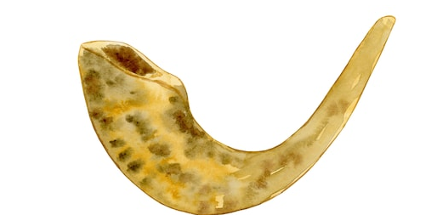

The Kedushas Levi zy'a once raised his shofar, and said to the women in the women section, "The shofar needs a rinsing," and they all began to cry. The baal makri (the one who calls out tekiyah, shevarim, etc.) asked my grandfather, Rebbe Dovid Biderman zy'a, what kabalistic kavanos he should have when he calls out the tekiyos. Rebbe Dovid Biderman replied, "I don’t know kavanos and you also don’t know. But one kavanah I will tell you. The shevarim is a small broken heart, and truah is a big broken heart…"

Reb Velvel Eisenbach zt'l was from the elders of Yerushalayim. (He was over a hundred years old and was niftar a few years ago on Rosh Hashanah .) He repeated what he heard from his grandfather, who heard it from his grandfather – to whom the story happened.
This grandfather (Reb Velvel Eisenbach's great-great grandfather) was by Rebbe Ahron Chernobler zy'a for Rosh Hashanah, when he was but a child. He was davening on the balcony (which was built special for Rosh Hashanah, to hold the many guests who came for Yom Tov).
It was extremely crowded and the child fainted. People threw water on him and revived him and brought him to the large opening in the floor, which opened to the beis medresh below, so he would have air. Lying there, he was able to watch Rebbe Ahron Chernobler approach the bimah for tekiyas shofar. He was also able to hear the vort that Rebbe Ahron Chernobler said before the tekiyos.
The rebbe said, "It is written (Tehillim 47): Elokim represents middas hadin (strict justice and punishment). It is raised and removed with äòåøú, with a broken heart. represents middas harachamim, Hashem's mercy. This can also depart, chas veshalom, when one thinks that everything is well, and he isn't worried at all." When the rebbe said this, the entire community cried. The child became wet once again, this time from their tears.

Reprinted from the 5777 Rosh Hashanah email of Torah Wellsprings: The Torah Insights of Rabbi Eli Biderman.

Eli Whitney's Rosh
Hashanah Resolution
By Rabbi Leiby Burnham

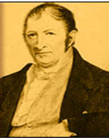
Eli Whitney
This Rosh Hashanah make sure your resolutions are S.M.A.R.T.

As Rosh Hashana rapidly approaches, we want to make resolutions that will help us change our lives for the better so that we don't make the coming year a repeat of this past year.
We can learn some important lessons about implementing change from Eli Whitney, a man who changed America and the entire world, more dramatically than Henry Ford or Alexander Graham Bell. A man who also made some fatal errors, ones that would cost him dearly.
Eli Whitney, a real Yankee from Massachusetts, graduated from Yale University in 1792, and moved south to fill a tutoring position which was supposed to assist him in paying off his college loans (some things never change). When he arrived, he found the employers would only pay half of what they had promised (again, some things never change). He left, and went looking for other work. He was invited to stay a week at a plantation outside of Savannah, while he went job-hunting.
At the plantation, he noticed a problem with Upland Cotton, the species commonly grown in the South. It had seeds covered in a coating resembling green velvet which stuck to the cotton fibers like Velcro. It took a full day of labor to "gin," or remove, the seeds from one pound of cotton. This was so inefficient that Upland Cotton was essentially worthless and the entire South was only exporting a few hundred bags of cotton to England each year.
Eli invented a machine called the cotton gin, which ginned cotton and cleaned itself. The South soon changed from an uncultivated wilderness to a wealthy blossoming agrarian region, eventually exporting as much as 920 million pounds of cotton to England each year.
This did not liberate the slaves; au contraire, slavery boomed, with the price of slaves rising from $50 in 1800 to $1,000 by 1850. However, the price of cloth dove down 99%, and people worldwide were clothed in comfortable, washable clothing. Even the common man could own more than one set of clothing for the first time in history.
But Eli didn't strike it rich. What was his big mistake? He tried to grab too big a piece of the pie. Recognizing the enormous benefit of his invention, he decided to set up his own cotton ginning centers where he charged farmers 40% of their crop. The Southerners found this ridiculous, especially coming from a Yankee, and began making their own crude cotton gins, waving a big thumb at Eli Whitney's patent. They even began a rumor that his machines were inferior, and soon factories in England wouldn't buy cotton ginned in his machines. He fought patent battles for years and ended up losing money on this world-altering invention.
Lesson #1: Every year we are tempted to make the coming year "the Big Year," when we fix all our bad habits. We're going to quit smoking, come home from work no later than 5:30 pm, go to synagogue daily, begin learning with a study partner once a week, and never say anything negative to anyone.
Let's learn from Eli. We may have the ideas for great innovations and positive changes, but we need to moderate them to ensure they will be doable. We can't bite a bigger piece than we can chew. In Social Work school, we learned the S.M.A.R.T. way to make goals; make them Specific, Measurable, Attainable, Realistic, and Time-Based. Just think where we'd be in 20 years from now if every year we were to take on one S.M.A.R.T. goal and actualize it.

Eli Strikes Back
After losing money on his gin, Eli needed cash, so he invented the system called mass production. Until then, most items were made beginning to end by one master craftsman, thus making every piece unique. If one part broke, the whole thing was useless. The U.S. Army was having a particularly difficult time manufacturing muskets. They took days to make, were expensive and, if one piece broke on the battlefield, the musket was useless, and the soldier became a sitting duck.
Eli invented a new system using high precision tools to manufacture parts. These parts could be assembled by any unskilled worker, and were entirely interchangeable. Thus, if a trigger were to break, a foot soldier would simply pull out a spare trigger and get back into action. The format Eli invented for the musket was adopted all over the world, revolutionizing manufacturing. Your car, washing machine, shaver, laptop, and bicycle are cheaper, easier to fix, and better as a result. Eli finally struck it rich.
Lesson #2: The problem Eli set out to fix can beset any of us. We often make resolutions which are complex and dependant on many factors. Here's one example: If I get up an hour earlier every day, and pray and exercise immediately after waking, then I'll be able to make my family a hot breakfast, and spend quality time with my kids before they go to school. That kind of resolution is dependant on far too many factors – if one detail breaks (you sleep through the alarm, your workout takes longer than expected, or one of your kids refuses to get out of bed), the entire resolution falls apart.
An example of a better resolution would be, "Every evening I will spend five minutes reviewing my day. I will make note of both the good things that should be repeated the next day, and the mistakes that should not." This is something that doesn't require other people's cooperation, it can be done anywhere, and at anytime in the evening, and if you miss one day you can be right back on track the next day.
Let's make sure our resolutions can be easily fixed if we slip, resolutions that can help us mass produce good deeds, and a happy life.

Reprinted from the September 16, 2006 website of Aish.com

How Sweet it is
By Sandy Eller

It seems as if it wasn’t all that long ago that Rosh Hashanah honey came in two basic varieties. Golden Blossom was sold in the jar with its iconic green and gold label, and store brand honey bore the name of whatever establishment you happened to be patronizing at that particular point in time.
As time went on, honey started showing up in those cute little plastic bear squeeze jars and in bottles bearing the names of just about every major kosher food company.
But today, honey is most definitely having a moment. On a trip to our local kosher supermarket two weeks before Rosh Hashanah I was greeted by a massive honey display. There was honey in shades ranging from gold to nearly black and even blue. There was honey packed in skinny straws, gift sets and decorative bottles.
There was raw honey still in the comb and honey in flavors like raspberry, mesquite, and avocado. I’ll tell you one thing – this definitely wasn’t the honey of my childhood – which now that I think about it, is perfectly fine with me.

Getting Buzzed
It goes without saying that a discussion about honey is going to have to include some talk about bees, although it seems fair to say that most of us have made it a habit to avoid those buzzing, winged creatures. Although honeybees do us a tremendous service, providing the honey that graces Rosh Hashanah tables far and wide while also pollinating more than a few varieties of fruit and nuts, they do come with those pesky, pointy stingers, which led me to believe that any rational human being would do their best to avoid bees.
That assumption proved to be wrong, however, when I spoke to two completely sane individuals who spend considerable amounts of their spare time not only working with bees, but also protecting them in order to reverse a trend that has the honeybee population dwindling rapidly each year.

Rabbi Daniel Senter is the chief operating officer of Kof-K Kosher whose hobbies run the gamut. A magician and an EMT who is certified as both a mohel and a shochet, he also enjoys restoring cars, brewing beer, foraging, and homesteading. According to Rabbi Senter’s official bio, he lives in both Teaneck and Woodridge, New York with “his wife, five children, four goats, a dozen chickens, and a few million bees.”
Rabbi Senter’s fascination with bees began approximately eight years ago when a friend who had a farm in upstate Dutchess County needed some help with a mobile chicken coop. Paying a visit in order to lend a hand, Rabbi Senter noticed a stack of wooden boxes and a chain link fence. Swarms of bees were flying in and out of the boxes and over the fence.
“I asked him what it all was and he told me ‘those are my bees,’” recalled Rabbi Senter. “I told him he was crazy and then asked what the fence was for. That one, he told me, was to keep the bears away.”
The sight was so intriguing that Rabbi Senter found himself taking on yet another project, and he started researching bees, buying his first hive the following spring. Today, he has more than 100 hives in various locations in upstate New York, Manhattan, and New Jersey. And in what can only be described as the ultimate irony, Rabbi Senter discovered the hard way that he was allergic to bee stings. His reaction is thankfully, not life threatening, but still fairly extreme.
“I blew up like a balloon and my kids told me I look like the Michelin Man,” said Rabbi Senter.
Unwilling to give up on his honeybees, Rabbi Senter takes monthly allergy shots and he goes out of his way to be ultra-cautious as he tends to his hives. While the average person might find the thought of thousands of bees unnerving, Rabbi Senter finds interacting with bees to be extremely relaxing. He even teaches beekeeping to high schoolers.
“We suit up and the kids are away from any technology,” explained Rabbi Senter. “There are no cell phones and no texting and after our 45 minutes, not a single kid in the group can tell you what time it is. They get lost in what they are doing. It’s back to the basics; just you and the bees.”

LIQUID GOLD
Approximately 80 pounds of honey have to remain in the hive over the winter for bees to survive in our area, but the remainder is available for harvesting. Rabbi Senter estimated that he has already gotten 2,000 pounds of honey this year, with at least another thousand still waiting to be collected from his hives. Over the years, Rabbi Senter has sold his honey at the Teaneck farmer’s market and through direct sales, and he has also filled orders for schools and institutions who use it for pre-Rosh Hashanha gifts and fundraisers. Rabbi Senter saves a portion of his honey harvest for people with allergies who find the pollens that are present in local honey help them build up their immunity to those allergens that are in the air.
Having always assumed that honey was produced from pollens on low-lying plants like clover and alfalfa, I was surprised to learn that it can also be derived from flowering trees.
Rabbi Senter’s favorite honey is a late spring variety with a mild flavor that comes from the flowers of the black locust tree, with apple, basswood, and Japanese knotwood proving to be good sources of honey as well. Always happy to share his passion of bees with others, Rabbi Senter has mentored other would be beekeepers including Monsey resident Zev Oster who, over the past four years, has worked his way up to approximately 100 hives, scattered throughout Rockland County. Like Rabbi Senter, Oster is all in when it comes to bees and honey – the license plate on his SUV reads “ILUVBEES” and a decorative beehive dangles from his mailbox.
Oster harvested his first honey in 2016, walking away with 30 pounds of the sweet stuff. Having acquired many more hives over the years, also a certain percentage are lost every winter, Oster was rewarded this year with 2,700 pounds of honey. All of it was extracted from the hives from May to mid-July, an effort that involved blood, sweat and tears.
“It was a tremendous amount of work and I got up at 6:30 in the morning before it got too hot,” said Oster. “By 9:30 or ten o’clock it just wasn’t possible to work out there anymore most days because of the heat and I went back out after work, staying out until 9 P.M. checking on the hives.”

Oster bottles his product under the Rockland Honey label, topping each bottle with a beeswax seal from his hives, often staying up until 3 A.M. bottling honey during the busy season. The honey he harvests is labeled simply as local honey, without no particular variety specified, because there is no way to know exactly what plants the bees are getting their pollen from.
“If you have hives in an area that is surrounded by nothing but acres and acres of blueberries, then you know that it is blueberry honey, but here we can’t say for sure exactly what kind of honey our bees are producing,” explained Oster, who is also experimenting with honey made from goldenrod which flowers in September, further extending the honey season.
In addition to its Monsey-area honey, Rockland Honey sells a wide variety of products brought in from other honey producers throughout the United States. Oster’s products are available online and in stores in Monsey and beyond and include more than ten flavors of pure raw honey and honey sticks in fruity, floral, sour and exotic flavors such as watermelon, pink lemonade, pina colada and chocolate. Like Rabbi Senter, Oster’s favorite honey flavor is also derived from the pollen of a tree I have never even heard of – tulip poplar.
While many Jewish families have small kitchens in their basements that are designated for Pesach preparations, the Oster’s downstairs kitchen is used exclusively for honey. This year’s bountiful harvest has had Oster tweaking his operations, moving his extraction equipment into the garage, while the bottling remains in the basement, a change that meant that Oster had to move hives that had previously been in his backyard to another location.

“Once we were spinning the honey in the garage, we couldn’t keep the bees in the backyard anymore,” said Oster. “In ten minutes, we could have had hundreds of thousands of bees in the garage, which would have been a big problem.”
Some of Oster’s hives are quite a sight to see, housed in colorfully painted boxes that are anything but typical. There is one painted to look like a police station, another done in a Kosel motif, and in a Trumpian reference, one bearing the words “Make America Sweet Again.” I took advantage of an opportunity to see them up close, maybe a little closer than I might have liked, after taking Oster up on an invitation to see the bees, donning a bee jacket, complete with an attached hood and veil that covered my entire face. It definitely wasn’t one of my finest fashion moments and thankfully there are no pictures to document that particular episode of my career as a writer.

HONEY, WE HAVE A PROBLEM
We take it for granted that there will always be honey on our Rosh Hashanah tables, but honeybees have been mysteriously dying out for quite a while. According to Newsday, 80 to 90 percent of the honeybees in central Maryland died from the summer of 2017 to the spring of 2018 and a report that appeared in Business Insider estimated that 10 million of the 83 million of the world’s beehives were lost in the year 2014 alone.
The jury is still out on the reasons for those losses, which affect not only honey production but other items pollinated by bees including apples, peaches, plums, nectarines, strawberries, and almonds.
“The plight of the honeybee is very concerning,” said Rabbi Senter. “They are disappearing in record numbers and it could be due to a number of factors including loss of habitat, a parasite called the Varroa mite, or pesticides.”
Thankfully, interest in beekeeping has been growing steadily and Oster is just one bee enthusiast who took up the hobby after hearing the honeybee population was declining, doing his part to bolster the honeybee population. In addition to expanding his hives every year, Oster founded the Rockland Bee Club several years ago, with 15 to 20 people turning out at every monthly meeting. Several parties have reached out to Oster and offered to let him put hives on their land, including the mayor of Haverstraw, a town located northwest of Monsey.
“It’s good publicity,” remarked Oster who has hives on a ramp to a heavily traveled local roadway. “People beep and they stop and get out of their cars and ask questions. They are really fascinated by it.”
Rabbi Senter notes that while honeybees may be in trouble, it’s not all doom and gloom for our little winged friends. Scientists have been working hard to solve the mystery of what is known as colony collapse disorder, with Israel leading the pack on pioneering research in the field. Citing a five-tiered approach that includes improving honeybee health and nutrition, preserving and restoring their environment, combatting disease, eliminating harmful pesticides and promoting awareness, Rabbi Senter expressed his hope that we will be able to enjoy our apples in dipped in honey for many years to come.
What kind of honey will grace your Rosh Hashanah table this year? It seems like this year there are more flavors to choose from than ever before. As for me, I’ll be polishing up my honey dish and pulling out a jar of vanilla creamed honey that I got as a gift. And of course, there is going to have be a plastic honey bear somewhere on my table at some point in time over the Yom Tov season. Some traditions are just too sacred to tamper with.

Reprinted from the Rosh Hashanah 2019 edition of the Jewish Echo.
Brooklyn torah gazette
For rosh hashanah 5781
Volume 5, Issue 1 (Whole Number 202) 1 Tishrei 5781/ Sept. 19-20, 2020
Printed L’illuy nishmas Nechama bas R’ Noach, a”h

How an Annual Religious Pilgrimage Created a Year-Round Jewish Community in Uman, Ukraine
By Cnaan Lipshshiz

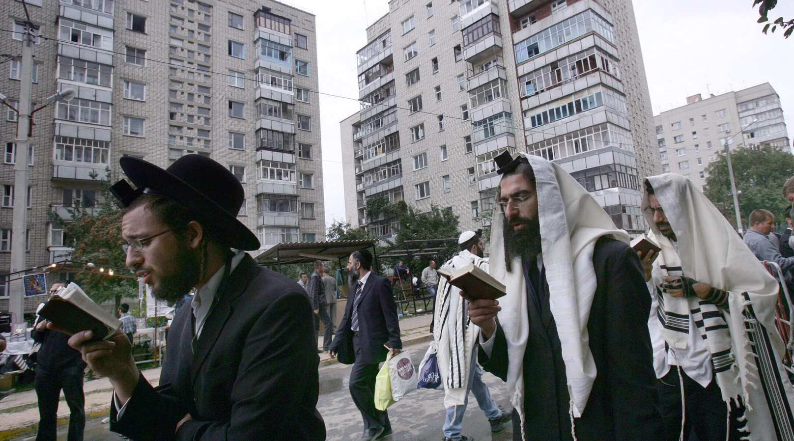
Jews pray on a street near the tomb of Rabbi Nachman of Breslov in Uman, Ukraine, Sept. 20, 2006. (Menahem Kahana/AFP via Getty Images)

(JTA) — Before deciding to stay permanently, Chaim Chazin would visit the small city of Uman, Ukraine, every year around Rosh Hashanah, the Jewish new year.
For Chazin, a religiously observant music producer from Israel, the brief annual visits were energizing spiritual experiences away from money troubles back home.
“There’s a feeling of holiness in Uman, of spirituality and of a return to the sources,” said Chazin, a father of seven. “It gives you the strength and inspiration to go on.”
Like tens of thousands of other observant Jews since the fall of communism in Europe, Chazin, 43, would come to this small city ahead of Rosh Hashanah because it’s the burial place of Rabbi Nachman, an 18th-century luminary who founded the Breslov Hasidic movement.

Prior to the Coronavirus, About 30,000
Jewish Pilgrims Would Come to Uman
Prior to Ukraine’s border shutdown due to the coronavirus, about 30,000 Jewish pilgrims, mostly from Israel, would come each year for the holiday. Many thousands more visit year round.
Chazin, his wife Liat and their children are among 70 families who have taken the Uman experience to a whole other level: They have moved there.
For most of the year, the city of 80,000 is sleepy and quiet. For Chazin, beyond the spiritual dimension of the place, he says “it’s easier to make a living here.”
Chaim Chazin drives through Uman, Aug. 20, 2020. (Courtesy of Chazin)

“In Israel, I was always busy with bureaucracy, overdue payments, repossession notices, negotiating with the tax authorities. Ukraine is much easier in this regard. This is not a bureaucratic country,” he said.
Like many of the 200-odd Israeli observant Jews who live in Uman year-round, Chazin makes his living catering to the stream of Rosh Hashanah pilgrims. He owns real estate that he rents out to them and also has a hotel, in addition to other businesses.
The pilgrims are not big spenders. They typically part with only $50-$100 a day per person during their stays of four to seven days. But most of that money goes to relatively few service providers who either belong to, or are in business with, the permanent Jewish community of Uman. Whereas most pilgrims come for Rosh Hashanah, the thousands who visit year round provide a dependable source of income for the local Jews.

A bird’s eye view of Pushikna Street in Uman, Sept. 8, 2017. (Cnaan Liphshiz)

In a country where the average annual salary is about $6,000, this income, meager in Western terms, is enough for members of Uman’s permanent Jewish community to live comfortably and afford certain communal amenities enjoyed by few other Ukrainian Jewish communities of their size. They have a permanent rabbi from Israel, a mohel who performs circumcisions, and a kosher butcher. There’s a small elementary school for boys, another school for girls and even a Jewish kindergarten.
In terms of food, Uman’s Jews have an unusual amount of choice, thanks to the 10 or so kosher restaurants. Their existence means local Jews can order anything from Italian to Yemenite dishes. The community also has a grocery store with kosher meat and dairy products.

The Pilgrimage is Very Important to Breslover Chassidim
The pilgrimage is so important to some followers of the Breslov sect that about 1,500 of them rushed in to beat the border closure, which took effect on Aug. 29, and which some believe was imposed on that date to prevent the pilgrimage. Israeli and Ukrainian health officials have urged would-be pilgrims to stay away from Uman this year, warning it could become the epicenter for a new wave of cases.
The festival, as some call it, isn’t only Hasidic Jews — the group of festival-goers has included more secular Jews each year, some looking to party. Adding to the mix, leaders of the Breslov movement emphasize euphoria and joy rather than the intellectualism of other Orthodox Jewish streams. The result is, in the eyes of some observers, an enormous week-long Jewish party, complete with drugs, unsanitary accommodations and trash strewn in the streets.
Friction and an undercurrent of anti-Semitism has shadowed the presence of the many visibly Hasidic pilgrims in Uman for several years. Protests against the pilgrimage are not uncommon, nor are petitions and op-eds in the media. Some, including activists and supporters of the far-right Svoboda party, oppose it on racist grounds; others oppose it for practical reasons, saying it’s an unwelcome disturbance.
In some cases, the tensions play out in violent assaults. Brawls often break out between Jews and locals. Muggings are generally rare in Ukraine but occur regularly in Uman, where each year several pilgrims are violently relieved of their wallets, cell phones and other possessions. One such assault involving a robbery happened last week outside a local supermarket.

Several Acts of Anti-Semitic Vandalism
Several acts of anti-Semitic vandalism have occurred at one of the city’s several synagogues. In what was widely seen as a provocation, locals erected a large cross near a lake where pilgrims take ritual baths. In response, Jewish visitors vandalized it.
Rabbi Ya’akov Djan, a 46-year-old father of seven, took the community’s main rabbinical post about five years ago, moving to Uman with his wife and seven children. His family moved back to Israel in 2018 because one of his daughters needed special education.
“There are amenities, thank G-d, but life here is not easy,” Djan told the Jewish Telegraphic Agency. “We are not wanted here. There’s a lot of anti-Semitism, and lately because of the coronavirus, hospitals here are refusing to treat us. I’m worried about this.”
The involvement of the mafia and nepotism around the Jewish businesses of Uman — and the pilgrims’ at times rowdy behavior — does little to assuage the critics’ concerns.
Some hotels in Uman refuse to rent rooms to Jewish pilgrims, who have earned a bad reputation thanks to some who have started barbecue fires inside rented rooms, thrown trash out of windows or engaged in other forms of inconsiderate behavior.

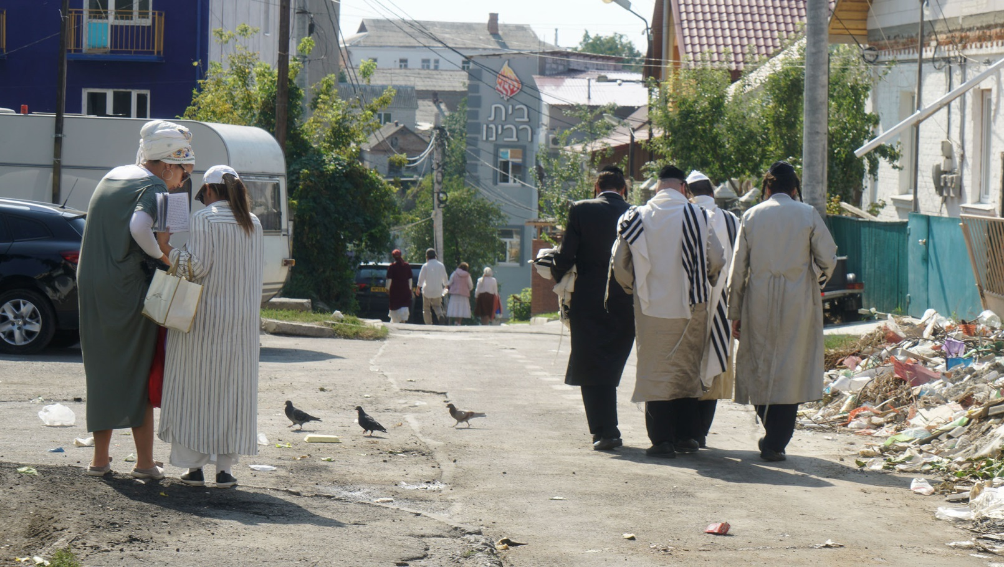
Jews walk down an alley leading to Pushkina Street in Uman, Sept. 8, 2017. (Cnaan Liphshiz)

But Chazin says the permanent Jewish community peacefully coexists with the rest of the city outside of the pilgrimage days. He added that tourist misbehavior used to be more common, but “is mostly a thing of the past, thanks to educational and outreach work” by spiritual leaders and local Jews.
One local, Shimon Buskila, told JTA in 2017 that some of the friction is “connected to misbehavior, abuse and violence by a certain fringe within the pilgrim community. Unfortunately, their actions can eclipse a record of coexistence which is mostly very positive.”
Chazin has a Ukrainian passport thanks to his parents, who were born there and immigrated to Israel decades ago. But most of Uman’s Jews have resident visas, which Ukraine gives anyone who can demonstrate they’ve made an investment of more than $100,000 in Ukrainian real estate or a business venture. A temporary staying permit can be obtained for much less.

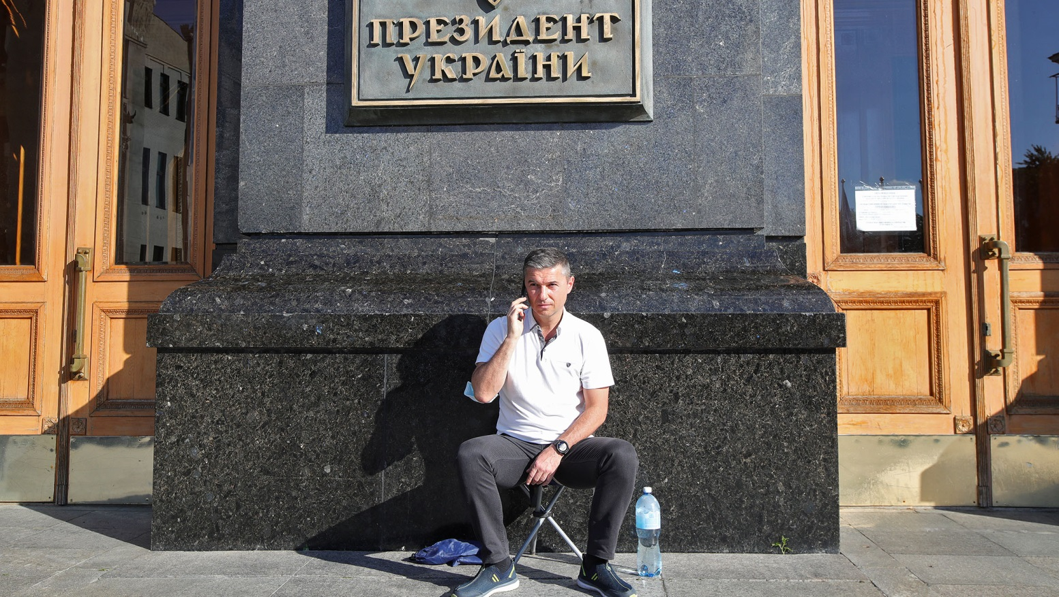
Oleksandr Tsebriy, the mayor of Uman, speaks on the phone outside the Cabinet of Ministers of Ukraine in Kyiv, Aug. 17, 2020. (Pavlo Bahmut/ Ukrinform/Barcroft Media via Getty Images)

Last month, Uman Mayor Oleksander Tsebriy complained in a filmed message on Facebook that Israelis are buying residence permits from corrupt immigration officials for $500, calling this a “form of fraud and manipulation that must stop.”
Tsebriy, a 46-year-old former car dealer who was elected to his post in 2015, is an outspoken critic of the pilgrimage, which he has placed at the center of his campaign for a second term in next month’s municipal elections. Amid fears that the pilgrims would be a health risk during the coronavirus pandemic, Tsebriy last month camped out outside the Kyiv office of Ukrainian President Volodymyr Zelensky, who is Jewish, demanding he ban the event.
A poll he conducted showed that “94% of Uman’s residents are against the traditional pilgrimage of Rosh Hashanah, though they have nothing against the pilgrims themselves,” Tsebriy told reporters outside Zelensky’s office.
According to his calculations, he said, the city’s annual revenue from the pilgrimage is only $270,000. Cleanup costs alone ate up more than a third of that income, in addition to extra water and maintenance costs.
The pilgrims aren’t the only tourists who come to Uman. Hundreds of thousands of people per year flock to Uman’s Sofiyivka Park, a 450-acre botanical garden that has been a symbol of creative arboreal design since it opened in the 19th century.
Chazin’s family are regulars at Sofiyivka, and on school vacations his wife, Liat, regularly takes the children to the beach in Odessa, a bustling metropolis with a vibrant Jewish scene that’s a three-hour drive away.
“In some important ways, the Uman community lives more comfortably than many other larger Jewish communities in Ukraine,” Chazin said.

Reprinted from the September 4, 2020 dispatch of the JTA (Jewish Telegraphic Agency).

Rosh Hashanah Cards
From the Holocaust
By Yad Vashem Photo Archives

A glimpse into some of the ways Jews before, during and immediately after the Holocaust marked the New Year. These images are part of a greater online exhibition on Yad Vashem's website.
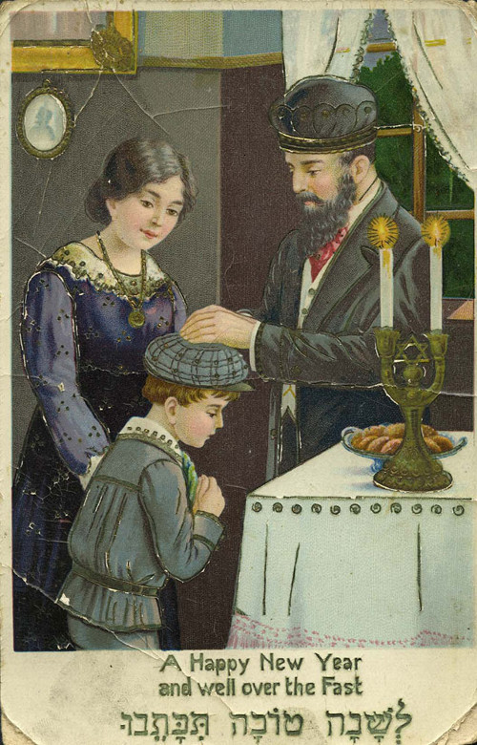
"Shana Tova" (Happy New Year) card sent to Henia Pollock in Argentina, from her relatives in Końskie, Poland, 1939
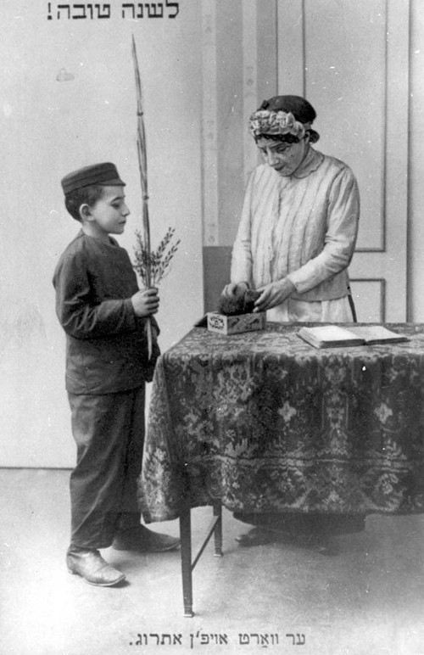
Prewar, Poland, a Rosh Hashanah greetings postcard, written in Yiddish
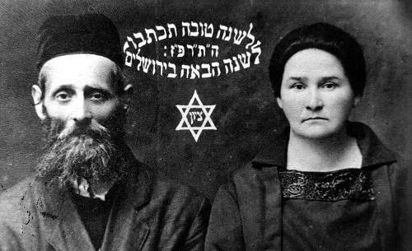
A Rosh Hashanah card sent by Aharon and Sheindl Blumen in 1926 from Luboml, Poland. The card reads: “May you be inscribed for a good year. Next year in Jerusalem.” The couple perished during the Holocaust.
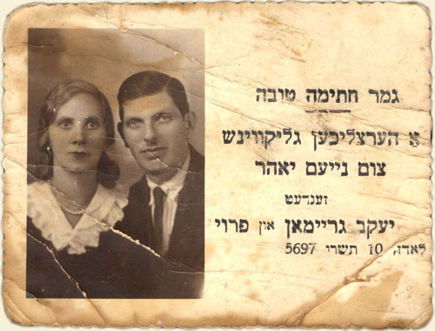
Jacob Graiman and his wife from Lodz, Poland on a New Year’s card, September 26, 1936. The couple perished during the Holocaust.
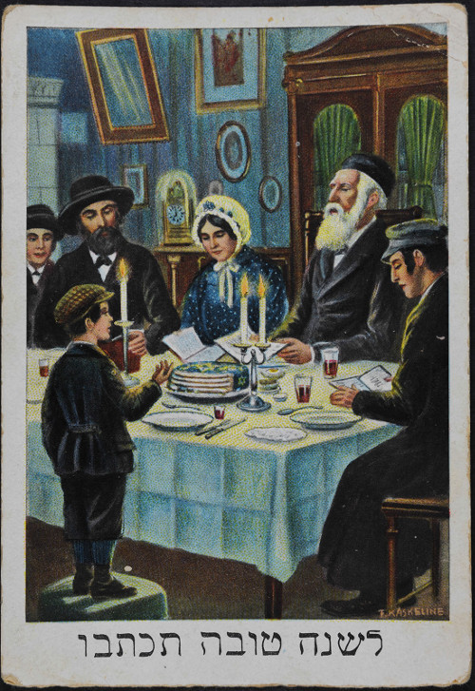
Postcard with greetings for the New Year that Miriam and Avraham-Simon Gorfinkel sent from Warsaw in the early 1930's to their son Schlomo and daughter-in-law Gitta who were living in Paris. "Your dear parents send to you and your wife, from deep in our hearts, wishes for a healthy and happy New Year, with prosperity and much joy."
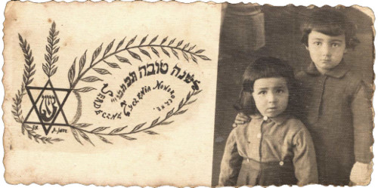
Druja, Poland, Meir Levitanus (the submitter) and his sister Chaya Miriam Marla, 1941
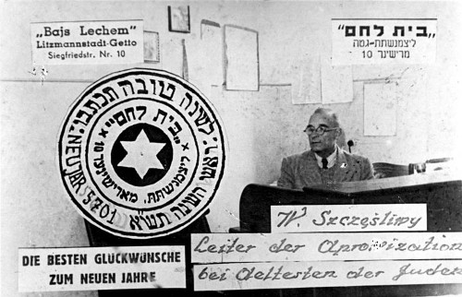
Lodz, Poland, a Rosh Hashanah greeting card, 1941. After the ghetto was closed in May 1940, a systematic array of services was installed. Among them, a food supply department whose officials began to apportion the meager provisions, and public kitchens and distribution points for bread and other staples were set up. This card apparently reflects one of those distribution points: Bajs Lechem (which appears in the upper left corner) means "House of Bread"

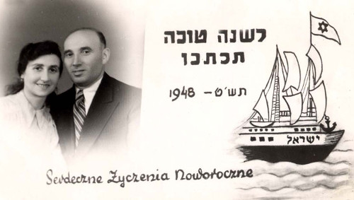
A New Year’s card sent by Yisrael Berman and his wife from Szczecin, Poland in 1948. The Hebrew inscription reads: “May you be inscribed for a good year.” The Hebrew on the boat reads: “Israel”.
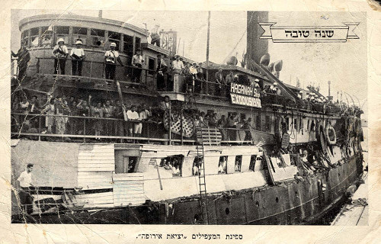
Pictured on this New Year’s card is the “illegal” immigration ship The Exodus 1947. The Exodus 1947 attempted to bring Jewish survivors to Palestine in 1947, only to be turned back to Europe by the British Mandate authorities and sent to Displaced Persons’ camps in Germany. The Exodus 1947 became an international symbol of the need for free Jewish immigration to Palestine. The refugees remained in the camps until 1948, when the State of Israel was established.
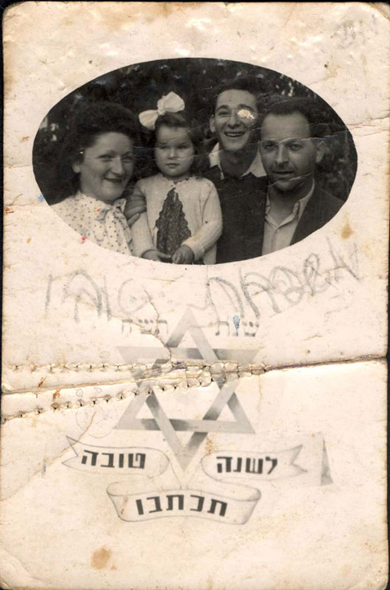
Lodz, Poland, a New Year greeting card, with the photo of the submitter's father's family.
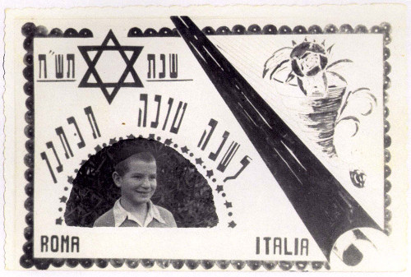
A New Year’s Card sent from the Meor HaGolah (Light of the Exile) Yeshiva in Rome in 1948. Many of the students of the yeshiva were Holocaust survivors. Pictured on the card is Israel Milkow, a student in the yeshiva from Slonim, Poland. During the Holocaust Israel was in a Russian orphanage in Samarkand, Uzbekistan.
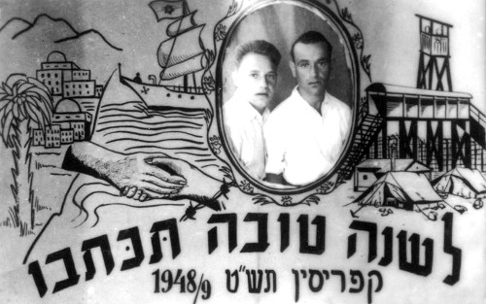
New Year greetings card, Cyprus, 1948. Sent by brothers David (right) and Yosef (left) Sin
Glossary for the Jewish New Year “Rosh Hashanah”
By Chabad.org Staff

Akedah: (lit. “the binding”); referring the Biblical account of The Binding of Isaac.
Aliyah: (lit. “ascent”); the honor of being called to recite the blessing upon the reading of the Torah scroll.
Aseret Yemei Teshuva: (lit, “the ten days of return”); the Days of Repentance, always the first ten days of the Jewish month of Tishrei, beginning on the Jewish New Year (Rosh Hashanah) and culminating on theDay of Atonement (Yom Kippur). A time period for focusing on prayer, charity and return to the G-dly path.
Arvit: the evening prayer service.
Avinu Malkeinu: (lit. “our Father, our King”); a prayer beseeching our Father in Heaven to grant us our needs, recited during prayer services throughout the High Holidays.
Baal Tokea: (lit. “master of the blast”); the person sounding the shofar ram’s horn in the synagogue.
Birchat Kohanim: (lit. “the blessing of the priests”); the blessings bestowed upon everyone in the Synagogue, on particular holidays, by the descendants of the priestly Biblical family of Aaron, known as the Kohanim (sin. Kohen).
Chag Sameach: (lit, “a happy festival”); one of the traditional holiday greetings.
Challah: (lit. “bread loaf”); a braided loaf baked in honor of theSabbath and major Jewish holidays.
D’vash: (lit. “honey”); traditionally eaten with challah bread and an apple on the Jewish New Year (Rosh Hashanah).
Eruv Tavshilin: (lit. “merging of cooked foods”); a procedure involving two prepared foods, that is performed on the eve of the holiday when a festival occurs on a Friday, to permit one to cook on the Friday for the Sabbath.
Gut Yom-Tov: (lit. “a good holiday”); one of the traditional holiday greetings.
Haftorah: (lit. “concluding portion”); a section from the Prophets read at the conclusion of the reading of the Torah scroll.
HaMotzi: (lit. “Who brings forth”); blessing recited over bread.
Hatarat Nedarim: the annulment of vows recited on the eve the Jewish New Year (alternatively it can be said earlier, or ten days later before the Day of Atonement).
Kara: (lit, “gourd”); one of the symbolic foods eaten on the evening of the Jewish New Year (Rosh Hashanah).
Karti: (lit. “leek”); one of the symbolic foods eaten on the evening of the Jewish New Year (Rosh Hashanah).
Ketiva vachatimah tovah: (lit. “may you be inscribed and sealed for a good year”); traditional greeting on the Jewish New Year (Rosh Hashanah).
Kezayit: (lit. “like an olive”); a measurement in Jewish law, formally described as the size of an olive, approximately one ounce or 25.6 grams.
Kiddush: (lit. “sanctification”); the blessings recited over a cup of wine at the onset of Sabbath and major Jewish Holiday meals, expressing the sanctity of the day.
Lekach: honey cake, traditionally eaten on the Jewish New Year (Rosh Hashanah). It is also traditional to request and receive a piece of honey cake on the eve of the Day of Atonement (Yom Kippur).
Leshanah tovah tikateiv veteichateim: (lit: “may you be inscribed and sealed for a good year”); traditional greeting on the Jewish New Year (Rosh Hashanah).
Maariv: the evening prayer services.
Machzor: (lit: "cycle"); the prayer book used on the Jewish New Year (Rosh Hashanah) and Day of Atonement (Yom Kippur).
Meren: (lit: "more" and alternatively "carrots"); a sweet carrot stew traditionally served during the Jewish New Year (Rosh Hashanah) meals.
Minchah: (lit. “the offering”); afternoon prayer service.
Musaf: “additional” prayer service recited on major Jewish holidays.
Pri chadash: (lit. “new fruit”) a seasonal fruit is eaten after the recitation of thekiddush on the second night of the Jewish New Year (Rosh Hashanah). The selected fruit should be one that one has not tasted since the beginning of the season.
Rosh dag: (lit. “head of a fish”); the head of a fish, ram, or other kosher animal is served on the Jewish New Year (Rosh Hashanah).
Rimon: (lit. “pomegranate”); a pomegranate is traditionally eaten on the night of the Jewish New Year (Rosh Hashanah).
Rosh Hashanah: (lit. “head of the year”); the holiday marking the Jewish New Year, always occurring on the first two days of the Jewish month of Tishrei; beginning the ten Days of Repentance (Aseret Yemei Teshuva).
Rosh keves: (lit. “ram’s head”); the head of an ram that some traditionally serve on the night of the Jewish New Year (Rosh Hashanah).
Rubia (Lubia): small beans that some traditionally serve on the night of the Jewish New Year (Rosh Hashanah).
Salka: beets that some traditionally serve on the night of the Jewish New Year (Rosh Hashanah).
Selichot: penitential prayers read daily before dawn during the week preceding the Jewish New Year (Rosh Hashanah).
Shabbat Selichot: The Sabbath preceding the Jewish New Year (Rosh Hashanah). The following morning begins the recitation of selichot penitential prayers.
Shacharit: (lit. “the dawning”); the morning prayer service.
Shana tovah: (lit. “good year”) traditional greeting during the Jewish month of Elul and on the Jewish New Year (Rosh Hashanah).
Shofar: A ram’s horn blown daily during the Jewish month of Elul (not including the last day), on the Jewish New Year (Rosh HaShanah), and at the end of the Day of Atonement (Yom Kippur).
Shevarim: the three shofar ram’s horn blasts of intermediate length.
Shofrot: (a) plural for the shofar (ram's horn); (b) one of the blessings in the musaf prayer service of the Jewish New Year (Rosh HaShanah), consisting of verses reflecting the importance of sounding the shofar.
Tapuach bidvash: a piece of apple dipped into honey traditionally served on the night of the Jewish New Year (Rosh Hashanah).
Tachanun: (lit. “supplication”); the penitential prayers recited on all non-festive days.
Tashlich: (lit. “You shall cast”); the riverside ritual of casting one’s sins into the waters on the Jewish New Year (Rosh HaShanah).
Tekiah: the protracted Shofar blast.
Tekiah Shevarim Teruah Tekiah: the traditional order of the sounds of the shofar: a long steady blast, a series of medium-length wailing blasts, a series of very short sounds in rapid succession, followed by another long steady blast.
Temarim: dates that some traditionally serve on the night of the Jewish New Year (Rosh Hashanah).
Teruah: the staccato Shofar blast.
Teshuvah: (lit. “return”); repentance, the return to the correct path of observance of G-d’s commandments.
Tzedakah: (lit. “justice, righteousness”); charity, traditionally given in abundance prior to the Jewish New Year (Rosh Hashanah).
Tzimmes: a sweet carrot stew traditionally served during the Jewish New Year (Rosh Hashanah) meals.
Unetaneh Tokef: (lit: “let us relate the power”); one of the powerful prayers recited during the High Holidays.

Reprinted from the Erev Rosh Hashanah 5777 email of Chabad.Org Magazine.

How Do You Wish Someone Happy Rosh Hashanah?
By Katie Whitfield

On Rosh Hashanah there is a custom to dip apples into honey and to blow the shofar

Rosh Hashanah is one of the most important dates in the Jewish calendar.
The date marks the first of the High Holidays, a ten-day period which ends with Yom Kippur, the holiest day of the Jewish year.
On Rosh Hashanah, Jews all around the globe celebrate the creation of the world and have an opportunity to ask for forgiveness and start afresh.
Rosh Hashanah is two days long and usually occurs during the months of September, this year beginning on the evening of Sunday, September 9, and ending on the evening of Tuesday, September 11.
Rosh Hashanah is the birthday of the universe in Jewish belief, the day G-d created Adam and Eve.
The celebration begins at sundown on the eve of Tishrei 1 - the Hebrew month corresponding with September/October.
Directly translated, Rosh Hashanah means ‘head of the year’.
How do you wish someone happy Rosh Hashanah?
There are a few ways to wish your Jewish friends a happy new year.
Saying ‘Shana Tova’, which means ‘For a good year’ in Hebrew, is the most common greeting.

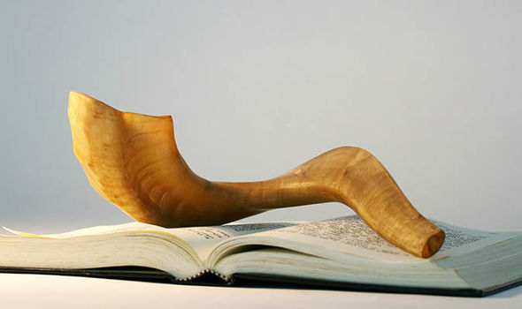
A shofar atop a Machzor, a special prayer book for Rosh Hashanah

If you want to express the same sentiment but more elaborately, you can say ‘Shanah Tovah Umetukah’, which means ‘A good and sweet year’.
And a Rosh Hashanah greeting used by the devout is ‘L’Shanah Tovah Tikatevu V'taihatem’, which means ‘May you be inscribed and sealed for a good year’.

How is Rosh Hashanah celebrated?
During Rosh Hashanah, Jewish people ask G-d for forgiveness for anything they may have done wrong the previous year.
The holiday is an opportunity to remind oneself not to repeat the mistakes again in the year ahead.
Rosh Hashanah is also seen as an annual observation of improvement and fresh starts.
Jews from all over the world celebrate Rosh Hashanah, and traditions can vary depending on the region.
Candle lighting in the evenings, festive meals and prayer services on both mornings are fundamental parts of the holiday.
A special prayer service is held at a synagogue, and the shofar - a horn from a ram - is blown.
Charitable giving, known as Tzedakah, is also an important part of the holiday.
Jews are expected to desist from creative work during Rosh Hashanah.

Food is a crucial element of Rosh Hashanah, including many special meals.
Meals begin with reciting the kiddush prayer over wine, and then a blessing over bread.
Sweet food is eaten to symbolise hope for a sweet year ahead.
Some other foods commonly enjoyed are pomegranates, apples in honey, challah bread, and fish.
Nuts, vinegar, horseradish and other sharp or bitter foods are avoided to prevent a bitter year.

Reprinted from the September 10, 2018 edition of the Daily Express (U.K.)

Supplemental Stories
for rosh hashanah 5780
1-2 Tishrei 5780/ September 19-20, 2020
Printed L’illuy nishmas Nechama bas R’ Noach, a”h

For a free subscription, please forward your request to keren18@juno.com

'Portuguese Schindler' Finally Honored After Saving Thousands From Holocaust. Here's His Story

Aristides de Sousa Mendes saved the lives of an estimated 10,000 Jews in World War II, and his efforts have finally been recognized by the Portuguese government. This is his story, first published by Haaretz in August 2013

The dilapidated home of diplomat Aristides de Sousa Mendes, who saved the lives of 30,000 people during the Holocaust, including 10,000 Jews. Photo Credit: Amit Schejter
By Judy Maltz
Published on June 22, 2020

It took nearly eight decades for Portuguese diplomat Aristides de Sousa Mendes to be recognized by his own government for saving the lives of an estimated 10,000 Jews during the Holocaust.

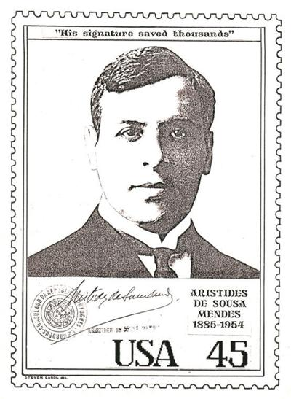
But on June 9, he finally received the long overdue honor with the Portuguese parliament voting to dedicate a monument in his name at the National Pantheon.
Seven years ago, Haaretz correspondent Judy Maltz visited the ruins of his family mansion in Cabanas de Viriato, a tiny village in central Portugal, and heard about his heroic efforts. This is her story from August 2013...
CABANAS DE VIRIATO, Portugal – The grand old house that lies in ruins at the corner of this tiny village in northern Portugal speaks volumes of the tragic fate that befell its once illustrious owner.
And to what did the diplomat Aristides de Sousa Mendes, a member of Portugal’s aristocracy and brother of its foreign minister, owe his devastating fall from grace? One simple crime: his decision, against his government’s orders, to issue visas to fellow Europeans desperately seeking refuge from the Nazis.

A passport from the exhibit that was issued by Aristides de Sousa Mendes. Photo Credit: Amit Schejter

Through this act of defiance, Sousa Mendes saved the lives of an estimated 30,000 individuals, among them more than 10,000 Jews. But he also died a destitute man, stripped of all titles and assets, shunned by society.
A temporary exhibit now open on the premises of the Sousa Mendes family property is part of an effort, more than 70 years after the fact, to pay tribute to this relatively unknown Portuguese diplomat who single-handedly, and at considerable risk to himself and his family, undertook perhaps the greatest act of rescue during the Holocaust – far greater in scope, in fact, than that of Oskar Schindler.
The exhibit is the brainchild of Eric Moed, a 25-year-old Brooklyn-based architect whose grandfather and great-grandfather were among those fortunate Jews granted visas by Sousa Mendes – most of them issued during a huge operation that took place at the end of May 1940 while the Spanish border was still open, and refugees could still move freely from France to Spain and from Spain to Portugal.
Consisting of three pavilions constructed of acrylic sheets, this “pop-up” museum, as Moed describes it, contains a timeline of events, headshots of many of those rescued, photocopies of passports, quotes from Sousa Mendes that address his motivations, and testimonials from those he rescued.
Etched into the sides of the pavilions are 30,000 copies of Sousa Mendes’ signature, one for each person saved, as it appeared on the life-saving visas he authorized.
The project was conceived as part of Moed’s senior thesis project at the Pratt Institute, for which he won a 5,000 euro grant from the UNHATE Foundation, a nonprofit run by Benetton that promotes tolerance. The Moed family had been living in Antwerp, Belgium, when the war broke out. Thanks to the visas his great-grandparents and their three children obtained from Sousa Mendes, they were eventually able to flee to the United States.
The exhibit, which was unveiled on June 20, will remain open until the end of the month. “The plan is then to turn it into a traveling exhibit that will be showcased at Holocaust and tolerance museums around the world,” Moed said in a telephone interview from New York.

Portuguese pilgrimage
The Sousa Mendes Foundation, established several years ago by the late diplomat’s descendants and the descendants of those saved by him, eventually plans to restore the entire mansion to its former glory and turn it into a permanent museum of tolerance, dedicated to him and other Holocaust rescuers.
Earlier this month, a group of several dozen individuals rescued by Sousa Mendes and their descendants, including Moed and his grandfather, embarked on a pilgrimage to the mansion, many of them following the routes to Portugal taken more than 70 year ago through France and Spain. Their pilgrimage coincided with the opening of the exhibit at a ceremony also attended by several of Sousa Mendes’ grandchildren.
The Sousa Mendes family mansion, known as the Casa do Passal, is now boarded up, but a peek through the shattered glass windows is enough to reveal its state of decay: Rotting wooden planks are strewn on floors covered with debris and weeds. Some of the outside walls of the four-story building appear to have suffered fire damage. It was in this 1,000-square meter edifice that Sousa Mendes, his wife Angelina and their 14 children, spent their time when they were not stationed overseas.

When World War II Broke Out
When World War II broke out, Sousa Mendes – a Catholic – was serving as the Portuguese consul in Bordeaux, France. In 1940, after France had capitulated to the Nazis, the Portuguese government, which had declared neutrality in the war, ordered its overseas diplomats to deny all requests for visas to those seeking refuge, particularly Jews.
Explaining his decision to defy this order years later, in a quote highlighted in the exhibit, Sousa Mendes said: “I could not differentiate between nationalities. I was obeying the dictates of humanity that distinguish between neither race nor nationality.”
Upon learning of Sousa Mendes’ act of outright disobedience, the Portuguese dictator, Antonio de Oliveira Salazar, had him immediately recalled to Portugal and dismissed from the foreign service. He was also banned from practicing law and died penniless in 1954, all attempts to have his name cleared during his lifetime rebuffed.
In 1966, Sousa Mendes was recognized as a Righteous Among the Nations by the Yad Vashem Holocaust memorial museum, and in 1988 the Portuguese government issued an official apology to him and his family. Because of the family’s huge debts, the house was taken from them after the war, but about 10 years ago Sousa Mendes’ descendants raised the money to repossess it.
The residents of Cabanas de Viriato clearly take pride in their local hero. His portrait is the first thing to greet visitors entering the village, and the local school is named in his honor. In recent weeks, the villagers have grown accustomed to the rather unusual sight of foreigners, many of them Jewish, suddenly descending on their town searching for the house where Sousa Mendes once lived. It is not uncommon for them to stop whatever they’re doing smack in the middle of the day and lead these visitors to their destination.

Reprinted from the June 22, 2020 edition of Haaretz/

A Blast from the Past
Louis Bamberger’s Big Store
By Joanne Palmer
Local Historian Writes about the Jewish Merchant
Prince who Gave Newark its Center

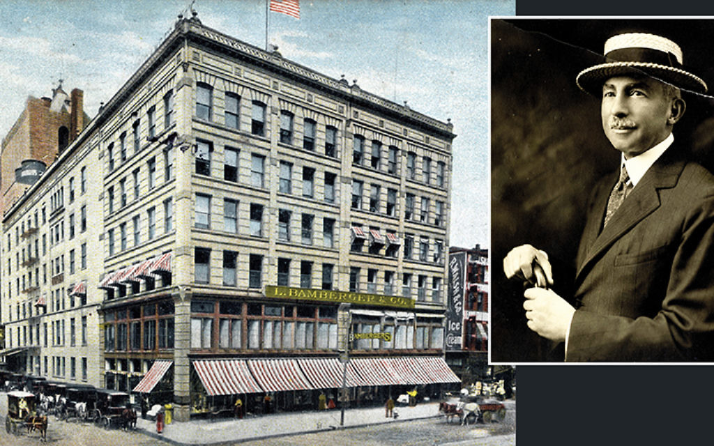
Consider Mark Zuckerberg. Steve Jobs. Larry Page. Sergey Brin. Jeff Bezos. Larry Ellison. Bill Gates.
To varying degrees, with different back stories, all are (or, in Jobs’ case, were) entrepreneurs, visionaries, technocrats, philanthropists, and, to some extent, social engineers. Not all, but many — if not most — of them were Jews. Each one of these men (and yes, they all are men) changed the way America — and, eventually, the world — did business. And they also changed the way people shop.
Because, as it turns out, the way we shop both mirrors and changes the way we live.

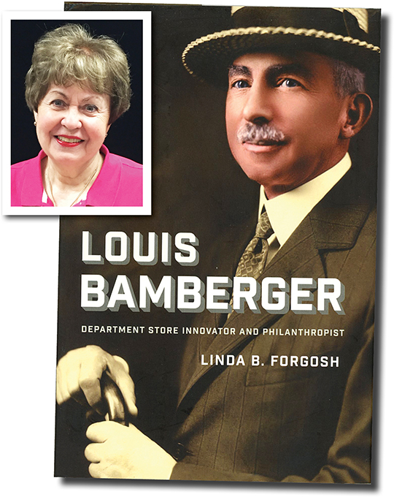

It was these men who moved us from the tactile, brick-and-mortar, touch and eyeball and sniff and taste act of shopping — that physical adventure that involved picking out goods, carting them to the cashier, paying for them, and carrying them home — to doing our buying privately, at all hours, at home, as an almost faith-based act of trust in electrons and FedEx.
We all shop differently now.
But also consider Isidor Straus. John Wannamaker. Julius Rosenwald. Benjamin Altman. Marshall Field. Edward Filene.
And, of course, and most relevantly to New Jersey, Louis Bamberger.
To varying degrees, with different back stories, all were entrepreneurs, visionaries, technocrats, philanthropists, and, to some extent, social engineers. Not all, but many — if not most — of them were Jews. Each one of these men (and yes, they all are men) changed the way America — and, eventually, the world — did business. And they also changed the way people shop.
Because, as it turns out, the way we shop both mirrors and changes the way we live.
Louis Bamberger is the subject of a new biography by independent scholar Linda Forgosh, who says that Bamberger — who never married and devoted his considerable intellectual energies first to his store and later to the world around him — presided over huge changes in retailing, helped maintain Newark as the great city that it then was, earned the undying loyalty of his employees, and later was responsible for such accomplishments as getting Albert Einstein into the United States and establishing the Princeton- (but not Princeton University-) based Institute for Advanced Studies.

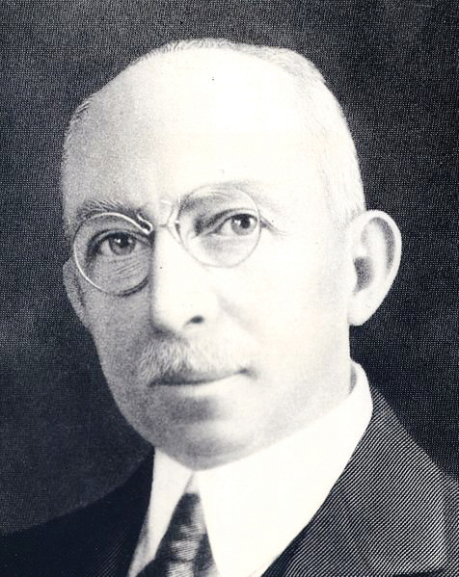
Louis Bamberger

His biographer, Ms. Forgosh, herself is a New Jersey native whose story in some ways is a story of the Jewish community here.
Let’s start with Louis Bamberger.
In the late 19th century, Newark was a manufacturing center, Ms. Forgosh said. “It was the fourth biggest city in America, and you name it, they made it. Leather goods and patent leather and jewelry and buggy seats,” among many other things; the emphasis on leather was because of Seth Boyden, a pioneer in the field, whose businesses were in Newark. It also produced a huge range of early plastics, lamps, and dentures. Thomas Edison invented the stock ticker in Newark. It was a seaport and a major rail hub. It was the brewing center for the whole eastern seaboard. It was full of immigrants and teeming with life.
It had a huge Jewish population. The city’s best-known Jewish neighborhood, Weequahic, unpronounceable to outsiders, made legend by Philip Roth but actually entirely real and the ancestral home of countless Jersey Jews, at its peak, in the 1950s and 60s, had “as many as 17 synagogues in a 54-block radius,” Ms. Forgosh said. “I would say that the whole city had up to 150 synagogues,” counting the sometimes nameless little neighborhood shtiebels.

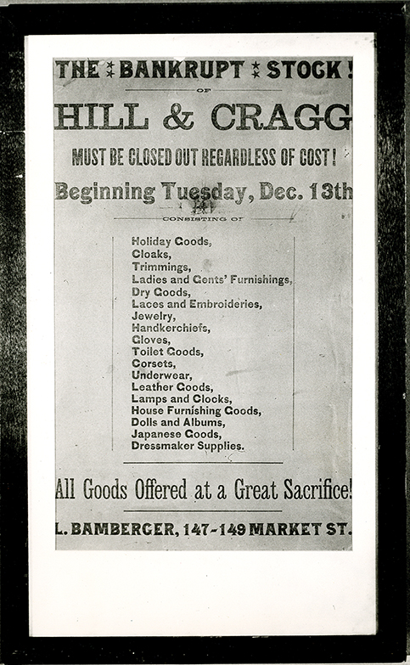
Louis Bamberger’s purchase of Hill & Cragg led to the opening of his new store

Louis Bamberger was born in Baltimore in 1855, six years before the start of the Civil War. His maternal grandfather, a successful merchant, founded a highly successful and influential general store, Hutz-ler Brothers, in that city; Louis’ father and his uncles worked there, and soon Louis did too. “Bamberger learned the business just sitting in his parents’ dining room,” Ms. Forgosh said. “During the Civil War, they were the largest manufacturers of uniforms for the Army, and of clothing items in general. They all discussed business, and he was a quiet sort of guy, who just sat there and absorbed it.
“He worked at his uncles’ store, and he spent his life learning the retail business.” But the business was his uncles’, not his father’s, and “I think that one morning he woke up and told himself ‘I will never advance here,’ so he moved to New York.” There, he gained more experience, realized that he wanted to work for himself, found a business partner, “went to Newark, and took a big chance.”

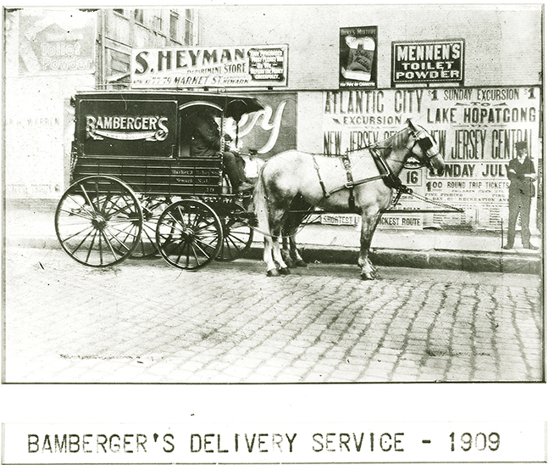
A Bamberger’s delivery carriage makes its rounds in this 1909 photo.

He opened his new store, L. Bamberger and Co., in 1892.
Bamberger did not pioneer the concept of the department store, which Ms. Forgosh defined as “a series of departments selling a series of specialties, all under one roof.” It was a break from the tradition of many small stores, each selling a small range of products, most of them handmade.
Bamberger based his new store most closely on Filene’s, the brainchild of another German Jew, and on other department stores across the country, but he refined and expanded the idea.
“He bought the stock of a company that had gone bankrupt, called Hill and Cragg,” Ms. Forgosh said. “It was just two stories, and it faced a very unattractive street, with a lot of saloons on it. It had its wares displayed on the sidewalk.
“Louis was advised not to open there, on Market Street, but to move it to Broad Street, which really was broad, and a much better address. But he always maintained that if you have something to offer, customers will find you.
“And they did.”

You Could Find Whatever
You Wanted in Bamberger’s
“You could find whatever you wanted in Bamberger’s,” Ms. Forgosh continued. Of course you could buy clothing — men’s, women’s, children’s, babies’ clothing. “You could buy a bird and buy a cage and birdseed for it. You could find the post office inside and do mailings. You could find an extension of the Newark public library and borrow books. You could go to the photography department and buy a camera or get your picture taken. You could buy a tennis racket or you could get your tennis racket restrung. You could buy a wedding dress and get it altered there.”
The radio station WOR also had its start in L. Bamberger & Co. “Somebody had to come up with an idea about how to sell a new invention — radio tubes,” Ms. Forgosh said. “The tubes were manufactured in Newark. Bamberger came up with the idea of starting a radio station. The store was the first one in the country to have its own station.”
The store, in other words, offered services as well as goods. “And it reflected the growth of the country,” Ms. Forgosh continued. “It was progressive and democratizing. Its opening coincided with the Chicago Exposition; every new invention and home device could be seen at the exposition — like home washing machines! — all found their way to Bamberger’s.
“The store sold technology that made housewives’ lives easier.”
In fact, the stores made women’s life in general easier. Although it employed men, most people who worked there were women.
Bamberger’s, like other department stores but even more strongly, emphasized service. “They offered refunds, prices were competitive, and there was one price. You didn’t have to haggle; you just looked at the price tag,” Ms. Forgosh said.
Soon, department store owners “decided to form a cooperative, where they all would share information,” she said. “Bamberger opened the store to anyone who wanted to do the research. They figured out why he was so successful.
“The answer was one word. Volume. That was the secret.”
Another similarly not-so-closely-held secret was that “the same attention that he paid to his customers he paid to his vendors. The commandment was ‘Thou shalt treat all vendors with respect, and pay them on time.’” That paid off for Bamberger later, when wartime needs demanded that many goods be directed first to the armed forces. That left less for everyone else, but “when Louis needed stuff for his stores, he got it,” Ms. Forgosh said. “His vendors remembered him.”
Bamberger also started a magazine, called Charm, a glossy women’s publication with high production values — one of its covers was designed and signed by Pablo Picasso — which did not promote any of the store’s products directly but instead positioned New Jersey as a desirable place to live.

Louis Bamberger started Charm, a high-values publication aimed at upscale women consumers.
Bamberger’s promotions were gargantuan in scale, calculated not only to impress but to educate and enlighten as well. “In 1936, he brought the Met” — as in the Metropolitan Opera — “to Newark to perform La Boheme.” It wasn’t a concert performance, either; the company brought costumes and sets. “The whole enchilada,” Ms. Forgosh said. “Bamberger loved music.”
And do you think that the Thanksgiving Day Parade was a Macy’s innovation? Nah, Ms. Forgosh said. That was Bamberger’s; when, eventually, Macy’s bought Bamberger’s, the parade went with it. (To be fair, other department stores in other cities sponsored similar all-out events.)
About that sale — in 1929, Louis Bamberger sold the store to Macy’s, although “the name stayed until 1986,” Ms. Forgosh said. “They were afraid to take the name off the building.
“He had spent an entire lifetime branding that name.”

A Serious Philanthropist
Louis Bamberger was a serious philanthropist. “He gave to everything that walked, talked, or breathed,” Ms. Forgosh said. “He was not religious, but there would be no Jewish hospital in New Jersey if it wasn’t for Bamberger and his partner, Felix Fuld, who later became his brother-in-law as well. They raised all the funds for Newark Beth Israel Hospital. And there would have been no Y” — Newark’s YM-YWHA — “had he not brought it there. And there would have been no Newark Museum. He was the sole donor. Not one other person put a dime into it. He backed the first Jewish social service agency in Newark, and the first Jewish day nursery.”
He sat on about 30 boards in all, Ms. Forgosh said; once he decided a cause was worthy enough for him to join its board, other people’s money generally would follow his. “His name on the letterhead was like cash in the bank,” Ms. Forgosh said.
He did not restrict his concern to the Jewish world; instead, he gave a considerable amount of money to civil rights causes, including the Urban League. (This was early in the civil rights movement’s history.)
Louis Bamberger’s family was unusual. He was one of seven children, Ms. Forgosh said; still, his parents had only one grandchild. Of the two brothers and five sisters, only two married, and only one had a child. But Bamberger was deeply loyal to his family; he had no close friends other than his siblings.

Did Not Live in the City of Newark
Despite his love for Newark, Bamberger did not live in the city. He had a 35-acre estate in South Orange, which included a working farm, Ms. Forgosh said, and this was just one of his many homes.
Bamberger’s interests included the Institute for Advanced Studies, an early (and still extant and much expanded) think tank. He endowed it with the proceeds of the sale of Bamberger’s, and among other things it provided an academic home for Albert Einstein. “Bamberger and Einstein were friends,” Ms. Forgosh said. “They shared many things — German Jewish culture, the German language, their love of music. But what they most had in common was social justice.” By the end of his life, Bamberger gave the institute $19 million dollars, a lot of money now but an absolute king’s ransom at the time.

Louis Bamberger was a strong American patriot.
“Through the sheer dint of personality and determination, he found and purchased the signatures of all 56 signers of the Declaration of Independence,” Ms. Forgosh said. Each was a separate signature, assembled into one piece. “They were exhibited at the Bicentennial, in 1976. But he made a very big mistake.
“His will did not restrict its use, so some stupid group of trustees of the New Jersey Historical Society, which received it, sold it at auction for an undisclosed amount of money. And there it went.”
It’s never been seen in public since, and its whereabouts are unknown. That’s a huge loss, Ms. Forgosh said.

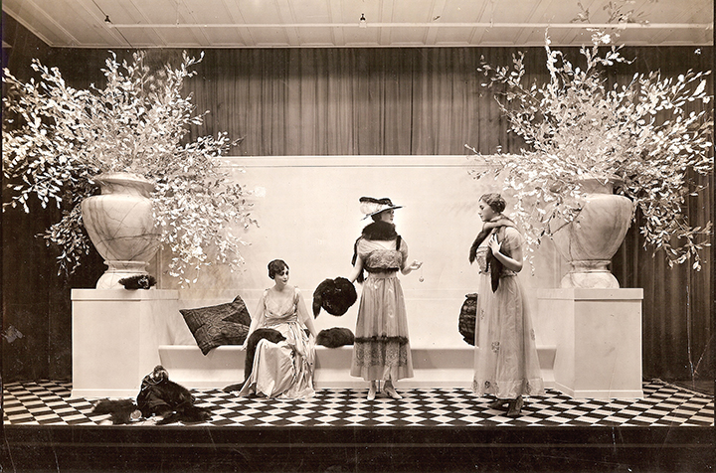
Elegant early 20th century fashions are on display at Bamberger’s.

Louis Bamberger belonged to Congregation B’nai Jeshurun, a large Reform synagogue in Newark, since relocated to Short Hills, although he did not go there very often. But when he died, in 1944, “1,200 mourners showed up for his funeral,” Ms. Forgosh said.
Had it not been for Louis Bamberger, she added, New Jersey’s Jewish community would have been far less rich, not only materially but in institutions, in its understanding of philanthropy, and in its ability to reach outside itself.
Ms. Forgosh’s own relationship with New Jersey is generations deep. (Lest you not realize it, all you have to do is ask her to pronounce the name of the city whose chief department store she has chronicled. “Nork,” she says, in that inimitable Jersey way.)
Her great grandparents, Esther and Nathan Grossman, settled in what is now called Avenel but then was Demarest-on-the-Hill in 1852. The town’s early settlers were Dutch, and the Grossmans, who ran a small grocery store, were its only Jews.

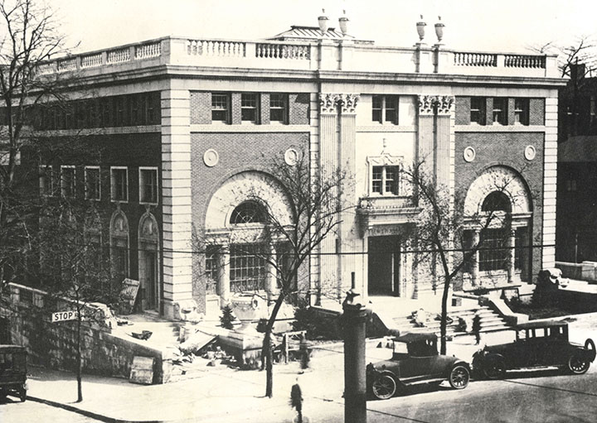
The Newark Y at the corner of High Street (now MLK Boulevard) and Kinney Street, funded wholly by Louis Bamberger.

Ms. Forgosh’s grandfather, David Grossman, and his wife, Eva Levy Grossman, stayed in Avenel. David Grossman was an ambitious entrepreneur. “He said, ‘First you go into business, and then you worry about what you do,’” she reported. His business was manufacturing concrete and cinder blocks; Capitol Concrete, as it was called, was extremely successful.
A Four-Generation Family Business
“He manufactured lawn jockeys — they came from his molds,” Ms. Forgosh said. He also made bird baths, garden gnomes, Madonnas, and rabbits; he basically made any piece of garden statuary you can call to mind. “It was a four-generation family business,” she added. “My grandfather took care of the rest of the family — I wouldn’t have gone to college if he hadn’t.”
That part of the family is gone from New Jersey now. They sold the business eventually, and then “my grandparents moved to Miami Beach,” she said. Other retirees buy apartments. “My grandparents bought an apartment building on Collins Avenue.”
Ms. Forgosh’s father died when she was young. Her father’s family name had been Solovetchic; she doesn’t know what the connection to the famous Soloveitchics might have been, but she does know that her father, wanting to sound less Jewish, changed his last name to Berman. (Go know…)
Ms. Forgosh always was fascinated by history. At least in part, she said, that’s because she grew up surrounded by it. “New Jersey is the crossroads of the American revolution,” she said. “More battles were fought here than in any other state.”

Executive Director of the New Jersey Jewish Historical Society
A thorough New Jerseyan, she did not leave the state even for college, spending those four years at Rider University in Lawrenceville. She’s now the executive director of the Jewish Historical Society of New Jersey, headquartered at the JCC in Whippany and funded in part by the Jewish Federation of MetroWest. “Sitting here in Whippany, we are within eight or so miles from Morristown, where Alexander Hamilton met his wife,” she said. George Washington slept all over the area. “He had his headquarters in Morristown. One of the most important sculptures documenting the revolution, called the Alliance, shows Washington flanked by the Marquis de Lafayette and Hamilton. It’s in Morristown.”
Ms. Forgosh has written books about local Jewish history, but her large, ambitious biography of Louis Bamberger is the first such book she has written, and it is also the first book to tackle Bamberger’s life.
Often, when she talks about her subject, Ms. Forgosh called him Bamberger, and sometimes it’s Mr. Bamberger, but often it’s Louis. That’s because she has come to know him well and to admire him greatly, she said. “I call him Louis because his family was so generous and gave me access to his papers, and that really made his story come to life.
“That was a real gift, and I loved every minute of it,” she said.

Reprinted from the September 2, 2016 edition of the Jewish Standard (New Jersey).
Max Fried Idolizes Sandy Koufax — and This Year
He’s Pitching Like Him
By Marc Brodsky

Max Fried pitches in a game for the Atlanta Braves against the Philadelphia Phillies at Citizens Bank Park in Philadelphia, Aug. 9, 2020. (Kyle Ross/Icon Sportswire via Getty Images)

(JTA) — Moshiach, thy name is Max — in Atlanta, anyway.
That is Max Fried of the Braves, who’s been among the most dominant pitchers in this pandemic-shortened Major League Baseball season.
s The Jewish lefty, in his second full season as a starter, has gone 6-0 after beating the Boston Red Sox on Monday and owns a National League best 1.60 earned run average. Fried has yet to yield a home run in his last 58 1/3 innings, including 45 this season.
Great pitching for sure. But the Messiah?

Max Fried at the beginning of the 2020 season

The 26-year-old southpaw qualifies as that for a Braves squad that saw its top starter, Mike Soroka, go down three starts into the season with an Achilles tear and the rest of the rotation struggle terribly. Still, Atlanta was sitting atop its division, the N.L. East, with a three-game lead over the Philadelphia Phillies and Florida Marlins as of Wednesday.
His teammates and manager are quick to cite Fried as the reason.
“I don’t think we’d be here without Max,” first baseman Freddie Freeman told mlb.com when asked who was the team’s Most Valuable Player.
And this from manager Brian Snitker, to the same website: “He was the one guy you could count on and he didn’t disappoint.”
Fried grew up in the Los Angeles area, throws hard, is a lefty – and yes, he’s a big-time Sandy Koufax fan.
In fact his uniform number, 32, is an homage to the Dodgers Hall of Famer who famously sat out a World Series game in 1965 played on Yom Kippur. (Fried did pitch last year on the Day of Atonement; it didn’t go well.)
Fried met Koufax in 2018 when the Braves and Dodgers faced off in the postseason.

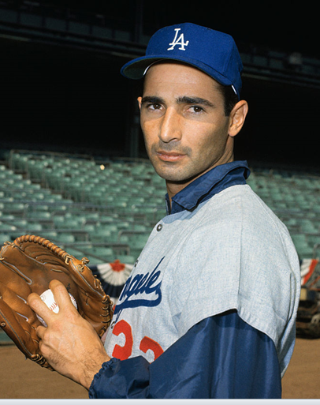
Sandy Koufax, the Jewish Baseball Hall of Famer

“Incredible,” was how Fried recalled the meeting in an interview last year with JUF News.
Fried talked in the interview about the famed Jewish athlete.
“The more success I had growing up, the more I heard about Sandy Koufax in the Jewish community,” he said. “Growing up in Los Angeles and being left-handed, eventually I started idolizing him. Obviously he was before my time. But I always strived to follow him. And everything I ever heard was about how great a person he was rather than how great of a pitcher.”
Now no one is calling the lanky 6-4, 190-pound Fried another Koufax. But great things were expected for the former first round draft choice.
“I’ve been saying it for a few years how special that left arm is,” Freeman said. “We saw it last year and now he’s really putting it together.”

Reprinted from the September 2, 2020 dispatch of the JTA (Jewish Telegraphic Agency).
Diaspora
The Jews Who Treated the Hindenburg Survivors
By Phil Goldfarb

The little-known story of two immigrant professionals
who acted quickly after the Nazi airship disaster

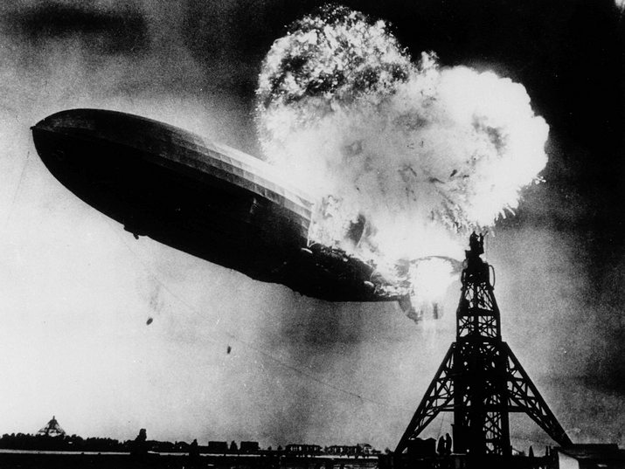
The Hindenburg disaster, May 6, 1937 (Public Domain / Gus Pasquarella)

The pride of Nazi Germany, the Hindenburg — officially designated LZ-129 Hindenburg — was the biggest commercial airship ever built, and, at the time, the most technologically advanced. It was 803.8 feet (ca. 245 meters) in length and 135.1 feet (ca. 41 meters) in diameter. It was more than three times larger than a Boeing 747, and four times the size of the Goodyear Blimp. Four engines powered the Hindenburg and it could reach cruising speeds of 76 mph (ca. 122 km/h) with a maximum speed of 84 mph (135 km/h).
The Hindenburg featured 72 passenger beds in heated cabins, a silk-wallpapered dining room, lounge, writing room, bar, smoking room, and promenades with windows that could be opened in-flight. Special precautions were taken to ensure that the smoking room was safe, including a double-door airlock to keep hydrogen from entering.
The Hindenburg was named for former German Weimar Republic President Paul von Hindenburg (1847-1934). It took its first flight in March 1936, and flew 63 times, primarily from Germany to North and South America.

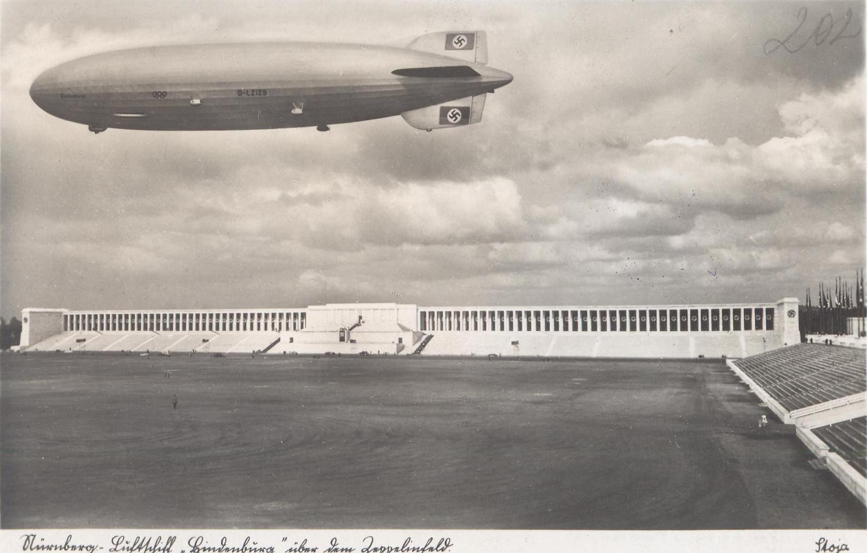
The recently launched Hindenburg over the Zeppelinfield in Nuremberg, Germany (Public Domain / Bulgarian Archives State Agency).

The Hindenburg was already under construction when the Nazis came into power in Germany in 1933. The Third Reich saw the Zeppelin as a symbol of German strength, as the Hindenburg was partly owned by the government and partly owned by the Zeppelin Company, its creators. Giant swastikas were painted on its tail fins.
The German minister of propaganda, Joseph Goebbels, ordered the Hindenburg to embark on a propaganda mission early on, before the ship’s endurance tests had even been completed. For four days, it flew around Germany, blasting patriotic songs and dropping pro-Hitler leaflets.
After opening its 1937 season, by completing a single round-trip passage to Rio de Janeiro, Brazil in late March, the Hindenburg departed from Frankfurt, Germany on the evening of May 3. It was the first of 10 round trips between Europe and the United States that were scheduled for its second year of commercial service. American Airlines had contracted with the operators of the Hindenburg to shuttle the passengers from Lakehurst, New Jersey to Newark, New Jersey for connections to airplane flights.
Except for strong headwinds that slowed its progress, the Atlantic crossing of the Hindenburg was otherwise uneventful, until the airship attempted an early-evening landing at Lakehurst three days later on May 6. Although carrying only half of its full capacity of passengers for the accident flight, the return flight, which never happened, had been fully booked. Many of the passengers with tickets to Germany were planning to attend the coronation of King George VI and Queen Elizabeth in London the following week.

The Hindenburg’s first landing at Lakehurst, New Jersey in May 1936 (Public Domain / Wide World Photos/Minneapolis Sunday Tribune). Click image to enlarge
The airship was hours behind schedule when it passed over Boston on the morning of May 6, and its landing at Lakehurst was expected to be further delayed because of afternoon thunderstorms. Advised of the poor weather conditions at Lakehurst, Captain Max Pruss charted a course over Manhattan Island, causing a public spectacle as people rushed out into the street to catch sight of the airship.
After passing over the field at 4:00 p.m., Captain Pruss took passengers on a tour over the seaside of New Jersey while waiting for the weather to clear. After finally being notified at 6:22 p.m. that the storms had passed, Pruss directed the airship back to Lakehurst to make its landing almost half a day late.

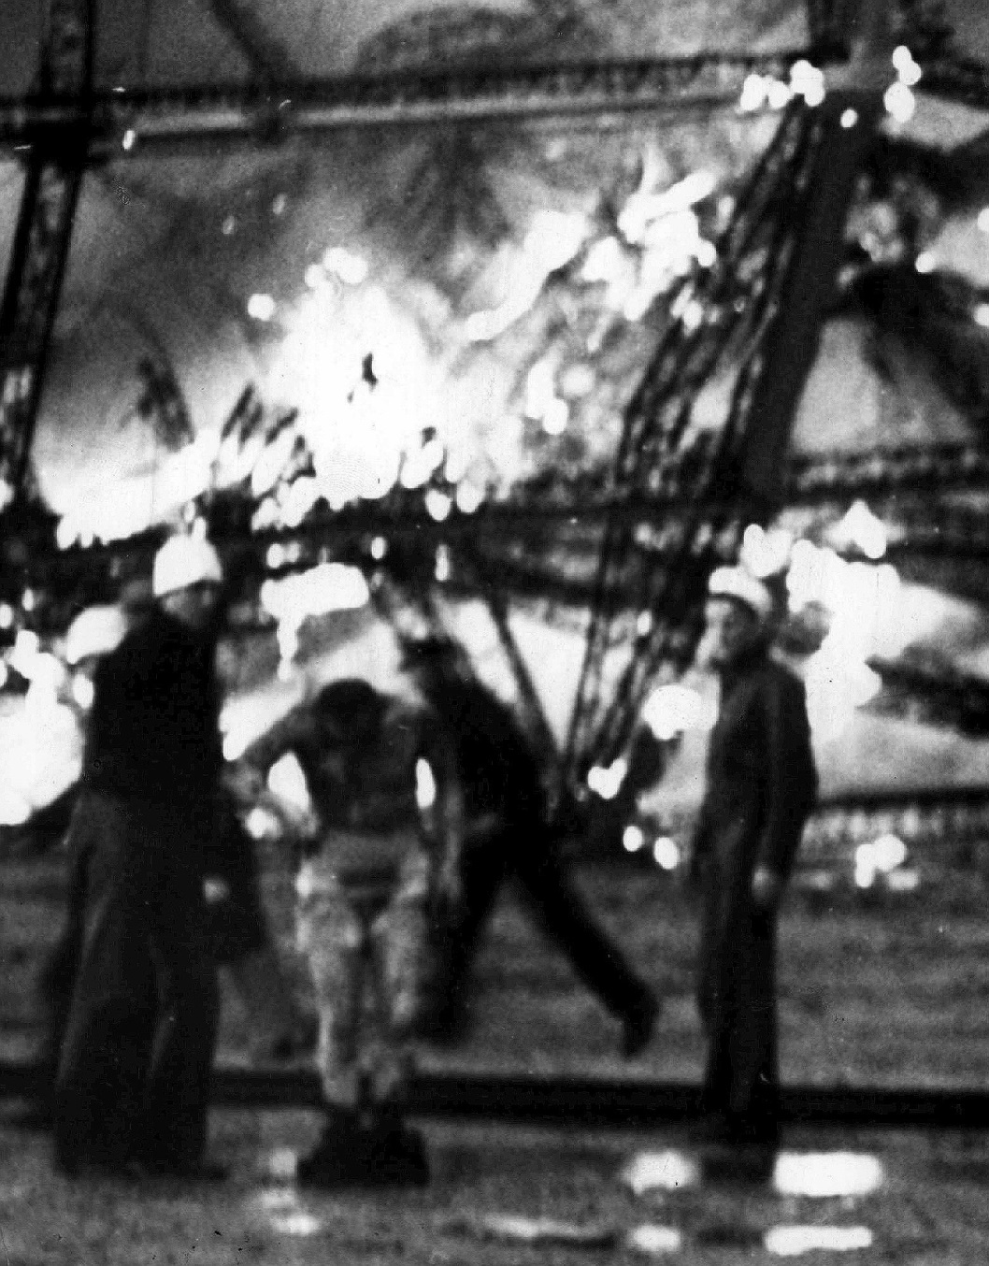
A passenger of the Hindenburg sheds his burning clothing as he is helped away from the wreckage of the airship (Public Domain / Acme News Photos)
At 7:25 p.m., the Hindenburg caught fire and exploded during its attempt to dock with its mooring mast at the Naval Air Station Lakehurst, filling the sky with smoke and fire. On board were 97 people (36 passengers and 61 crewmen). There were 36 fatalities (13 passengers and 22 crewmen), as well as one ground crewman, a civilian linesman.
The massive airship’s tail with its Nazi symbol fell to the ground, while its nose, hundreds of feet long, rose into the air like a breaching whale. It turned to ashes in less than a minute. Some passengers and crewmembers jumped dozens of feet to safety while others burned. Despite the sheer ferocity of the colossal fire, 62 of the crew members and passengers survived, but most of them were severely burned.
The majority of the victims were burnt to death, while others died jumping from the airship at an excessive height, or as a consequence of either smoke inhalation or falling debris. Immediate survivors were taken with broken bones and burns to the small, 40-bed, Paul Kimball Hospital in nearby Lakewood, New Jersey, eight miles (13 kilometers) away, which was overwhelmed by the number of patients.
Treating the Hindenburg patients, regardless of Nazi party affiliation or religion, was prominent Lakewood physician, Adolph Towbin, M.D. (1888-1966), a Jewish immigrant from Kaments-Podolski, Ukraine. Dr. Towbin arrived in the U.S. at the age of 15 in 1903, and had graduated from Fordham University Medical School in 1916.
After an internship at Flushing Hospital in New York, he was drafted into the army and assigned to Lakewood, New Jersey in 1918 as WWI soldiers were being treated at the Laurel in the Pines Hotel, following poison gas injuries. He liked Lakewood so much, he decided to stay and open up his medical practice after the war.
The treatment at the time for burns, malaria, herpes, and smallpox, was picric acid, as it was an astringent and antiseptic. With the number of patients being treated, the hospital quickly ran out of picric acid, gauze, bandages, and other medical supplies. Dr. Towbin immediately called his best friend and relative by marriage, pharmacist Max Gitow, R.Ph. (1894-1973), the owner of Lakewood Pharmacy, to bring him all that he had in stock.
Gitow, (whose original name was Moishe Gitovich), was another Jewish immigrant, from Mogilev, Belarus, who had arrived in the U.S. in 1904. He had graduated from the New York College of Pharmacy in 1913 at the age of 18, and his father, who was also a pharmacist in Belarus and later in Ukraine, had purchased Lakewood Pharmacy in April 1914. He personally brought over the needed supplies to the hospital 1.5 miles (2.4 kilometers) away and stayed to see if he could be of assistance. It was these two Jewish professional men whose quick actions helped save the lives of numerous German (several of whom were Nazis) and non-German Hindenburg passengers.

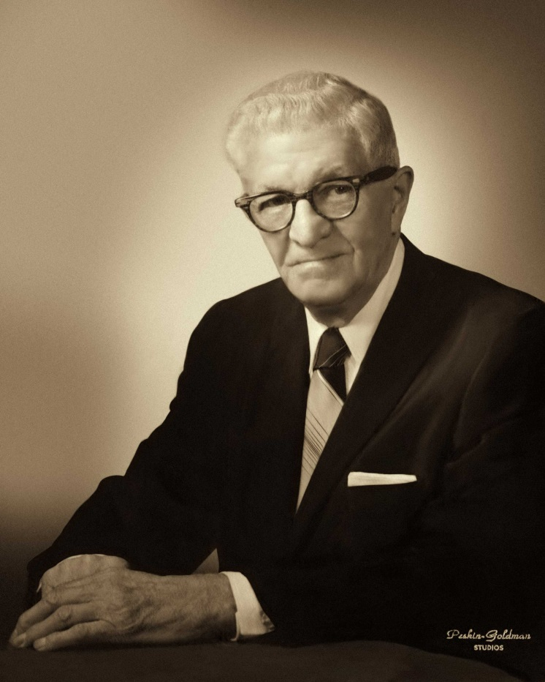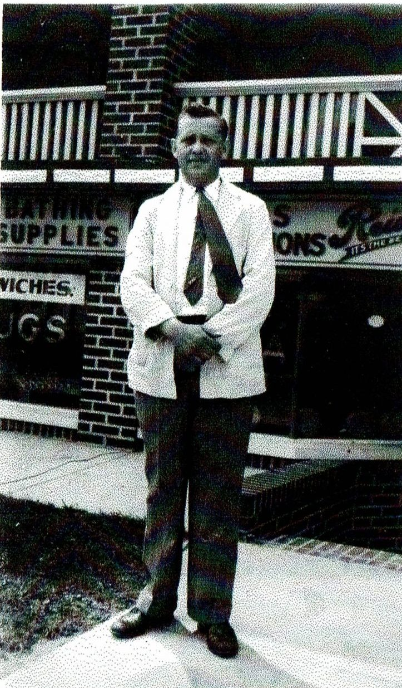
Dr. Adolph Towbin, (shown in the left side photo) prominent Jewish physician who treated the survivors (Courtesy: Phil Goldfarb) Max Gitow, RPh, Jewish owner of the nearby Lakewood Pharmacy, (shown in the right side photo) who provided critical supplies to treat the injured (Courtesy: Phil Goldfarb)

At the time, the Hindenburg was supposed to be ushering in a new age of airship travel, but the crash instead brought the age to an abrupt end, making way for the era of passenger airplanes. The crash was the first massive technological disaster caught on film, and the scene became embedded in the public’s consciousness.
The actual site of the Hindenburg crash is marked with a chain-outlined pad and bronze plaque where the airship’s gondola landed. It was dedicated on May 6, 1987, the 50th anniversary of the disaster. Hangar No. 1, which still stands, is where the airship was to be housed after landing. It was designated a Registered National Historic Landmark in 1968.

Special thanks to David Richmand, M.D., of Plainfield, New Jersey, the maternal grandson of Dr. Adolph Towbin, who provided input for this article. Max Gitow, R.Ph., was the maternal grandfather of the author.

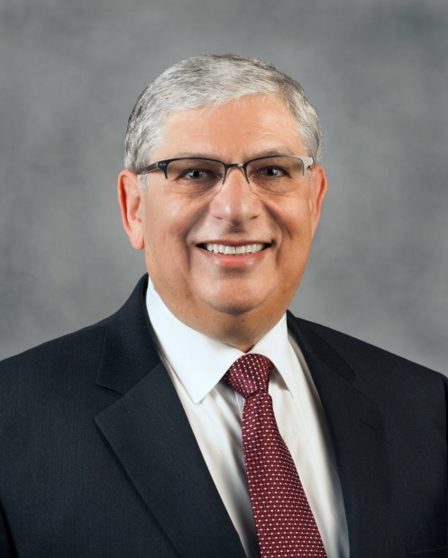
Phil Goldfarb

Phil Goldfarb was born and raised in New Jersey and currently lives in Tulsa, Oklahoma. He is the Founding and current President of the Jewish Genealogical Society of Tulsa. He has been a genealogy contributor for several web sites, lectured extensively on various topics in genealogy, published articles on genealogy, authors a monthly column in the Tulsa Jewish Review and co-authored a chapter on the Migration of Jews to Oklahoma in the initial Avotaynu On Line.
Phil has written two books titled “A Page of History: Passport Applications 1851-1914” and “A Page of History: Passport Applications Volume II 1915-1925. He co-produced a documentary along with the Tulsa Historical Society titled L’Dor V’dor: Generation to Generation Jews in Oklahoma which is currently up for an Emmy Award for Historical Documentary.

Reprinted from the July 2, 2020 email of The National Library of Israel. This article was originally published in the December 2019 edition of the Tulsa Jewish Review. It appears here as part of Gesher L’Europa, the National Library of Israel’s initiative to share stories and connect with people, institutions and communities in Europe and beyond.
Lenora Garfinkel, Monsey Architect Who Designed Atrium, Viznitz Synagogue, Dies of COVID-19
By Nancy Cutler

MONSEY - Lenora Garfinkel didn't just break glass ceilings — she built strong structures.

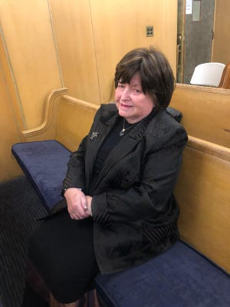

Women architects were not common when Garfinkel started in the field in the 1950s. Her career stretched more than 60 years and delivered distinctive buildings that served the greater Orthodox Jewish community throughout the metropolitan area.
Garfinkel died April 29 at age 90. Her daughter, Letitia Forspan, said the cause was COVID-19.
The family held a socially distanced funeral, Forspan said, at Garfinkel's Monsey home.
She found herself decked in HAZMAT gear, standing in the driveway, planning to hold a shiva via Zoom.
"All that I could think of was there was no dignity," Forspan said. The cemetery in Paramus allowed just three family members in to witness the burial. She said she understood and supported the precautions.
But, she said, "I cannot put into words how hard it is."

Juggled 5 kids, architecture career
Garfinkel's work was well-known among the region's Orthodox Jewish community. She designed the Atrium catering hall in Monsey and numerous schools for the Satmar sect in Orange County.

The Atrium in Ramapo was designed by Monsey architect Lenora Garfinkel.

In the early 1990s, Garfinkel gained attention for her design of a new synagogue in the Village of Kaser. The mammoth 45,000-square-foot Romanesque structure drew attention for its stylistic nod to the Viznitz Hasidic sect's roots in the former Soviet Union, its incorporation of the old synagogue, and its large area with a removable roof to accommodate crowds for shared meals during the holiday of Succoth.
"She juggled five kids, and an architecture career," said Forspan, former owner of Letitia's Bridal in Spring Valley and now owner of Bashert Designs, which makes custom gowns and has studios in Teaneck, New Jersey, and Long Island.
Her grandson, Ariel Dahan of Monsey, recalled going to her building sites with her when he was a kid.
"She was the authority back in the day for religious institutions," said Dahan, now an ADA in the Rockland District Attorney's Office. His grandmother had become an expert on religious laws regarding buildings, particularly the structure of mikvahs, or ritual baths.
"It was a weird dynamic," he said of a woman explaining the finer points of Jewish law to rabbis.
Rabbi Yehuda Zaks of Money said Garfinkel raised the standards of architecture for the Orthodox community. “She had an exceptional artists’ mind,” said Zaks, whose father, Rabbi Mayer Zaks, is dean Yeshiva Chofetz Chaim and Mosdos Chofetz Chaim in Ramapo. “Changed even thinking of what a religious school or a religious shul could look like.”
Zaks said Garfinkel cherished her children, grandchildren and great-grandchildren. She was a lady with a heart of gold.
Lenora Josephi was born in 1930 in the Bronx.
She was among the first women to study architecture at Cooper Union around 1950.
She married Sam Garfinkel, who was a pharmacist, and moved to Monsey around 1958. Sam, who later became a math teacher at Pomona Junior High, died in 1998.
Lenora Garfinkel retired from her architecture business at age 85.
The couple had five children.
She is survived by 20 grandchildren and more than 40 great-grandchildren. "That was her primary focus, I think," Dahan, one of her grandsons, said.

High-Stakes Decisions
Forspan said she was her mother's health proxy. She also served as a health proxy for two other family members who died of COVID-19 within the last month.
Family members, Forspan said, often have to make high-stakes decisions quickly. Calls came day and night, weekends. While she is Sabbath observant, Forspan said she would be on the phone Friday nights and Saturdays handling life-and-death situations.
"I took notes on everything, got off the phone, called my son, did research, discussed it together," Forspan said.
The disease is unpredictable.
On March 31, she recalled, she got a series of calls from staff from Hackensack University Medical Center, where her mother was being treated. "They told me she was not going to make it through the night."
Forspan said she reached out to the large, extended family. "We need somebody to be there before she dies," Forspan recalled. They stood outside Garfinkel's hospital window so she would not be alone.

Her Mother Survived that Scare.
Forspan said Garfinkel was treated with hydroxychloroquine, the same drug that President Donald Trump recently said he had been prescribed as a prophylactic for the virus.

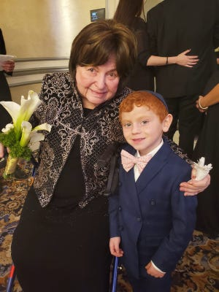
Lenora Garfinkel with one of her dozens of great-grandchildren

She was also given sarilumab, known as Kevzara, one of several biologic drugs that have been studied as COVID-19 treatments, Forspan said. "It didn't work."
Dahan, who consulted with his mother about various treatments recommended for his grandmother, said families face difficult decisions. "It's a very scary thing to try these experimental treatments but you're desperate," he said.
But the biggest challenge, Dahan said, was the isolation. Before, if his grandmother was hospitalized, a family would sleep over to be with her. "We couldn't be there. It was very hard."

Reprinted from the May 20, 2020 edition of the Rockland/Westchester Journal News.

My Father and
The Jews of Iraq
By Yahya Qassim
On the 79th anniversary of the Farhud,
a look back to Yahya Qassim and his fight for Iraqi Jews

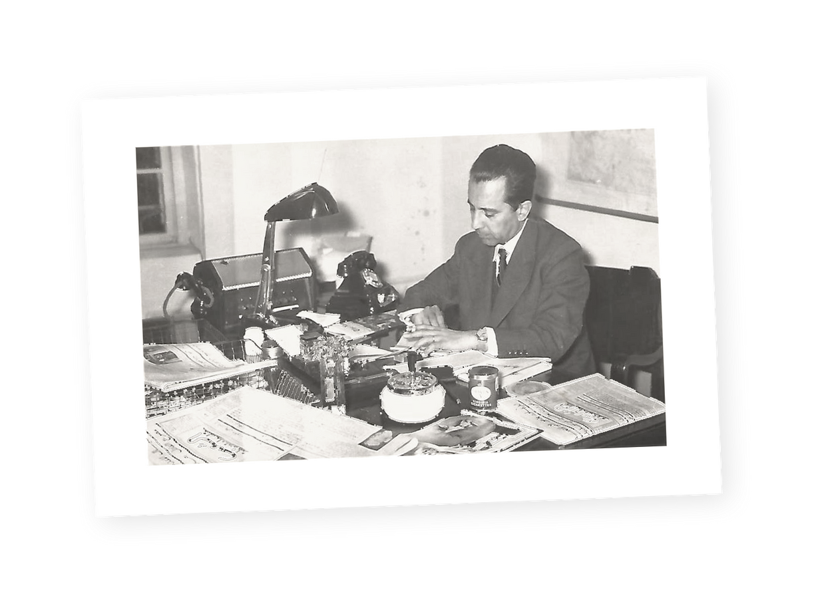
Yahya Qassim in 1954 at his desk as editor of ‘Al-Sha’b’ newspaperCOURTESY OF RAAD YAHYA QASSIM

The story that I am about to tell is that of my late father, Yahya Qassim, the owner and editor of Al-Sha’b—a newspaper published from 1945 to 1958, when Iraq was under the rule of the Hashemite monarchy. The story is focused on Qassim’s defense of Iraqi Jewry in the tremendous ordeal that the Iraqi Jewish community faced immediately before and after the creation of the State of Israel in 1948.
This story almost certainly would have been forgotten had it not been recounted by professor Orit Bashkin in her 2012 book New Babylonians: A History of Jews in Modern Iraq.

The Oldest and Once Second-Largest
Jewish Community in the Arab World
The Jews of Iraq occupy an important place in Judaism, as the country was home to the oldest and second-largest Jewish community in the Arab world. As with other Jewish communities in various parts of the world, Iraqi Jewry suffered from varying forms and different degrees of repression, persecution, and pogroms throughout history—spanning biblical Babylonia, the Islamic Caliphate, the Mongol invasion, the Ottoman Empire, and modern Iraq in the 20th century.
Prior to discussing the events of 1947-1953 in relation to the ordeal faced by the Jewish community in Iraq at the time of the creation of the State of Israel, it is interesting to highlight the major phases of the history of the Iraqi Jewish community in the modern era.

Once Ruled by the Turkish Ottoman Empire
What is known today as Iraq consisted under Ottoman rule (1533-1917) of three provinces (Wilayats in Turkish): Mosul, Baghdad, and Basra, corresponding to the northern, central, and southern regions of present day Iraq. During this period, the Jewish community in Iraq had been generally treated fairly.
This was one more point in the similarity between the Ottoman and the Austrian empires: Both were multiethnic and relatively benign toward their constituent ethnicities; both entered WWI on the same (eventually) losing side along with the German Empire; and both met the same fate, namely collapse and dissolution at the end of the Great War.
The Iraqi Jewish community, along with the rest of the population in Iraq, suffered great hardships during WWI, but under the British occupation that followed, Iraqi Jews enjoyed greater security and prosperity. Then came the Hashemite Kingdom of Iraq (1921-1958).
Under Hashemite rule, a pluralist Iraqi identity was created, forged, and nourished, and Jews were increasingly integrated into Iraqi society as a whole. However, this trend suffered a major interruption in April 1941, when an anti-British and pro-Nazi group of Iraqi army officers, supported by civilians, staged a coup d’etat and installed a short-lived dictatorship.
Immediately after the dictatorship was ousted in late May, the Jewish communities in Baghdad and Basra suffered a pogrom at the hands of street mobs in an incident known as the Farhud (Arabic for pogrom). Rioters killed around 200 Jews and injured 1,000, raped an unknown number of Jewish women, and looted around 1,500 Jewish stores and homes.
However, after the restoration of the Hashemite monarchy, the Iraqi Jewish community’s stability and prosperity not only began to recover, but also showed clear signs of growth.

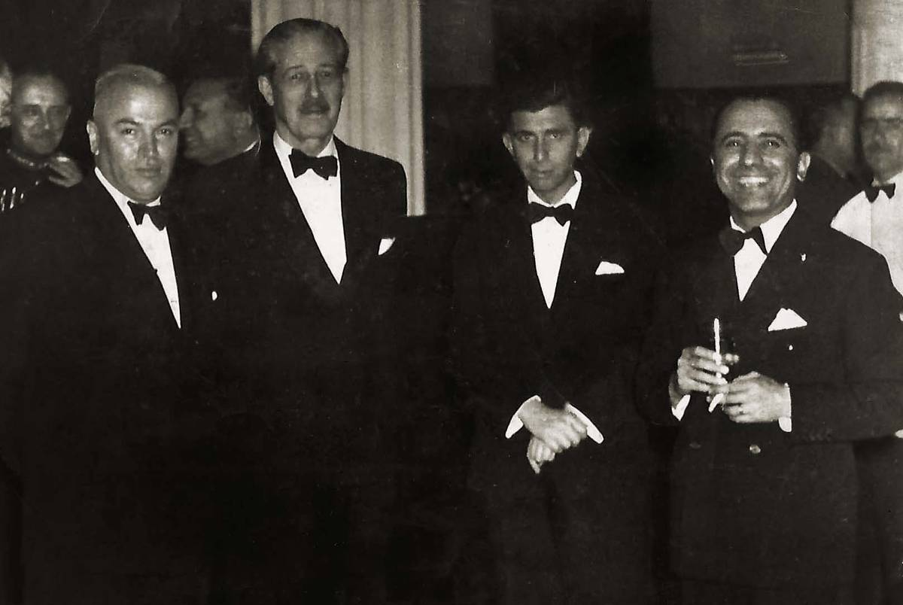
Yahya Qassim, on the right, with Saíd Qazzaz, Iraqi minister of the interior, British Foreign Secretary Harold MacMillan (later British prime minister), and Iraqi Minister of Development Nadim Al-Pachachi (later general secretary of OPEC). This photo was taken at a reception at the British Embassy in Baghdad on Nov. 29, 1955.COURTESY OF RAAD YAHYA QASSIM

Returning to the core of my story—Al-Sha’b (the people in Arabic) was launched in 1945 by Yahya Qassim with the aim of using the editorials he penned to advocate daily and emphatically for a pluralist, democratic Iraq, where citizens—whether Muslim, Christian, Jewish, or of any other set of personal faiths and beliefs—are considered fully equal under the rule of law.

The Largest Circulating Newspaper in Iraq
In less than a year, Al-Sha’b rose to become the leading newspaper in Iraq in terms of its circulation, its liberal editorial policy, and its independence from any political party or group. True to Qassim’s pluralist principles, there were several Jewish professionals working at Al-Sha’b alongside Muslims and Christians, both as journalists and in administrative positions.
In 1946, with Al-Sha’b in its second year of publication, the political atmosphere in Iraq started to grow increasingly tense in view of the expected creation of the State of Israel. Iraqi public opinion was roughly divided into three views on this matter:
The first view was that of Iraqi political parties and newspapers pushing the Arab nationalist approach of considering Iraqi Jewry and Zionism as one and the same and exhibiting outright hostility toward the Jewish community in Iraq.
The second view, predominant in the ruling establishment, looked at the question through a somewhat more moderate and pragmatic lens, taking into account the pressure exerted by some other Arab governments, particularly Syria’s, to follow a hard-line policy toward Zionism and the creation of the State of Israel. The third view was that of a minority, in which Yahya Qassim was a leading example. This view was embodied in Qassim’s daily editorials in Al-Sha’b, arguing that Iraqi Jews were—both de jure and de facto—fully equal to other Iraqi citizens, and that the creation of the State of Israel was a separate and distinct question of Iraqi governmental foreign policy.

No Conflict with Sympathing with Palestinian
Arabs Yet Recognizing the Rights of Iraqi Jews
Furthermore, Qassim argued that sympathizing with the plight of the Palestinian Arabs in no way conflicted with the recognition of the full rights of Jews as Iraqi citizens.
In view of this division of public opinion in Iraq and the buildup to the imminent creation of the State of Israel, the position of Iraqi Jews became increasingly vulnerable to growing public pressure from Arab nationalist political forces and newspapers in Iraq, which in turn inflamed emotions and passions in various segments of society.
At the same time, these Arab nationalist forces and newspapers also exerted intense pressure on the Iraqi government to adopt hostile positions toward Iraqi Jewry through the enactment of laws that were highly discriminatory, to say the least, and of questionable legality. Nor were such measures restricted to Iraqi Jews living in Iraq. For example, all Iraqi Jews living abroad were ordered to return to Iraq or risk confiscation of their property without compensation.
It is within this inflammatory atmosphere in Iraq that Yahya Qassim made his stand on a matter of principle—namely that Iraqi Jews are fully equal to Iraqis of other religions and beliefs and should be treated as such. Furthermore, Qassim argued forcefully, emphatically, and incessantly in his Al-Sha’b editorials that the questions of Zionism as a political movement along with the creation of the State of Israel, and the unquestionable full citizenship status and concomitant rights of Iraqi Jews, are separate and distinct.

Arguments Directly Opposing Arab Nationalist Groups
Qassim made these arguments daily in the pages of Al-Sha’b in direct opposition to Arab nationalist political groups and parties within Iraq, and to the chagrin of some in Iraqi governmental circles who were sympathetic to Arab nationalist views for a variety of reasons.
Additionally, Qassim did not only expound his liberal views, but also acted upon them, hiring even more Iraqi Jews at Al-Sha’b for both journalistic and administative work. And last, but by no means least, Qassim took on the role of lawyer for hundreds of Iraqi Jews when the Jewish community was faced with a plethora of ad hoc governmental laws, acts, and regulations. For example, he negotiated many of the deals regarding the notorious Denationalization Law with the Iraqi government.

Reprinted from the June 26, 2020 email of Tablet Magazine.

“Excuse Me , Are
You Jewish?”
By Rena Udkoff

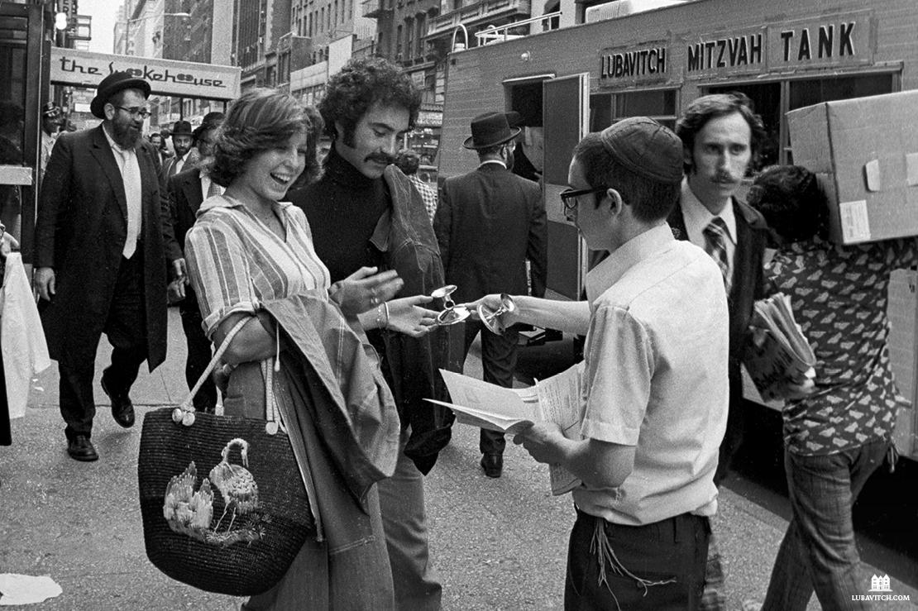
A Mitzvah Tank on the streets of Manhattan, 1975 Photo Credit: JEM; The Living Archive

Mitzvah Tanks have been a fixture on the streets of New York City for nearly five decades. Today, they can be spotted in many places where Chabad is active. Parked on street corners and near college campuses, these specially decked out RVs carry rabbinical students who invite Jewish pedestrians inside or curbside, with the offer to connect over a mitzvah.
The unconventional approach was a hit in the countercultural heyday of the ‘70s. But in an age of targeted online ads and sophisticated social engagement techniques, why does Chabad continue to canvass for Jews on the street? Does stopping people at random to talk about Judaism even work? And what actually happens inside a Mitzvah Tank?
Ubiquitous, peculiar, and at times, controversial, Mitzvah Tanks elicit mixed reactions wherever they go. Lubavitch International takes a deep dive into the inimitable world of the repurposed RVs that bring old-school Judaism to high-traffic metropolises around the world.
“Excuse me, are you Jewish?”
It is a sight familiar to many in New York City: young rabbinical students in black hats and suit jackets standing in front of an RV covered in signs promoting Jewish practice. They approach New Yorkers at random with the startling question.
In an average four-hour shift on “Mitzvah Tank duty,” a rabbi may approach as many as 200 people, hoping to reach a Jew who may benefit from an impromptu spiritual experience.
The question is direct and the responses vary. Many move right along, averting their eyes and quickening their pace. It is New York, after all. Others respond with a “no” expressed in tones ranging from annoyed to apologetic. Still, others reply, “Not today,” “I’m Irish!” or “Not interested,” walking away with a curt nod.
Like clockwork, the undeterred young student wishes each one a practiced and polite, “Have a great day!”
There is rejection after rejection. Then an eager looking older couple approaches the RV. “Are you Jewish?” No. They are tourists from Norway who want to know if they can snap a photo of the boys, who smile obligingly.
But occasionally, there is a yes.
On an early Friday afternoon in the winter, a man quickly approaches the Mitzvah Tank parked at the corner of 51st street, pushing up the sleeve of his coat jacket as he steps onto the vehicle. He’s done this before. “I’m late for a meeting, so let’s make this fast boys.” The yeshiva students do not need to be asked twice and are already wrapping tefillin straps halfway up his arm.
The next person who passes by is a 24-year-old college student from Chicago.
“Excuse me, are you Jewish?”
Taken aback, she replies with a tentative yes.
“Would you like some Shabbat candles to light Friday night? It’s a mitzvah that brings more light into the world.”
“My grandmother used to do that,” she says hesitantly.
“It’s easy, I promise! All the instructions are inside this kit. Just light candles at 5:18 this evening to welcome Shabbat.”

“Ok, I guess. Thanks.” She pockets the candles and hurries around the corner.

Bringing Judaism to the Streets
Since their inception, Mitzvah Tanks have activated the laser-focused mission of Lubavitch: bring Judaism to Jews wherever they are. Enthusiastic Chabad representatives, typically yeshiva students between the ages of 15 and 22, strive to share Judaism in a positive and accessible way, through action-focused Jewish rituals that help Jews of all backgrounds connect with their faith.

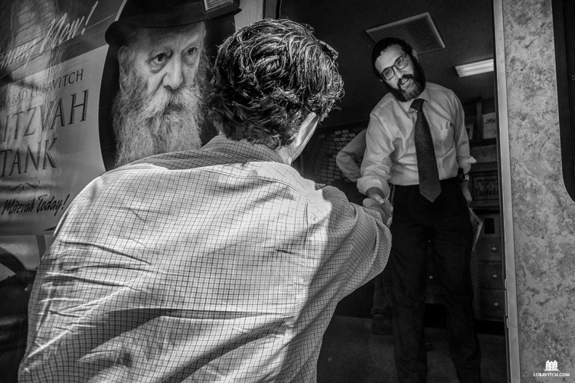
Rabbi Levi Baumgarten welcomes a pedestrian into his Mitzvah Tank (Photo Credit: Gene Lowinger – www.genelowinger.com)

In 1988, Rabbi Levi Baumgarten started making rounds on the Mitzvah Tank circuit as a 25-year-old newlywed. He never stopped. His “Chabad House on Wheels” is the longest consistently running Mitzvah Tank in Manhattan, where he has interacted with an estimated 500,000 people over three decades.
“We are there to help facilitate people in doing a mitzvah, whether that is putting on tefillin, lighting Shabbat candles, taking part in a seasonal mitzvah, or just hearing a Torah thought,” the rabbi shares. “Our goal is to give people the opportunity to express their Jewish identity and perhaps inspire deeper spiritual exploration.”
The on-the-street approach is intended to reach people in their daily lives, reminding Jews to pause for a moment of spiritual engagement, not just in a synagogue or on the High Holidays, but in the everyday.
Mark Oppenheimer, a lecturer in English at Yale University, co-host of Tablet Magazine’s podcast Unorthodox, said that, while being called out on the spot and asked, ‘Are you Jewish?’ can be painful for some, “those who are secure in their own Judaism don’t get offended when people challenge them or ask them to identify on the street.
“The people who are most troubled by [these efforts] are themselves uncertain of who they are. People who have clarity where they stand don’t feel judged when they are asked to engage, or when others disagree. Having to answer that question has brought them closer on a journey to their authentic self.”
Countless Jews have experienced a taste of their heritage for the first time
through a Mitzvah
Tank-enabled interaction, with a spontaneous bar mitzvah or extemporaneous Torah lesson. These moments have a transformative and lasting effect.
A 1998 survey, conducted by a major Israeli newspaper, collected information about Israeli Jews and the growth of their personal religious observance. Interestingly, it noted that the first contact for most respondents was neither a seminar nor a Torah class, but rather the observance of a mitzvah, either through an experience at the Kotel or an encounter with a Mitzvah Tank.
“People want to feel that they are part of something bigger than just themselves, and rituals connect,” explains Joseph Telushkin, noted rabbi and author of the acclaimed biography, Rebbe. Chabad’s concrete, “ask” to do a mitzvah, makes the interaction meaningful and tangible.
For all their spectacle, the Tanks are not a sideshow. Rabbi Mordy Hirsch, co-director of the Mitzvah Tank Organization, under the auspices of Lubavitch Youth Organization, explains that the mobile outreach centers are an important complement to Chabad’s various other activities.
“Chabad has always met people wherever they are,” said Hirsch. “That’s why we send emissaries to every corner of the globe. When people moved online, Chabad emissaries met them there. In our multi-pronged approach to connect with Jews everywhere, of course, we are going to be going out in the street! That’s where people are.”
Yeshiva students regularly connect Jews with their local Chabad so that Jews who are inspired by the Mitzvah Tank encounter can deepen their experience of Judaism back at
home. With Chabad programming growing ever more sophisticated, the Mitzvah Tanks present a throwback engagement technique that cuts to the essence of the Rebbe’s mission.

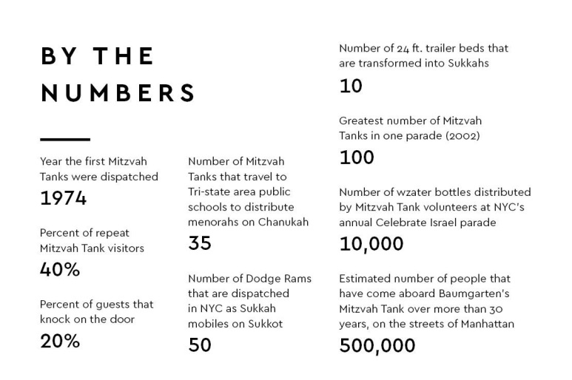

“We aren’t trying to impose religion on other people,” said Hirsch. “If they say no, we try the next person. But, so many people are looking for connection and it is a gift to be there for them. Just the simple act of telling people that they are valued and that their Judaism has meaning, is incredibly powerful.” Thousands of non-Jews stop by Mitzvah Tanks as well, sometimes out of curiosity, other times simply seeking a good word or spiritual guidance. It is this hope–to be of spiritual service—that keeps the students on the street, in rain or shine.
“Every guy who has done this has their own story that lives with them,” said Hirsch. “For me, it is a man who we later learned had come to Manhattan looking for a building to jump off of. He was struggling and wanted to end his life. He was stopped by a student near the Mitzvah Tank and was asked to do a mitzvah.
“The man was so startled by the boy’s willingness to share with a total stranger that he stepped inside the Mitzvah Tank just to listen. He decided to return home that day, googled his local Chabad, where he found support and has since found a life of purpose.”
Not every story is as dramatic, but every Mitzvah Tank regular has at least one powerful personal exchange they can share. Those that have been in the trenches for a while can rattle off tale after tale of encounters that have been transformative–to both parties.
Michael Sherek, a 54-year-old businessman in the garment district, had his first Mitzvah Tank encounter with Rabbi Baumgarten in 1988. Sherek was a year out of college and was walking through the streets of Manhattan with a friend when they noticed a Mitzvah Tank. Sherek was too shy to approach the Tank as he had never had a bar mitzvah, but his friend insisted.
Sherek put on tefillin. Something clicked. The next week he found himself seeking out the Mitzvah Tank again with questions about his Jewish roots. Week after week he returned, with new questions each time. Eventually, Sherek set up a regular study schedule with Baumgarten to slowly explore and reclaim his Jewish identity.
“It wasn’t easy,” said Sherek, who had grown up without a basic understanding of Jewish life and spiritual practice. “I felt less of a Jew than [Baumgarten]. When I shared my feelings with him he told me ‘When I have a minyan and you are the 10th man, you are as equal a Jew as anyone else.’ I started to feel better because the focus was always positive. The more you do, the more connected you are to G-d.”
Sherek is now fully engaged in his Judaism and his daughter attends the Hebrew School at Chabad of the West 60s.

Tanks Against Assimilation
The very first Mitzvah Tanks date back to the spring of 1974. The idea came on the heels of a traumatizing slew of events. Months after the Yom Kippur War in Israel, and days after a gruesome terror attack during a high school field trip in Ma’alot killed 22 teenagers, the Lubavitcher Rebbe reached out to his Chasidim and encouraged them to redouble their efforts in mitzvah outreach. The Rebbe had already been launching mitzvah campaigns to engage Jews in traditional rituals like tefillin. Now his dedication to these efforts found new urgency.

Rabbi Sholom Duchman, a young yeshiva student at the time, recalled that he and his friends were galvanized by their teachers to reach out to unaffiliated Jews and that enthusiasm for the mitzvah campaigns reached a fever pitch in Chabad circles.
“If we were already going out to the streets to engage with Jews,” said Duchman, “we wanted to make the biggest possible impact.”
Then, one day shortly after taking to the streets with their ever-present tefillin, the group’s activities came to an abrupt halt with a downpour of heavy rain. Together, the students concocted the idea to rent step vans where people could hop inside for a “Jewish rest break” and do a mitzvah. One technically-proficient student rigged a speaker system to blast lively Jewish music. The mitzvah mobiles drew in more Jews than ever before.
The grassroots initiative was welcomed with approval by the Lubavitcher Rebbe, who further suggested they replicate—a painting that was gifted to the central Chabad library—of a pair of tefillin with its straps wrapped like the treads of a tank—and hang it on the vans.
A few days later, New York Times reporter Irving Spiegel visited 770 accompanied by the Rebbe’s secretary and Chabad-Lubavitch spokesperson, Rabbi Yehuda Krinsky, and asked about the colorful trucks parked outside. Referencing the painting on the trucks, the Rebbe later told Rabbi Krinsky, “Tell him these are our tanks against assimilation.”

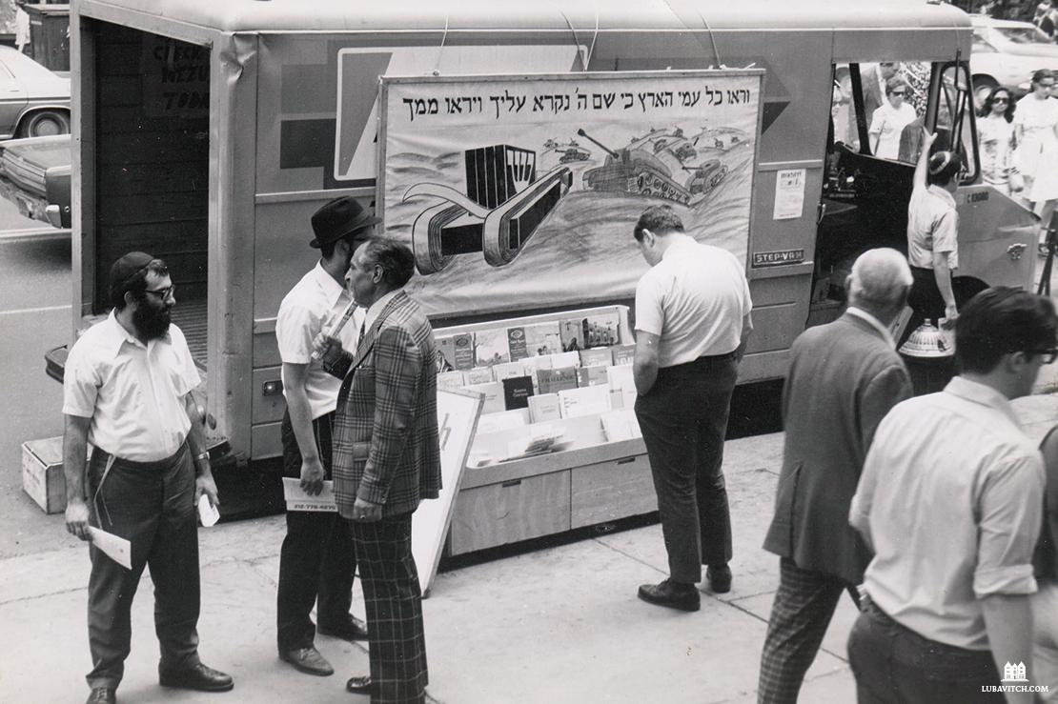
Mitzvah Tank on the streets of NYC in the 70s

With a title handpicked by the Rebbe, the outreach vans became officially known as “Mitzvah Tanks.”
As the Mitzvah Tank initiative moved into its first winter, it became apparent that people were not willing to step into a freezing truck to do a mitzvah. Problem-solving once again, the enterprising young students rented mobile homes with proper heating. From that day forward, the mobile home became the Mitzvah Tank of choice.
Mitzvah Tanks bearing the banner, “Mitzvahs on the spot for people on the go,” were soon spotted in metropolitan cities from London to Tel Aviv, regions from South Florida to Brazil, and eventually, to the outbacks of Siberian Russia and rural Australia.

“The Five Stages of Being Asked If I’m Jewish by Chabad”
The Rebbe’s prediction that the vehicles would be “tanks against assimilation” proved proficient. After all, it is impossible to blend in and hide your Jewishness when your identity is being called out on the street. For better or worse, the public display of Jewishness and the straightforward question, asking people on the street, “Are you Jewish?” always gets a reaction. One Jewish writer for The Gothamist referred to Mitzvah Tanks as a “mobile guilt trip” that always comes around the Jewish holidays. Many others are annoyed or even personally offended by the question.
Stephanie Butnick, a cohost of the podcast Unorthodox, said that she’s experienced what she calls “the five stages of being asked if I’m Jewish by Chabad—annoyance, anger, guilt, shame, and acceptance.”
Some are offended at public inquiries about their personal faith or consider the question “religious profiling.” Still, others are offended not to be asked. “What? Don’t I look Jewish enough?” Some are inspired and delighted, some run in the other direction.
Some lash out, even going so far as to accuse Chabad of inciting anti-Semitism by “harassing people on the street.” But no study has ever proven that anti-Semites lower their bigotry when Jews hide their Jewishness.

In 2017, the hosts of Unorthodox spent the day with Chabad’s Mitzvah Tank and tried their hand at asking people on the streets of New York if they are Jewish. Mustering up the courage only to get waved off, Butnick gained a “new appreciation for our Lubavitch friends. This is not easy work.”
At times, people can react with exceptionally crass or hurtful responses, perhaps forgetting that the 16-year-old boy on the receiving end of their rude comment was just there trying to do some good.
The time-wisened Baumgarten said that, over the years, he has heard it all. “I took upon myself that even if someone swears at me, I respond with a pleasant ‘Have a great day, I hope you feel better, I’m sorry if I offended you.’”
Often, the positivity will inspire a retraction as people question why they were so rude. Baumgarten has met many who told him that after they denied being Jewish to him or another Mitzvah Tank emissary and refused tefillin, they then went home and dug out their pair from the attic and put them on.
Rob Cohen from Washington, D.C., is more emphatic. “If [people] are offended, they should work to ameliorate their own insecurities that keep them from merely politely declining or ignoring innocent inquiries by people with different culture, value, and priorities.”

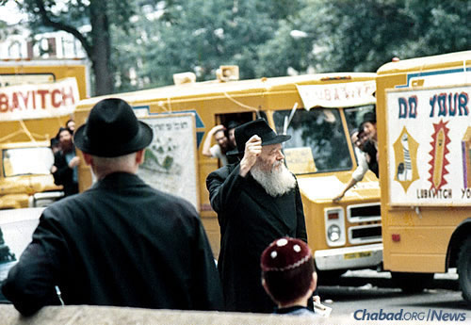
The Lubavitcher Rebbe, of blessed memory, giving encouragement to Chabad tankists

In an op-ed for the Forward, Rabbi Joshua Krisch, a Chabad emissary at Ithaca College, wrote that affiliated Jews who were offended by the question should “check their privilege.”
“For every ‘no’ or angry, privileged Jew who stomps off (indignant, outraged that someone who doesn’t look like him or her dared to speak out of turn) there’s another Jew who has never had access to a set of tefillin, doesn’t know how to ask to try it, and may not have another opportunity to do so.
“Many Jews did not have that luxury and will never have the option to put on tefillin unless a [Chabad representative] stands on a street corner bellowing, ‘Excuse me, sir. Are you Jewish?’ We’re making mitzvot accessible to a Jewish population that won’t come to your progressive synagogue services or seminars, or who wouldn’t set foot in one of your community outreach events,” he continued.
This proved true in the case of Aviva Miriam Patt who shared that she used to find the Mitzvah Tank approach obnoxious. As an observant Jew, she felt condescended by the notion that she needed guidance and reminders about doing mitzvahs.
“Later, I met a Lubavitcher rabbi at a Chanukah party and was surprised and a little offended when he asked—everyone, not just me—if we wanted Chanukah candles,” she said. “How ridiculous, I thought, anyone who wants to light candles knows where to find them and can get them for themselves. But,” she continued, “then I saw people take him up on his offer, some saying that they hadn’t lit candles since they were children or since their parents died. I realized then what a genuine kindness it was for him to offer.”
“In the years since then, this same rabbi has provided me with shmurah matzah for the Seder, something I used to do myself and can no longer afford.”
Daniel P., a middle-aged Manhattan businessman, often passed by Mitzvah Tanks on his way to work and never responded. One day, when approached by a yeshiva student he instinctively said, “I’m not Jewish.” The denial weighed on him and continued to tug at him whenever he saw the boys. A few months later, Daniel’s father passed away. Remembering the guys from the Mitzvah Tanks, he finally sought them out looking for a way to say Kaddish. He was welcomed onto the Mitzvah Tank with open arms.
Interactions are not one-time occurrences, as the Chabad representatives build relationships with returning visitors. Baumgarten has gained a reputation and can usually count on engaging with up to 400 people who come by each week. A full-fledged community has blossomed around his “Chabad House on Wheels.” When he throws a Chanukah or Purim party, almost 500 people show up.
At least 40% of weekly visitors are returning guests. Another 20% reach out of their own accord, either knocking on the door with a question or coming because they were referred by a friend.
“There are people from all walks of life. Some are very religious and stop by looking for a minyan or asking about the closest kosher restaurant. Others come in just to get their spiritual recharge—it is an oasis right in the middle of their busy workday.”
On April 5, 2020, three days before Jews around the world would sit down to quarantined Passover Seders in their own homes, a fleet of 10 LED-screen trucks from Crown Heights, Brooklyn, embarked on a mission. It was the height of the pandemic crisis in NYC, with strict stay-at-home orders, hospitals and communities in crisis, and Jewish communities grappling with the challenge of celebrating the holiday of freedom under lockdown. With Judaica stores closed and grocery store stock unpredictable, many Jews worried about securing their Passover staples.

The Mitzvah Tank Parade passes the Barclays Center in downtown Brooklyn.

Adapting to Coronavirus Times

“Every year, days before Passover, we distribute thousands of pounds of shmurah matzah at our annual Mitzvah Tank parade,” said Hirsch. The parade is held every year to honor the anniversary of the birth of the Rebbe on the 11th day of Nissan. “This year, as we saw that things had to be different, we decided that we were not going to downgrade our goal because of the pandemic.”
The parade was quickly adapted to comply with social-distancing regulations. Instead of in-person RVs, the office rented a slew of LED trucks, with a flashing message to remind the 1.5 million Jews living in New York City that Passover was coming. Loudspeakers and signs advertised a website and hotline where people could order a free box of shmurah matzah delivered to their door.
“We mapped out the five boroughs and arranged a route that drove through every single street in New York City. We recorded a professional voiceover to wish everyone a Happy Passover and shared a message of strength in the face of the challenge,” Hirsch explained. The roving billboard PR campaign worked. A special phone hotline set up for orders and www.Matzah.nyc were flooded with requests for Passover assistance. On Twitter, requests for matzah and messages of thanks poured in from every corner of the city. One grateful father shared that his daughter, who was working twelve-hour shifts as a nurse in a Manhattan hospital, “now had matzah thanks to Chabad.”

“We had to extend the deadline for matzah orders three times, up until Passover eve,” said Hirsch. “We hit our goal numbers of matzah distributions—without ever having to stop someone in the street!”
Hours before sitting down to his own home Seder, Hirsch returned the last of the trucks’ keys to the rental service. As he was about to walk away, he turned to the agent, with Chabad’s iconic open-ended question of possibility, and called from six feet away,
“Excuse me. Are you Jewish?”

SIDEBAR
Tweeting from the Tank

The RVs playing Jewish music round the corner of a busy downtown street, and Chasidic yeshiva students at the vehicle’s windows greet passersby with “Shalom!” People on the street pull out their smartphones, snap photos of the spectacle and share them with friends. The unpredictable cultural display is social media catnip.
But if Mitzvah Tanks had to choose their favorite social media platform, it would have to be Twitter. The platform of short thoughts shared with strangers bears a striking similarity to the invitational person-on-the-street “Are you Jewish?” conversations. From #AreYouJewish to #ChabadFoundMe, people love to tweet about their experience. One year, during the annual pre-Passover parade, the phrase “Mitzvah Tanks” hit number 2 on Twitter’s list of trending topics for New York City.
Rabbi Zushy Rivkin manned the @MitzvahTank Twitter account for four years and noted that people were always surprised when he responded to their tweets. “People openly tweet their various thoughts about the Mitzvah Tanks, but they don’t expect us to also be online!” said Rivkin.

Special Chabad Mitzvah Tank for London, United Kingdom

The online conversations can even lead to in-person interactions. When Jack F. from Miami tweeted, “Aww! Just missed a Mitzvah Tank. Wish I could have stopped in,” Rivkin replied instantly: “Where are you?” Locating the young man on 57th Street, he quickly texted the closest Mitzvah Tank to circle back so that Jack could have his own mitzvah experience. Standing by with his computer and cell phone, Rivkin has connected people with their local Mitzvah Tank from Golders Green, London to Melbourne, Australia.
The most common phrases used in response to the Mitzvah Tanks? The hashtags #OnlyInNYC, #OnlyInIsrael, #OnlyChicago, #OnlyLondon…
“If it’s ‘only’ in that many cities, it is not that only!” says Rivkin. “Many people think their experience is unique to their locale, but the truth is we’re global!
“We’ve been doing this for almost 50 years. I promise you, if you’ve thought up a clever response to the question ‘Are you Jewish?’ we have heard it hundreds of times before!”

Ask a Mitzvah “Tankist”
Why the name “Tank”? Isn’t that a little aggressive?
The name “Mitzvah Tank” was coined by the Rebbe. He explained that a tank is designed to go places no other vehicle can go. So too, the Mitzvah Tank can reach Jews who might otherwise be missed.
Why do I sometimes see one Mitzvah Tank parked on a street corner and other times see a parade of 50 crossing the Brooklyn Bridge?
Different tanks for different times! In New York City, three to five Mitzvah Tanks go out weekly, usually on Fridays (“Get your Shabbat candles here!”). These are your everyday Mitzvah Tanks.
Other occasions, usually an important date on the Chabad calendar or a Jewish holiday, call for pomp and circumstance. That’s when you’ll see endless convoys, parades of tanks. On the holiday of Sukkot, they are outfitted as “Sukkah mobiles.”
On Chanukah, there are scores of RVs along with hundreds of private cars topped with menorahs. The largest parade of the year is usually pre-Passover, a day that coincides with the Rebbe’s birthday, when thousands of pounds of shmurah matzah are handed out.
Was that a real Mitzvah Tank in the background of my favorite TV show?
Probably! Mitzvah Tanks have become an iconic part of the Big Apple’s landscape, and they’ve made their way into over a dozen popular movies and TV shows. Some film directors have even requested a Mitzvah Tank in the backdrop of a shot to give the scene local flavor. If it means reaching more Jews who may see us on the screen and be inspired to look into their Judaism, we are in!

Reprinted from the July 27, 2020 Summer Magazine edition of Lubavitch International.

Maybe Now’s The
Time to Get a Dog?
By Joanne Palmer

Lyn Ofrane describes how she helps people navigate the pet-adoption world

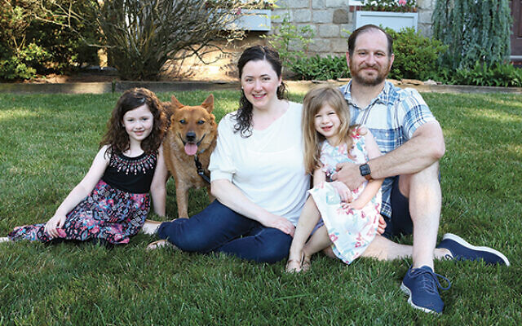
Marc Melzer, Michal Telem, and their daughters cuddle with Toasty, from 2 Hands Saving 4 Paws. (Photos by Lyn Ofrane)

There are so very many ways to divide the world into two different kinds of people — including, of course, the people who divide the world in two different kinds of people and the ones who do not.
For argument’s sake, let’s divide the world into people who cannot imagine sharing their homes with smelly, needy, noisy, labor-intensive dogs, on the one sad hand, and the people who cannot imagine their lives without the wet noses, wagging tails, puppy-dog eyes, and pure unquestioning love that dogs offer, on the other.
It’s possible to convert people who don’t want dogs into dog lovers. (It’s hard to go the other way, although sometimes people who want dogs can’t have them. That’s another matter entirely.)
But there are times when life seems bleak, or at least empty and looming — times like, say, this exact one, when covid-19 has shut down life as we know it, and we either stare at our screens or make our own amusements — when people who haven’t had dogs start thinking about what it would feel like to have a companion who loves you a lot and doesn’t talk back.
But how do you get one? Especially now. Where do you go? What should you look for? What does this dog-talk mean? How do you decode it?
That’s where Lyn Ofrane of Teaneck comes in.
Ms. Ofrane is a portrait photographer; to be successful at an artistic career means that you must combine talent and passion. She’s done that. She has a studio in her home; she’s taken pictures for nearly 40 years.
But now she’s in her 60s, and in the last few years her desire to devote herself to photography has waned and another interest has taken over. “I’ve had a passion for animals for years,” she said. Particularly dogs.
“I had dogs growing up,” in Scranton, Pennsylvania, she said. “In the early ’60s, breeding dogs was a reputable profession, and reputable people did it. We started adopting dogs.
“We started a humane society, and my mother would come home with dogs. We had a ton of dogs. And then, when we got married, we didn’t have a dog — I had twins! And then I had my studio, and I didn’t even think about having a dog.
“But then my mother passed away of cancer, many years ago — she was very young — and I started wanting to volunteer. So I inquired at Ramapo Bergen” — that’s the Ramapo Bergen Animal Rescue, where she’s now on the board — “and at that time, which was very different from now, it wasn’t the most organized place, and no one answered my call.
“But I am extremely stubborn.”
A bit later, when the rescue’s executive director “was a kid my kids’ age, and I knew him from Solomon Schechter, I started volunteering.”
It’s now “the number one no-kill shelter in Bergen County,” she said. “We partner with a whole bunch of other rescues and shelters,” and it does a lot of very good work. “It’s also very generous,” she said. “I have been able to pick up crates for people — they are not inexpensive — and water bowls, food bowls, and other important things. They help me help others.”
Her work at the shelter has made clear to her how many dogs there are who need homes, how many people there are who can provide those homes, how love can flow and grow between the dogs (and cats and other species as well) and the humans who make them part of their families.
It’s always been surprisingly complicated to get a rescue dog; covid-19 has made the process more difficult. Many dogs come to families in the northeast from the south, where they are rescued from abusive situations or shelters where they’d be euthanized. There’s a lot of logistics involved in that work. Now, it’s even harder.

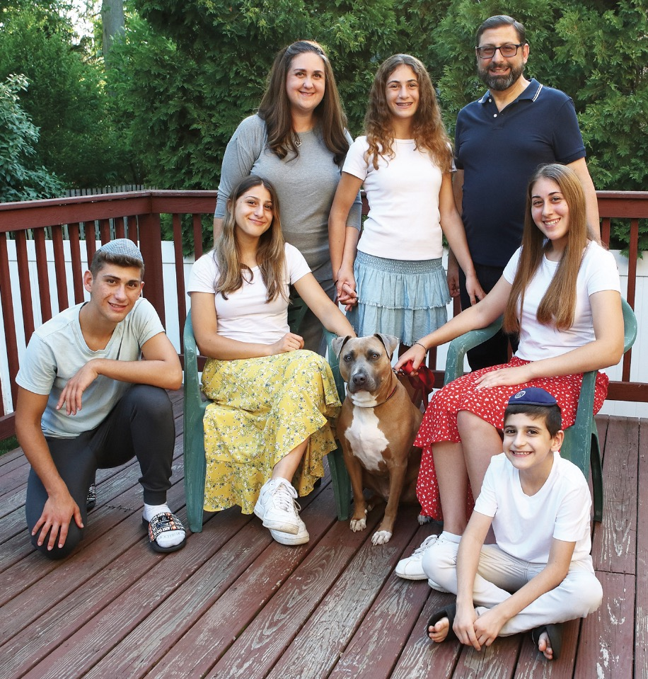
Gila Guzman and her family with Dustin, who was adopted from Mutt Mafia Dog Rescue.

Just as more families realize that this would be a great time to get a dog — they’re all at home, there’s no place to go and nothing much to do — it’s gotten harder to connect dogs and people. We’ve all heard about how broken links in the supply chain make it harder to get some supplies to people — think about toilet paper at the beginning of the pandemic — and just apply that to dogs.
Ms. Ofrane works with families to figure out which dog might be best for them; how to look, what to look for, how to decode, what to expect, what to do.
“I’ve been helping people get dogs for years now,” she said. “But now, people are getting in touch with me 24/7 for help. I don’t charge anything to help; if people want to donate anything, they donate to the shelter.”
She feels strongly about how important it is to take dogs from shelters rather than buying them from pet shops or breeders. “Many people think that if you get a dog from a shelter, that dog is damaged, so they go and buy one” she said. “There are few reputable breeders now, and people can be fooled.
They think their breeder isn’t like that, but often they are. Some of the dogs are ripped too young from their mothers, bred from animal puppy mills.” Ms. Ofrane can talk about some of those puppies — in fact she does — but that’s not part of a feel-good story like this one.
To segue to the feel-good part — “At shelters, we get a lot of dogs who are 18 months to 2 years old. When they were little, they were perfect. Fluffy. Cute. Their real personality doesn’t show, and a lot of people don’t put in the time for training, so we get a lot of them back.
“Hopefully, they will end up with families who will take care of them.”
For that reason, “I don’t help people adopt puppies,” she continued; a dog’s personality doesn’t come through until it’s about 18 months old, and she wants people who know what they’re getting.
She’s been getting a lot of calls from the observant Jewish community, both in Teaneck and from farther away. “What I love about the community is that if they like you, then you’re in,” she said.
She learned that first from her photography work — once a family likes the pictures you’re taken for them, their friends will call. “That’s what’s happening now with dogs,” she said.
And much as she loves working with anyone who’s interested in adopting a dog, she most loves working in the Jewish community. “It’s a mitzvah,” she said. “It’s such an important thing to do.” And the mitzvah is the family’s — but it’s also hers.
What’s going on now, in the covid-era dog adoption world? “Here’s the deal,” Ms. Ofrane said. “There used to be tons of dogs, but not enough people applying for them. And now, people who have been considering adoption have the time, but there are 10 or 15 applications for every dog.”
She’s worked with about 12 families in the last few months.
This is how it works.
Shelters and rescues post online, on sites like PetFinder. Prospective pet owners may be overwhelmed by what they see, but they find appealing dogs and apply for them. Those dogs may be in shelters — brick-and-mortar places with kennels — or in rescues — the homes of people who foster them until they’re ready to move on to a more permanent situation.
“Most reputable shelters and rescues will not do same-day adoptions,” Ms. Ofrane said. “They check references.”
“There’s no average time,” she said. “Some people take just a few days, but others take a few months. Some people literally look every day. And it’s not like you send in only one application. Some sent in 15 or more.”
Each application must be approved; every shelter and rescue does it differently, and they do not share applications. Ms. Ofrane compares it to the way college applications used to be, before the common application made part of the process easier. You have to repeat a lot of basic information, in similar but different ways. “When I was applying to college, we had to fill out 50 million applications,” she said. “I am waiting for that to happen in the dog rescue world. The problem is that some of the applications are 10 pages long, and they have been up there for years. The people in charge don’t even know how they work. So I help people go through it.”

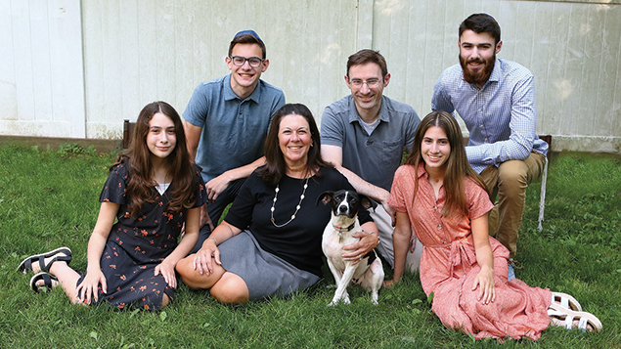
Sharon Rifkind and her family adopted Freddy Mercury from Rescue Ridge by the Jersey Shore.

Not surprisingly the process often isn’t smooth. “A lot of the time, the dog you wanted already was adopted, but you’ve already been approved,” she said. Before covid, that generally meant that the next time that shelter or rescue got a dog similar to the one you’d wanted, they’d call you; now that isn’t as likely to happen.

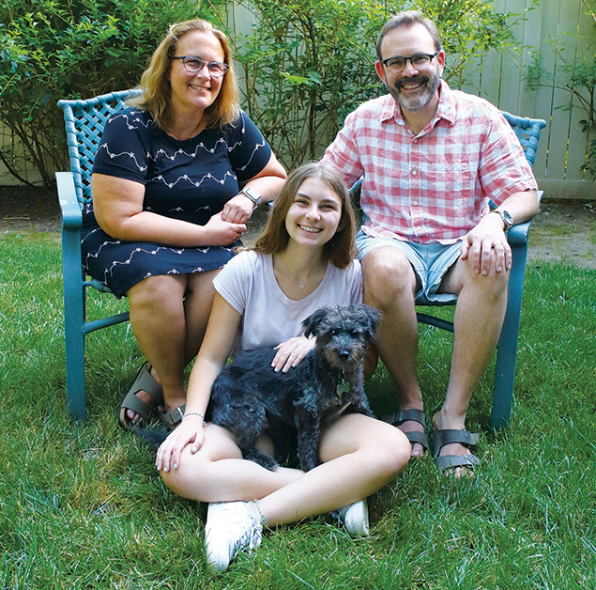
Deb Goodman and her family adopted Louie from Darling Paws Rescue.

As she guides people through the process, Ms. Ofrane listens to them, and translates between them and the dog world. Many of them haven’t had dogs before; she helps them figure out what they think they want, and what they really want. Do they really want a big dog or a small one, can they really handle a dog who sheds, do they want one who’s more energetic or perhaps more placid? Once that’s done, “then we look on Pet Finder,” she said.
She helps them decode what they see there — just like any other insular group, dog people use terms with meanings that are specific to that group but unclear to outsiders. She also helps them craft their application; “I don’t create their answers, but I help them elaborate them.”
Once the dogs are in their new homes, if the family still wants help, Ms. Ofrane offers it. She can give advice based on knowledge and experience.
And she can also give art.

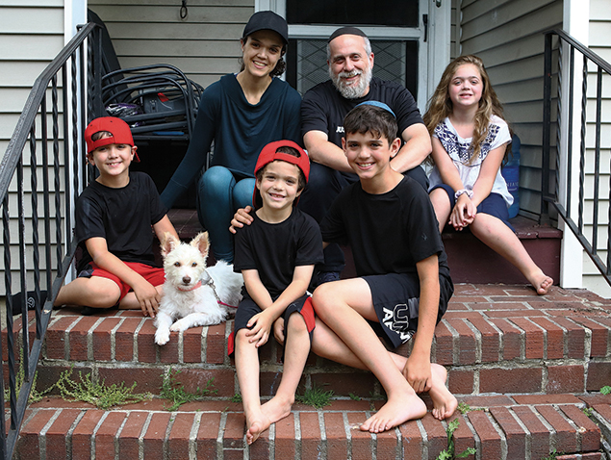
Devorah Heidings and her family are with their dog Fifi; they got her from Darling Paws.

Before covid, “I was using my studio to shoot pictures of anybody who fostered, rescued, or adopted any kind of animal, as long as the animal wouldn’t flip out in my studio,” she said. “I’d take free photos for them.” Now, during the pandemic, “I can’t bring anyone into my studio, but I still can take photographs in the park.” She loves being able to offer those whole-family photographs to her clients.
Marc Meltzer of Teaneck is among those clients.
“I grew up without a dog and always wanted one,” Mr. Meltzer said. In fact, he and his wife, Michal Telem, had adopted a rescue two years ago. “It came about a little randomly, from an email off the
Teaneck shuls list, and it was not a great fit. Ultimately we found her a new, better-fitting home in Syracuse.” That experience taught Mr. Meltzer and Ms. Telem two things — that they wanted a dog, and they needed a better way to go about finding one.

The Pandemic Provided the Opportunity.
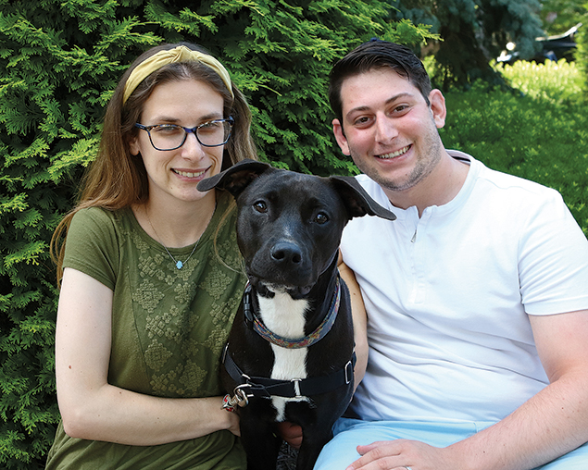
Josh and Rachel Krantz are fostering for Mutt Mafia Dog Rescue; this is Taffy, formerly known as Noodles FKA, who has been adopted. Taffy was their first foster dog, and now they’re on their third.

“I knew that we would be there for midday walks for at least a number of months,” he said; he’s an attorney in Manhattan, and his wife teaches at Solomon Schechter in New Milford. Their daughters, Aliza, who is about to turn 8, and Naama, 5 1/2, are old enough to enjoy a dog, they thought.
They heard about Ms. Ofrane from friends down the block, who’d worked with her and are happy with their dog. “We knew that the last time we were too hasty, and too ignorant. We needed a Sherpa. So we got in touch with Lyn, right after Pesach.

Rebecca Stein and family with George, from Trina & Friends K9 Rescue

“She’s very passionate about rescue dogs, and she provided the knowledge to fill the gaps we had in terms of how to read the listings.
“We have a friend who is a real estate broker who knows how to read apartment listings. We had to know how to read between the lines. She was able to discourage us from dogs that we thought would be good for us but wouldn’t be. We were concerned about the dog’s energy level, and we had to decode what we were reading. We had to be able to understand the various ways of describing whether a dog is good with children.
“And she helped us craft our answers on the application, so that they were honest but we would get the best opportunity. We were honest about having rehomed a dog; we knew that it could get us blacklisted, and we would have struggled more about how to write it had we done it on our own.”
The Meltzer-Telem family first heard about Toasty “on a Facebook post of one of the rescues that Lyn identified for us. It was late on a Thursday, and we didn’t get to look at it until the kids were in bed. We filled out the application using the model we had worked on with her.” It didn’t hurt to apply.
The next day, Ms. Telem read the listing carefully. It said the dog would be “ideal for a retired couple with a fenced yard. Michal said that would be ideal.” They had learned what that meant — that the dog wasn’t demanding. “He’s between 2 and 3, and that is what we were looking for.”
Ms. Telem talked to Ms. Ofrane, who confirmed that the rescue was trustworthy, and that the dog seemed a good fit for the family. “So I was cooking Shabbat dinner, and Michal had that conversation, and then she said, ‘We are getting a dog on Sunday,’” Mr. Meltzer said. It was around Memorial Day; the process had taken somewhere between three and four weeks.
Toasty, an Australian cattle dog, came from Georgia; he’d been living on a golf course, where apparently he’d been abandoned by a family who’d done some rudimentary training before they’d tired of him, or he’d somehow gotten lost. He was driven up to a parking lot at a mall in Lyndhurst. “I drove there with my older daughter; we’d been to a drive-by birthday party before, so we were there toward the end of the pick-up time,” Mr. Meltzer said. “Everyone was masked, and he was in a little playpen. Two people from the rescue were there for about half an hour, so we had the chance to meet him and walk him around a little bit, just to be sure he wasn’t too afraid of us.
“He was foster to adopt, so we had two weeks to be sure he wouldn’t reject us, but he seemed happy and comfortable.” He’s part of the family now.
“Our daughters love him,” Mr. Meltzer said. “And he’s very placid. He’s barked only twice in six weeks, and both times it was fully justified.”
Michele Major of Teaneck is the director of educational technology at Ma’ayanot High School. She grew up with dogs, but she and her husband, Brian, did not have any. Mr. Major, a lawyer who spends long hours at work in Manhattan, had not
had a dog growing up, and he was not interested. There are five children in the family — Tzivia, 17; Chavi, 16; Aron, just about to turn 14; Mordy, almost 11; and Orly, 9 — and both parents have demanding jobs.
Still, the idea of having a dog was alluring, so “we were a foster family,”
Ms. Major said. Her youngest child was afraid of dogs. “She could see one on the other side of the street, and she’d freeze.

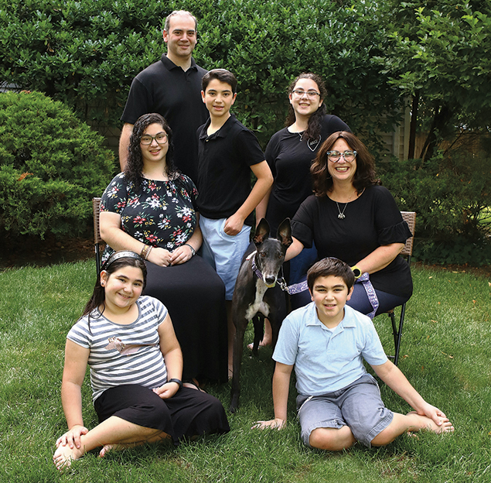
Michele Major and her husband, Brian, with their five children and their new dog, Roux, who came from Greyhound Friends of New Jersey.

“I know the benefits of having a dog, and to be so scared is a terrible thing. So I tried to convince my husband to have one, so we looked into fostering.”
About three years ago, they brought the first fostered dog home. “It took my daughter three days to leave the stairs,” she said. That dog stayed at their house for a few days; it had been lost and was reunited with its owner. “That was a happy ending, but my daughter was so sad.”
The Majors kept on fostering; the more they said yes, the more calls they got. It turns out that families like the Majors are perfect for dogs transitioning to homes with children. “I explained to my kids that we were the stop between a dog being in a bad situation and going to their fur-ever homes,” Ms. Major said; she spells that “fur-ever, not forever,” she added.
Then the calls dried up.
That was when covid hit, and the need for fosters, like the need for adoptive families, collapsed along with the supply chain of dogs from the south. “And I saw Lyn Ofrane on Facebook, and I reached out to her,”
Ms. Major said; although Ms. Ofrane usually works with families looking to adopt, “she said sure. And we talked for a long time.”
Ms. Ofrane suggested that Ms. Major apply to some rescues, and she did. “And then she said, ‘Hey, Michele, what about Greyhound Rescue?’ And I said, ‘No. they’re huge.’
“It was bashert.” So yes, reader, it’s true. The Majors’ dog, Roux, is a greyhound.
The rescue was reluctant to place Roux in a foster home, but eventually agreed; they tried to talk Ms. Major into thinking about adoption, but she didn’t want that. But they took Roux home, and it was love.
Not that it was easy. “They brought us Roux, and she stood outside for 40 minutes like a statue, until I finally convinced her to come in. I said to the kids, ‘You have to give her space. Ignore her. Let her approach you.’ And then she started feeling more comfortable.

“Greyhounds are used to sleeping with other greyhounds, and she slept downstairs, so she would cry at night. She didn’t know where her pack was. That happened for two nights. So then I slept on the couch for a week and a half. I was her pack leader, and she knew where I was. She didn’t cry any more.
“So then I finally decided to bring her bed upstairs. She could sleep in the hall, where she could hear me and see me.” That worked. “She doesn’t cry.”
Roux was still a foster, though. That was fine until the rescue told Ms Major that another family wanted her, and was about to submit an application. Would Ms. Major talk to that family as a preparation to hand the dog off to them?
“I was like a deer in the headlights,” she said. “We had her only for three weeks, but it was coronatime.” Time moves oddly now; three weeks seemed like an eternity. Roux was a Major by then. “I said that I was not ready to give this dog up.”
The people at the rescue told Ms. Major that the foster family always had priority on a dog, but they had only three days. “It was Tuesday, and I had until Friday. I knew that my kids would be heartbroken to give her up. She was the match for us

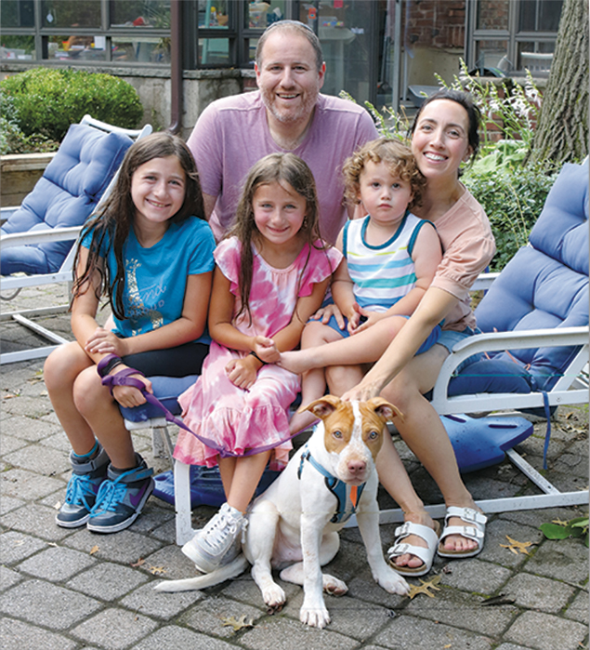
David Weissmann and his family are fostering for Mutt Mafia Dog Rescue; this is Scout, who just got adopted.

“She is a couch potato. She is not high maintenance. If I am 10 minutes late for a walk, she’s fine. We get each other. She gives my kids space, and they give her space.” The problem was convincing her husband.
“On Thursday night, I said to my husband, ‘They want me to speak to an adoptive family, and I really want to adopt her. I want her to be my dog.
“My husband is an amazing partner and husband and father.” His hesitation was about how his work schedule, once he’s back in the office, would preclude him from committing to walking the dog regularly, and about how his wife would work it around her schedule, but he agreed.
“So I called the rescue back, and said I want to adopt, but I don’t want to tell my children until I’m sure that it’ll be approved.”
It was, so she and her husband prepared the big reveal.
Ms. Major went to Petco; the store has a machine that makes dog tags that includes their names and contact information; she got a tag that says Roux and has the Major family’s address. “I also bought a purple paisley collar that I feel fits her personality,” Ms. Major said.

That night, “We all watched ‘Call of the Wild’ together,” she continued. Not coincidentally, “It’s about a dog.
“We streamed it, and at the end of the movie, my husband said, ‘There must be an extra credit outtake scene here,’ so we started watching it.
“I had videoed the tag being engraved at Petco.” That’s what streamed over the family’s big-screen TV. “One of my kids said, ‘This is the weirdest outtake.’ And then one of my kids said, ‘Is that a dog tag? Are we adopting Roux?’
“All of my kids were so excited. They were so emotional.
“My kids love Roux,” she continued. “It’s amazing for us. It gives them companionship and structure.” She walks the dog with the kids, and that gives her the chance to spend time alone with each child. “We are so happy to have her. Greyhounds are great family dogs. They’re calm, and they love their human family.” And they’re like cheetahs; they are incredibly fast for very short times; if you have a fenced-in yard, they can give a spectacular show. “They zoom at 40 miles an hour, and then that’s it. They’re done.”
Ms. Major is thrilled with Roux, and she’s grateful to Ms. Ofrane. “Lyn is unbelievable,” she said. “She was such a huge support to me. I put her in touch with friends who were thinking of adopting. It’s so amazing; each of those families decided to adopt a dog, and we know that these dogs are being rescued. They’re saved, and they’re in these amazing homes.
“It’s such a very good feeling.”
If you want to get in touch with Ms. Ofrane to learn more about adopting a dog, find her on Facebook or email her at lynofrane@gmail.com.

Reprinted from the July 16, 2020 dispatch of the Jewish Standard of North Jersey and Rockland, NY.
His Brother’s Keeper: Norman Rosenbaum, 63,
Fierce Advocate for Justice Challenged
City’s Response to Crown Heights Riots,
And Brother Yankel's Murder
By Mordechai Lightstone

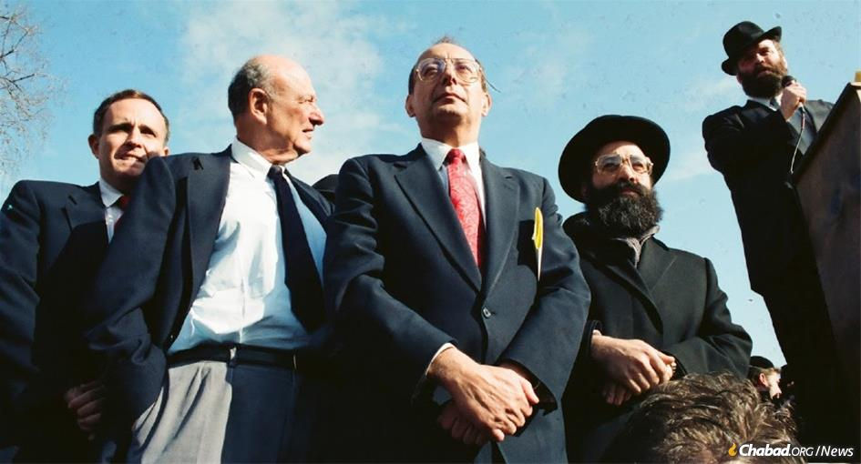
Norman Rosenbaum, upper right, speaking at a rally soon after the anti-Semitic murder of his brother, Yankel, in the 1991 Crown Heights riots. Listening were, l. to r., future New York City Mayor Rudy Giuliani, former Mayor Ed Koch, and U.S. Senator Al D'Amato.

For more than a decade, Norman Rosenbaum was a fixture in New York City, a fiery Australian who became a fixture on front pages and nightly newscasts for his impassioned speeches—many on the steps of City Hall, demanding justice in the face of entrenched anti-Semitism after the infamous 1991 Crown Heights riots, in which his younger brother Yankel was brutally murdered.
His booming voice and forceful advocacy wo/uld ultimately shake up the New York political establishment. Driven with a mission to right the wrongs he witnessed in his lifetime, he was, as one friend recalled, “a man obsessed with justice.” Rosenbaum passed away on July 25 in Melbourne, Australia. He was 63 years old.

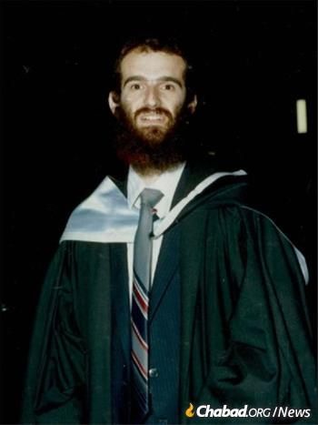
Yankel Rosenbaum, hy”d
A Barrister by Profession
A barrister by profession, Rosenbaum was a fixture in the Melbourne Jewish community for most of his adult life. “People were always turning to him for legal advice, general help,” his friend Ephraim Finch, emeritus executive director at the Melbourne Chevra Kadisha, told Chabad.org. “It didn’t matter what it was, he never said no.”
Applying his know-how and dynamic personality, Rosenbaum—working in tandem with Finch—would help ensure that Melbourne’s Jews would receive a proper Jewish burial.
“Sometimes, we’d get a call at two in the morning from Rabbi Yitzchok Groner that our services were needed with a tragedy,” recalls Finch. Rosenbaum would dive into action, cutting through legal bureaucracy, and preventing autopsies and other procedures that run contrary to Jewish law.
Rosenbaum enjoyed a warm relationship with his parents, Max and Fay Rosenbaum, and his younger brother Yankel. “His parents were devoted to their boys,” says Finch, “and the boys were devoted to their parents and to each other.”
Everything changed for Norman Rosenbaum on a sunny Melbourne afternoon in August 1991. Halfway across the world and a 14-hour time difference away, his brother Yankel had been doing research at the archives of the YIVO Institute for Jewish Research in New York City for his doctoral thesis on anti-Semitism in Eastern Europe before the Holocaust. Returning from a visit to family members in another part of Brooklyn at 11:20 p.m. on Aug. 19, Yankel was attacked by a mob of as many as 20 youths.

Shout of “Let’s Kill the Jew”
Amid shouts of “Let’s kill the Jew,” Yankel Rosenbaum, who stood at 6’4” with a full beard and yarmulka, attempted to take flight. He was overwhelmed by the vicious crowd, who proceeded to beat him, fracturing his skull, and then stabbed him repeatedly. He was rushed to nearby Kings County Hospital after identifying one of his assailants to police, but passed away at 2:25 a.m.
The four days from Aug. 19th to Aug. 22, which became known as the Crown Heights riots, were precipitated by a tragic car accident. At 8:20 p.m. on Aug. 19, a station wagon driven by a Chassidic Jew trailing the Rebbe on a return trip from the Old Montefiore Cemetery in Queens, N.Y., was hit by another car while crossing the intersection of Utica and President Streets in Crown Heights.
The station wagon spun out of control, careening into a nearby apartment building and pinning two young Caribbean American children—cousins Gavin and Angela Cato—against the building’s wall.
An angry crowd of several hundred people, largely teenagers drawn from the Caribbean and African-American communities, surrounded the car. The driver attempted to help the children, but amid shouts of “Jews! Jews! Jews!” the mob began pummeling him and his three passengers.

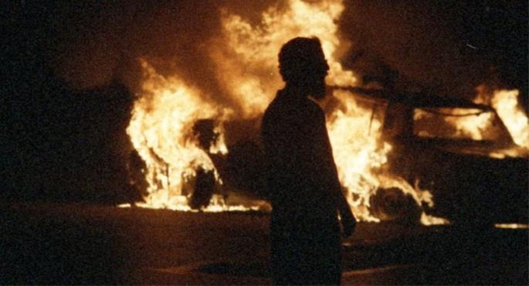
Crown Heights on fire during riots

Hatzolah Quickly Arrived
When Hatzolah, the Chassidic-run EMT service, arrived minutes later, it became apparent that they lacked the advanced life-support equipment needed to treat the wounds of 7-year-old Gavin Cato.
The Hatzolah member tried in vain to work on the two injured children, even as the angry mob beat them. When a city ambulance arrived on the scene, the police sent the Chassidic Jews away.
Nona Capace, one of the police officers at the scene, would later recount to Columbia University Libraries’ Shoeleather podcast that she repeatedly yelled at the Hatzolah members to “Get out of here! Look at what they’re doing to you!”
But the Hatzolah EMTs only stopped working on the children after Nona vulgarly cursed at them to leave the scene, she recounted. The driver and his passengers then left with Hatzolah while city EMTs continued to work on the children.
After the two children were stabilized, they were transported to the county hospital. Tragically, Gavin passed away shortly after arriving.

Negative Rumors Spread
About the Chassidic Jews
Rumors that the Chassidic Jews had purposefully abandoned the two black children or that the drivers were drunk quickly spread among the crowd. Speakers began to encourage those gathered to violence with calls to “get the Jews.” Bands of violent youths began rampaging in Crown Heights, throwing bottles, rocks, bricks and debris at visibly Jewish houses, cars and passersby.
The Crown Heights riots were widely described as a pogrom, a deadly attack by a mob against Jewish lives and property.
Despite the sudden, uproarious violence convulsing through the streets of Crown Heights, the police department and Mayor David Dinkins were slow to request an increased police presence, and full mobilization was not completed until 2:40 a.m.
At 11 p.m., Charles Price, a drug addict and petty thief, stood on the roof of a car and began to excite the crowd of some 500 people with calls of “No justice. No peace!” urging bands to “take Kingston Avenue and get the Jews,” referring to the main drag filled with Jewish-owned stores and synagogues.

Lemrick Nelson, Jr.
Was in the Crowd
Among those in the crowd was Lemrick Nelson Jr., a troubled teenager from neighboring East Flatbush. He was found by the police hiding in the bushes just minutes after the mobs attacked Yankel. Nelson was brought by police at the scene to Yankel, who lay languishing on the hood of a car as blood streamed down his back. Seeing Nelson’s red shirt and baseball cap, Yankel identified him, “Why did you do that to me?” he cried out in anguish. “You in the red shirt!”
Nelson’s clothes were stained with Yankel’s blood, as were the contents of his pants pocket: three blood-spattered dollar bills and a bloody knife with the word “KILLER” etched on it.
‘I’m Here for the Long Haul’
Norman Rosenbaum, back in Melbourne, rushed home from work when he heard the horrifying news of his younger brother’s murder.
Yankel was the last person in the world he expected to die, Norman later told the playwright and professor Anna Deavere Smith. “I mean the fact that my brother could be attacked or die, it just hadn’t even entered my mind.”

Devastated by the Murder
Of His Younger Brother
As Finch, his friend, recalls it in Australian-tinged Yiddish:
“Yankel’s murder took the kishkes, the guts, out of him.”
Yankel Rosenbaum’s body was escorted past Chabad-Lubavitch World Headquarters at 770 Eastern Parkway in a funeral that attracted some 2,000 mourners as rocks and bottles rained down on them from neighboring rooftops. Some 500 people drove with the hearse to the airport, where he made his final trip back home to Australia.
After shiva had concluded, Norman was tasked by his parents with traveling to New York to bring justice for his brother.

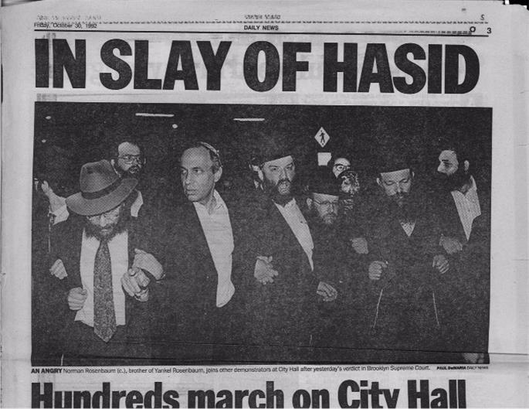
Norman Rosenbaum, center, leads a demonstration at New York's City Hall.

He made contact with Rabbi Shea Hecht, today the chairman of the National Committee for Furtherance of Jewish Education and then a member of the Crown Heights Emergency Committee, an entity set up to help in the response to the riots. He stayed at Hecht’s home during his quest for justice.
“I’m here for the long haul. I’m not going away,” Norman told The Jewish Week at the time. Despite a successful law practice in Australia, a teaching position at the University of Melbourne’s law school, and above all, his family back home, Rosenbaum dug in, sometimes spending weeks at a time in New York.
“Norman was an expert on tax law, not a criminal lawyer,” relates Hecht. “But he possessed a deep understanding of how the law worked. He was incredibly sharp.”

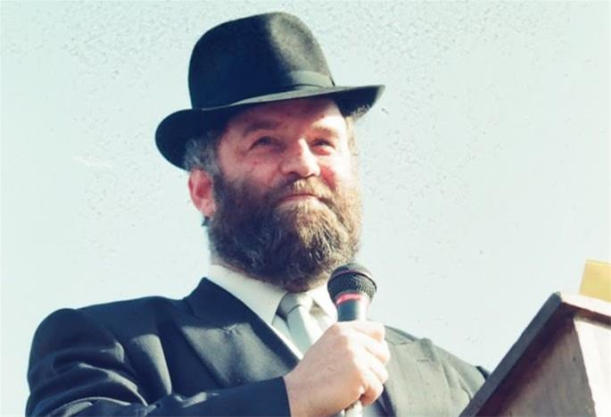
Norman Rosenbaum speaking at a rally for justice for his brother Yankel

Focused on the Search for
His Brothers Killers
Rosenbaum focused on the search for his brother’s killers. Though Nelson had been arrested, he had been only one of as many as 20 people who attacked Yankel.
Even though Yankel had been alive and lucid for three hours after the stabbing, he was never questioned by police.
Key witnesses were let go without further questioning, and numerous other details were left uninvestigated by the NYPD. Rosenbaum made little secret of his deep frustration and anger with the police and the mayor.
“To Norman, it was inconceivable that the city decided to prosecute only one person,” says Hecht. “They seemed to stop their search for justice after they found only one of many people culpable for Yankel’s murder.”
Norman became a fixture, regularly speaking at protests and gatherings across the city.
“My brother’s blood cries out from the ground,” he boomed at one event in front of City Hall, intoning the biblical verse after Abel’s murder to indict the city. “His blood is on their hands. And I hope they never, ever forget. My brother was killed in the streets of Crown Heights for no other reason than that he was a Jew!”
Rosenbaum’s frustration was only magnified by the city’s bungled attempt to prosecute Nelson. With a confession, bloody murder weapon and victim identification all locked away, a conviction for Nelson seemed like a done deal.
Shockingly, Nelson was found not guilty in October 1992. Jurors attended a post-decision victory celebration for the freed man, hosted by his defense lawyers at a restaurant in downtown Brooklyn.
“I am incensed at what’s happened,” Rosenbaum called out at a large gathering after Nelson’s verdict later that week. The miscarriage of justice wasn’t “a black or a white issue. [It] affects every decent New Yorker.”
“It’s going to be long, hard and slow, but we’ll get justice. Let me assure you of that,” he told JTA at the time.

The Lopsided Coverage of the Riots
Another point of contention for Rosenbaum was what he saw as lopsided coverage of the riots and their aftermath.
“Norman would often point out how the media equivocated the accident that took Gavin’s life with the murder of his brother Yankel,” says Hecht. “It was deeply upsetting.”
‘It’s a Pogrom! You Know What That Means?’
For four days, violent anti-Semitic mobs coursed down the streets of Crown Heights. Angry protests led by outside agitators during the day gave way to chaotic riots each evening. The fear of the Crown Heights Jewish community is palpable in the records of 911 calls made at the time.
On the second evening of the riots, a Jewish woman told the dispatcher how she made her way home with three small children as angry rioters chanted “Heil Hitler!” and “Kill the Jews,” all while police officers stood passively by, observing from the street corners.
As she entered her building, bricks and bottles burst through her windows. Shielding the children, she was hit by a rock and a shower of broken glass. Even as she entered, the angry mob began to pound on her door, taking off its hinges until the door was only held in place by the lock.

Frantically Calling 911
Taking cover under a table, she frantically called 911.
“You’ve got to get the National Guard,” she told the operator. “I don’t know what you can do … They’re throwing bottles … they’re breaking stores! It’s a pogrom! You know what that means? It is bad. If we have to wait for the killings, we’re finished. If we have to wait … my door’s broken. I’m not safe in my house anymore. I want to get out. How am I gonna get out of here?”
Records show that she called 911 half a dozen times that evening. Yet despite repeated promises from the operator that authorities were on their way, the cops never came.
Time and again, the Jewish community saw the police stand by—unwilling or unable to act—as windows of Jewish homes were smashed, cars were burned, and Jewish bodies were assaulted.

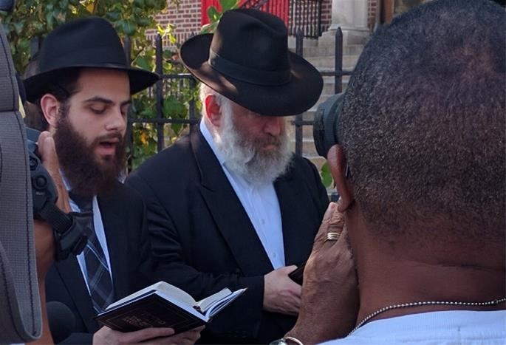
Rosenbaum at a recent memorial gathering for his brother, Yankel.

Mob Attack on Isaac Bitton
In one particular incident, a group of some 50 people attacked Isaac Bitton, a Chassidic musician, as he walked home with his son Yechiel.
Pelted with bricks and stones, Bitton watched in horror as the police stood off on the sides of the intersection. After a brick struck his head, Bitton fell on top of his son in an attempt to protect him.
The mob swarmed around the two fallen Jews, pulling the child out from under his father as they beat them. Finally, Peter Noe, a Caribbean American reporter for The Village Voice, ran in to save them from the bloodthirsty mob.

A Cavalcade of Charlatans
As a cavalcade of charlatans and hucksters, attempting to capitalize on the pain of the Cato family, led successive waves of rioters down the streets of Crown Heights, the trauma experienced by the Chassidic community lingered.
Brokha Estrin, 68, a widowed Holocaust survivor and refugee from the Soviet Union, leapt to her death from her third-floor apartment, just down the block from the site of accident.

The Girgenti Report
“The Girgenti Report,” the official fact-finding report ordered by New York Gov. Mario Cuomo, noted that the riots—resulting in 152 police officers and 38 civilians injured, 27 vehicles destroyed and an estimated $1 million in property damage—“exhibited a kind of violence rarely witnessed in New York City since much of the aggression was directed against one segment of the community.”
Yet the general press, set on framing the events in central Brooklyn through the lens of national issues of race, failed time and again to identify the raw anti-Semitism of the riots.
Ari Goldman, who covered the riots for The New York Times and is today a journalism professor at Columbia University, wrote about his experiences decades later in The Jewish Week.

Journalism Going Terribly Wrong
“Over those three days, I also saw journalism go terribly wrong. The city’s newspapers, so dedicated to telling both sides of the story in the name of objectivity and balance, often missed what was really going on. Journalists initially framed the story as a ‘racial’ conflict and failed to see the anti-Semitism inherent in the riots. ... When I picked up the paper, the article I read was not the story I had reported.”
In 1997, the federal court began a civil case against Nelson for violating Yankel Rosenbaum’s civil rights. Slowly, excruciatingly, a modicum of justice was underway.
“Anyone involved in the criminal justice system knows that the pursuit of justice is a life-long struggle,” says Devorah Halberstam, director of external affairs for the Jewish Children’s Museum and an advocate for justice after the murder of her own son, Ari Halberstam, who was riding in a van with other Chassidic boys on the Brooklyn Bridge in 1994.
Only in 2003 was Nelson was finally found guilty of Yankel Rosenbaum’s murder.

The 10th Anniversary
On the 10th anniversary of the riots, Rosenbaum broke bread with the boy’s father, Carmel Cato, in a ritual meal of sorts they would repeat several times over the years.
“We shared a terrible time in New York history,” Norman recalled in 2016. “It’s important for people to see us meet, so that people see that we’re all part of one community.”
‘This Was Anti-Semitism in America’
Even as he toiled tirelessly for justice in New York, he served as a beacon for goodwill and kindness back home in Australia.

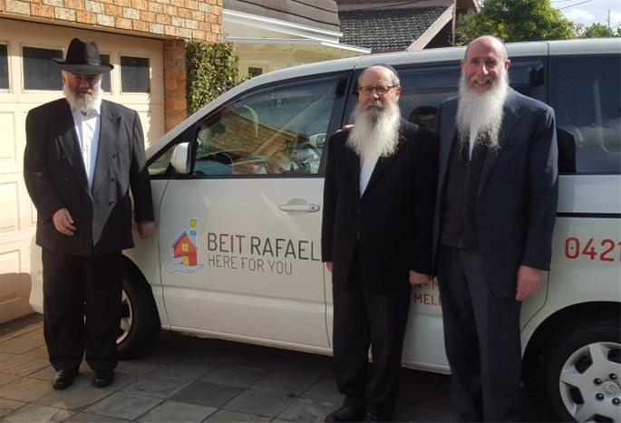
In recent years, Rosenbaum, left, was a mainstay in the Melbourne Jewish community and active in many charitable organizations there.

Launching Beit Rafael,an Organization to Help Patients
In 2012, he helped launch and served as the director of Beit Rafael in Melbourne, an organization dedicated to bringing patients to and from doctor’s appointments, and providing accommodations and kosher meals for family members visiting loved ones in the hospital for Shabbat.
Despite the pain of his brother’s absence, an extended “numbness” as Norman called it, he remained vigilant in his many duties and advocacy.
Back in New York, his continued advocacy slowly began to create a shift in the city. In many ways, “The Girgenti Report”—the state’s formal acknowledgement of the riots in Crown Heights—was due to Norman’s advocacy.

Almost Had Celebrity-Like Status
“Norman worked every crowd; he was passionate and charismatic, he almost had celebrity-like status,” recounts Hecht. “He did whatever he could to make sure the city would not only never forget, but actually change for the better.”
According to Edward S. Shapiro, professor emeritus at Seton Hall university, changes in policing after the riots factored into the NYPD’s rapid and “laudatory response to the events of Sept. 11, 2001.”

But above all, Rosenbaum centered Yankel’s murder clearly in the lens of his unfinished research: an act of anti-Semitism with broad-reaching implications.
“Norman recognized that Crown Heights was something larger than Yankel, something larger than Brooklyn,” says Halberstam. “He didn’t let people forget that this was anti-Semitism in America, and that it affected each and every one of us. He knew that the knife that killed Yankel was pointed at every Jew—and he fought for us. He truly was his brother’s keeper.
Predeceased by his wife, Ettie, in 2014, Norman Rosenbaum is survived by his mother and his children—Ari, Yoel, Yoni and Michal—as well as grandchildren.

Reprinted from the August 6, 2020 dispatch of Chabad.Org News.

Story #1184
Father of Orphans
From the desk of Yerachmiel Tilles
editor@ascentofsafed.com

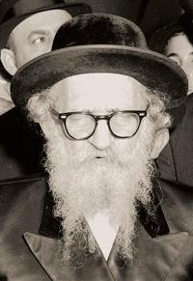

Rabbi Eliezer-Zusia Portugal was a prominent follower of the Shtefaneshter Rebbe, of the Rhuzhiner dynasty, but he did not assume the mantle of Rebbe until well into his sixties. His first "career" was as Rabbi of the town of Skulyany (Skulen), in Bessarabia (wherever that is, or rather, was!). His focus there was on increasing the spiritual level of his town-folk, including writing booklets in Yiddish specifically tailored to the spiritual needs of his neighbors.
When the Sadigorer Rebbe visited Skulen and saw Rabbi Eliezer Zusia's accomplishments, he urged him to move to Chernowitz, where he could serve a larger community. The Skulener complied, and before long was chosen as chief rabbi of that city. (The wisdom of the Sadigorer Rebbe was demonstrated soon after, when Bessarabia was invaded by the Russian Communists, under whom the Jews suffered terribly.)
Chernowitz, too, changed hands several times during World War II, eventually ending up in the Soviet Union. A new chapter in Rebbe Eliezer Zusia's life opened after the war, when he became the father of hundreds of war orphans, even formally adopting scores of them. Later he smuggled his "family" into Rumania and settled in Bucharest where he adopted even more children. [In his will, the Skulener asked that his "children" show their appreciation by remaining loyal to Judaism and studying Torah at every possible moment.]

Nothing Could Stop the Skulener Rabbe to
Fulfill His Mission to Rescue Jews in Need
Nothing could stand in the diminutive Skulener's way to fulfill his mission to rescue Jews who were in need. In Chernowitz, he assisted Soviet Jews who had smuggled themselves across the border into Romania. It was much easier there to get papers to enable them to go on to America or Israel.
Whenever these Jews were caught they were immediately found guilty. The punishment was imprisonment in Siberia or a quick bullet to the head. The Rebbe was indefatigable; "I will get them out - regardless!" he exclaimed.

* * *
The colonel who was in charge of the border guards lived in Chernowitz and knew the Skulener well. The Rebbe had won him over many a time with heartrending entreaties on behalf of his brethren. The last time he was there the colonel had told him, "This is the very last time you will bother me. If you come again on behalf of your Jews, I will kill you!"
Nonetheless, when the Skulener was notified about a family of nine people that had been captured, he immediately undertook the daunting and dangerous task of rescuing them. Nothing worked, not even a hefty bribe. They were adamant; these people were to serve as an example for others.

Went to the Colonel and Risked His Life in Doing So
There was only one avenue left to be employed: he would go to the colonel and beg, regardless of the imminent personal danger involved. Jewish lives were at stake and that was more important than his own life.
His family begged him not to go. "How can you risk your life like this?" they asked. He responded, "It is not clear that he will take out his wrath against me, but one thing is for sure, their lot is sealed unless I am able to do something in their behalf."
The Skulener approached the colonel's house with trepidation, climbed up the steps and knocked on the door. When the colonel saw who stood at his doorstep, he was overcome with anger. He grabbed the Rebbe and threw him down the stairs. The Skulener was hurt badly, yet, with extreme difficulty, he was able to get up. With the little strength he had left, he once again climbed the stairs and knocked on the colonel's door.

Could Not Believe His Eyes
The colonel opened the door and could not believe his eyes. There stood the Skulener Rebbe, dirty, bloodied, clothes torn - but with defiance in his eyes. "I must speak to you, colonel!" the Skulener said, with tears streaming down his face. The colonel listened: the Rebbe begged, he cried, as he depicted the bitter plight of this hapless family. The colonel's hardened heart could not ignore the selfless pleas, the heartfelt emotion of the Skulener Rebbe. His devotion to others at the expense of his own wellbeing finally overcame the colonel's resistance. The family was freed.
* * *
At the end of the World War II, he immediately founded institutions for the orphans of the Holocaust. He saved thousands of orphans. He personally cared for some three hundred of them, all of whom called him "Tatteh." Almost all of them settled in Israel and remained observant Jews.
Many people in Israel claim to be sons-in-law of the Skulener Rebbe, and call him their father-in-law. This sounded strange because the Skulener did not have girls of his own at all. Then the mystery became understood: the orphaned ones were regarded as his daughters, and the Rebbe had married them off to men who were then regarded themselves as his sons-in-law.

The Memoirs of Rabbi Binyamin Gorodetzky
In chapter 19 of the memoirs of Rabbi Binyamin Gorodetzky, who was the Lubavitcher Rebbe's emissary for "secret operations" in Europe and North Africa, Gorodetzky describes how the Skulener Rebbe enlisted the help of Lubavitch and of the Joint Distribution Committee to free Jews who were imprisoned in Rumania. At that time, communist Rumania did not permit emigration. However, the Skulener reported that for $2k, a Jewish prisoner could be released and permitted to emigrate from Rumania secretly with his family. From 1960 to 1962, a total of 400 families, including over 2000 individuals, were saved, thanks to the Skulener Rebbe.
Because of his rescue activities, the Skulener was persecuted, and sometimes tortured, by both the Germans and Russians. More than once his life was in danger. One day he was even taken out to be executed by a firing squad, but he was saved from the Germans by a miracle.
The Russians also imprisoned him several times as did the Rumanians. Nevertheless, the Skulener never stopped his appointed task. Despite the danger, he remained in Romania. He was loathe to leave the country until the last of his "children" had reached safety. During this period the well-being of all of Romanian Jewry was hanging by a thread. The Rebbe's home was the only address for all matters of holiness and Jews would come calling day and night.

His Spiritual Work was Seen as a Challenge to Communism
The governmental authorities viewed his spiritual work as a challenge to Communism and accused him of trying to supplant the state as the orphans' guardian in order to send them to Israel. Two weeks before Passover in 1959, the Skulener was imprisoned with his son. They were put in a notorious prison together with dangerous criminals, isolated from one another so that they would not conspire together. The charges: smuggling children to Israel and spying for the US and Israel. They were jailed for five months.
After months of tremendous international efforts, including the intervention of United Nations Secretary-General Dag Hammar-skjold, (and at the behest of the Lubavitcher Rebbe, the influence of a prominent, non-chasidic Rabbi in Cincinnati, Eliezer Silver, who intervened at the U.S. State Department and with the Romanian ambassador), the Skulener Rebbe and son were freed. He emigrated immediately.
* * *
Eventually, in the spring of 1960, the Skulener was able to settle in the United States. He chose America over Israel so he could better help those who remained in Rumania [similar to the decisions of the 6th and 7th Lubavitcher Rebbes].

How Can One Give the Most “Pleasure: to G-d
When he was encouraged to open a yeshiva in his new country, his response was, "What would my yeshiva add to all the others? A person who wants to do a mitzva must ask how he can give the most 'pleasure' to G-d." Instead, he founded the "Chessed L'Avraham" network of schools in Israel to compete with leftist anti-religious schools for the children of immigrants to that country.
In 1961, Rabbi Eliezer Zusia visited Israel for the first time. One of his side-trips was to a left-wing kibbutz to forgive a Rumanian socialist who had been one of his fiercest opponents years before. (That man's descendants later became observant.)
An aide of the Skulener Rebbe once related: Among the many people whom the Rebbe had rescued from Europe was a woman who had informed the Rumanian government of his religious activities, which led to his arrest and imprisonment. The aide asked him why did he want to go to such effort and expense to save a person who and caused him so much trouble and pain?
"You have no idea," the Rebbe said with tears in his eyes, "how much she suffered beforehand, and how tempting the authorities make it to inform."

Did Not Always Have a Morning Minyan
Towards the end of the years that he lived in the Crown Heights district of Brooklyn, in the mid 70's, the Skulener shul did not always have a morning minyan, due to the extraordinary length of the Skulener Rebbe's prayers and the fact that most of his Chasidim no longer lived in that section of Brooklyn. On many such occasions the Skulener Rebbe would go to the main Lubavitcher shul nearby. If the Lubavitcher Rebbe was present and it was a day when the Torah was read, the Lubavitcher would give his aliya to the Skulener. It is not clear that anyone else was ever given that honor by the Lubavitcher Rebbe.
In a private audience with the Rebbe in 1974, the Rebbe contended that the Skulener Rebbe had the power to actualize the final redemption. When the Skulener Rebbe resisted, the Rebbe remarked, that he was displaying "uncalled-for humbleness."
* * *
The Skulener Rebbe was endowed with many fine traits which he applied to his Divine service, in particular his intense feeling and talent for music. As a "sweet singer of Israel", he composed many Chasidic melodies which are sung with enthusiasm still today, drawing the hearts of Jews across the spectrum.
His niggunim are very soulful, yet full of emotion and enthusiasm. Sometimes he would interrupt the singing to give a Torah explanation to some of the words of a song and then continue the melody. Similarly, at Havdala, he would recite it normally, then, when he came to "LaYehudim Haysa Orah," he would sing his own niggun and start everyone off dancing. It was an incredible experience!
On occasion he would suddenly halt whatever he was doing and sit at full attention. Everyone present would freeze as the Rebbe began to hum a new tune never heard before. Eventually they would join in and a new Skulener niggun would be officially born, direct from Heaven. [I, YT, personally witnessed this one Shabbat night.]

He Prayed with an Extraordinary Enthusiasm
He prayed with an extraordinary enthusiasm, and very lengthily. It was not unusual for those in his minyan to open a Gemara, Chumash, or other holy book to learn during Maariv after Baruch Hu until the Rebbe finished the Shma prayer 10-15 minutes later! No one became bored or wanted to leave because of the delay, for they knew they were praying together with someone really special. [Somehow I once merited to be a guest for the Shabbat evening meal at the table of the Skulener Rebbe, R. Eliezer-Zusia Portugal-- just he, me, and the Rebbetzin. Kiddush took as long as the Shma Yisrael!]
It has been said: "Whoever did not see the prayers of the first Skulener Rebbe never saw a real davvening." Those who did not witness the intensity of his prayers and hear the melody which accompanied his deep concentration, never witnessed how a heart can cling to the love of his Creator.
The Skulener Rebbe continued his rescue and outreach efforts after arriving in America, visiting Israel eight times and expanding his Chessed L'Avraham network of charity organizations and schools.
Throughout his lifetime, he was a paragon of kindness and the mitzva of 'redeeming captives.' He passed away in 1982.
* * *
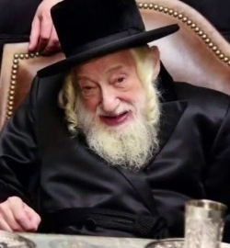

His only natural son, Rabbi Yisrael-Avraham Portugal, the second Skulener Rebbe, continued his father's holy work in America as well as in Israel, from his home on the Boro Park section of Brooklyn. He passed away last year at age 95. His funeral was attended by many tens of thousands. He left five sons and three daughters.
The oldest son, Rebbe Yeshaya Yakov Portugal, who already had many followers, was crowned as the Skulener Rebbe in Boro Park. His second son, Rebbe Meir Portugal, was crowned as Skulener Rebbe in Williamsburg. His third son, Rebbe Efraim Yehuda Portugal, was crowned as Skulener Rebbe in Monsey. His fourth son, Rebbe Zvi Noach Portugal, was crowned as Skulener Rebbe . in Lakewood. His youngest son, Rebbe Shmuel Mordechai Portugal was crowned as Skulen Rebbe in Jerusalem. His three sons-in-law are all important Skulener rabbinic personages.
Source: Compiled, reordered, supplemented, updated and edited by Yerachmiel Tilles from previous stories in this series, #561 & 613, from ten plus years ago (see there for original sources). Both photos courtesy of Chabad.org.
Biographical note: Rebbe Eliezer Zusia Portugal [1 Cheshvan, 1898 - 29 Av 1982], the first Skulener Rebbe, immigrated to the USA in 1960, after imprisonment in Rumania and international efforts to secure his release. He is the author of Noam Eliezer and Kedushas Eliezer, but is best known for his superhuman efforts to rescue Jewish orphans and refugees in Eastern Europe before, during and after WWII and his continuing support of them, and his Chessed L'Avraham network of schools for children that continue until today.
Those who merited to be in his presence were astonished by the length of his prayers and the beauty and intensity of the tunes that he composed, many of which have become internationally famous today.
Connection: Wednesday, Erev Rosh Chodesh Elul, 29 Menachem Av, is the 38th yahrzeit of Rabbi Eliezer-Zusia Portugal.

Reprinted from the Parshat Shoftim 5780 email of KabbalOnline.org, a project of Ascent of Safed.

Discovering the Real
Resting Place of Rabbi
Levi Yitzchok of Berdichev
By Dovid Margolin
An unexpected find reveals another story of Soviet oppression

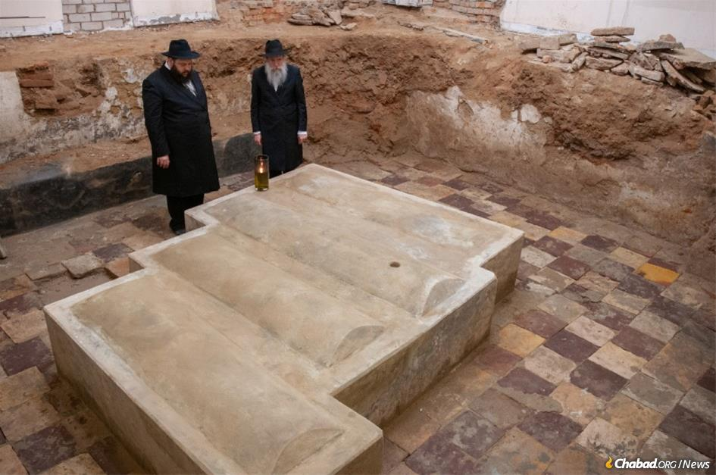
Rabbi Moshe Thaler (left), rabbi of and Chabad-Lubavitch emissary to Berdichev, Ukraine, stands together with Rabbi Shlomo Wilhelm, director of Chabad of Western Ukraine and rabbi of nearby Zhitomir, at the newly unearthed original mausoleum and gravesite of the great Rabbi Levi Yitzchak of Berdichev (1740-1809), the great "defender of the Jewish people." (Photo: Chabad of Berdichev)
In Eastern Europe, there is a truth that lurks just beneath the surface. Beyond the glitz of new developments and predating the drab grayness of Soviet-era construction lie remnants of a lost Jewish world and its inhabitants. Synagogues, yeshivahs, Jewish homes and businesses. Cemeteries and mass graves. It’s all there, buried under asphalt and overgrowth and deep within the recesses of memory.

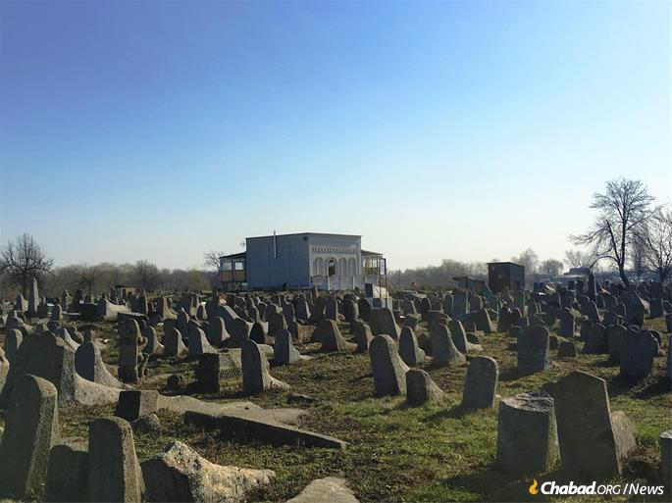
Rabbi Levi Yitzchak's gravesite (center) is located in the old Jewish cemetery of Berdichev. Thaler was installing heating under what was thought to be the floor when workers realized they had hit a brick wall. (Photo: Dovid Margolin)

No matter the attempts, modern or historic, malicious or pragmatic, to build over and erase all signs of Jewish life in the region’s villages, towns and cities, there is no escape. Like the landmines or unexploded bombs that emerge from time to time from this war or that, each discovery of a mezuzah mark, Hebrew inscription or Jewish gravestone in Eastern Europe reminds us once again that the past is never dead.
It’s the reason why Rabbi Moshe Thaler, director of Chabad-Lubavitch of Berdichev, Ukraine, and the city’s lone rabbi, was unsurprised when construction workers at the tomb of Rabbi Levi Yitzchak of Berdichev (1740-1809) suddenly hit something. It wasn’t just cement or dirt. It was a brick wall, beautiful and old. Thaler, supervising the work, instructed them to stop while he consulted rabbinic authorities on how to proceed.

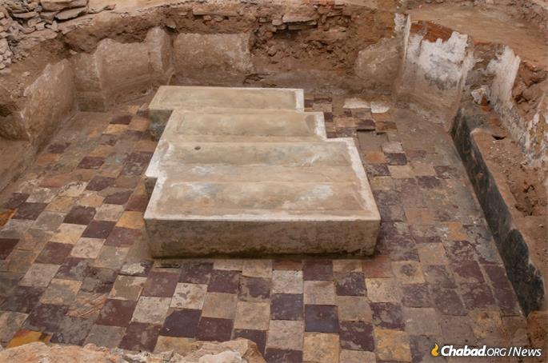
The digging revealed five feet of elegant plastered brick walls from the original structure that stood there until the 1930s, a tiled floor and four horizontal gravestones. (Photo: Chabad of Berdichev)

Berdichev was once known as the Jewish capital of the Russian Empire—an ir ve’am b’Yisroel, or “a city and mother of Israel.” Eighty percent of its population was Jewish, even that figure being an understatement. “In fact,” wrote eyewitness Boris Bogen in 1923, “the city is entirely Jewish as the non-Jews live on the outskirts.”
There is, above all, one person whose name universally evokes Berdichev and with whom the small city’s story is forever intertwined: Rabbi Levi Yitzchak, the Berdichever.
He was a student of Rabbi Dovber, the Maggid of Mezritch, the successor of the Baal Shem Tov—the founder of the Chassidic movement—and a contemporary and friend of Rabbi Schneur Zalman of Liadi, the founder of the Chabad-Lubavitch movement.
Rabbi Levi Yitzchak and Rabbi Schneur Zalman were further connected by the bonds of family after two sets of their grandchildren married, each calling the other mechutan, “the inlaw.”

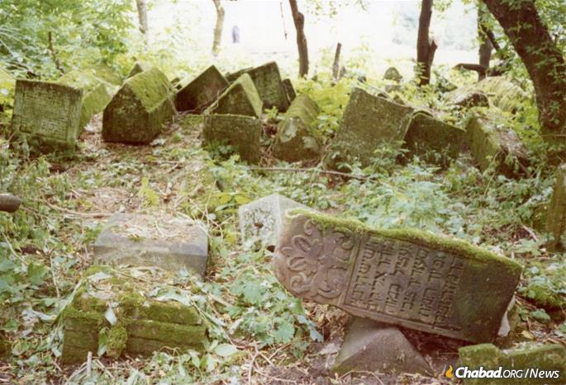
Berdichev's Jewish cemetery, like those in the Soviet Union and throughout the Eastern bloc, was purposefully desecrated and left to the wild, seen here circa 1990. (Photo: Center for Jewish Art)

While Rabbi Levi Yitzchak did not establish a dynastic Chassidic court, some of his teachings, published in Kedushat Levi, survived. More than anything else, however, it was his reputation as a fiery advocate for and lover of all
Jews that has enshrined him in collective memory as the “defender of the Jewish people.”
100,000 Visitors a Year
Rabbi Levi Yitzchak’s resting place in Berdichev, two-and-a-half hours southwest of the capital of Kiev, has thus drawn Jewish pilgrims and petitioners for centuries—men and women beseeching the great rabbi to intercede on their behalf on High. Since the fall of Communism, Jews from around the world have beaten a path to Berdichev, some 100,000 visitors a year.
Ukraine is cold in the winter, and the stone floor in his mausoleum can remain unbearably frigid even as temperatures outside turn warmer. As the coronavirus brought travel to a standstill, Thaler, who oversees the city’s Jewish cemetery, thought he could use the lull in visitors to place heating in the mausoleum’s floor.

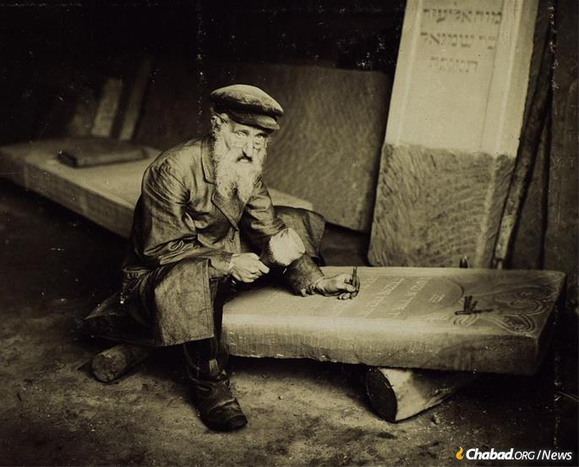
A Jewish tombstone cutter in the village of Ostrah, Ukraine, circa 1912-13, taken during the ethnographic expeditions of S. Ansky.Photo: Solomon Yudovin/Peter the Great Museum of Anthropology and Ethnography [Kunstkamera].
Carefully and under Thaler’s watchful eye—even the minutest work at a Jewish cemetery needs rabbinic supervision to adhere with Jewish law and respect the sanctity of the place—the workers began to dig. After hitting the wall, Thaler heeded the rabbinic instructions he received that work recommence at an even slower pace.
Following the path the wall took, the base of an entire structure emerged: four elegant plastered brick walls, a doorway on one side and a built-in stone bench opposite it. Next came a patterned tile floor. And then, finally, the rectangular outlines of four horizontal gravestones.

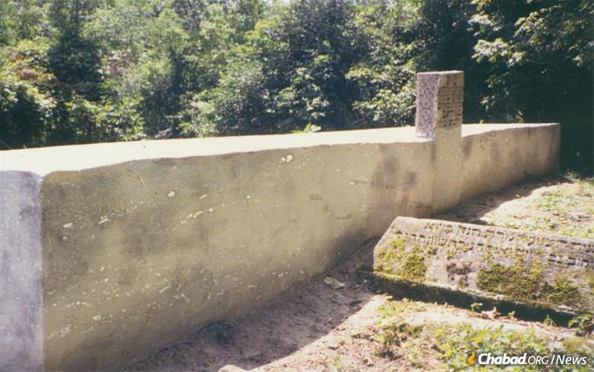
Rabbi Levi Yitzchak's open air gravesite circa 1988, shortly before it was restored for the first time. The rabbi's headstone is the further one and appears to have been inscribed by an amateur in the post-war era. (Photo: Michael Greenberg)

Thaler had discovered—some five feet below what was thought to have been the mausoleum floor—the original tomb constructed for Rabbi Levi Yitzchak, beside whom were buried his three sons, some two hundred years earlier.
The Jews of Berdichev had long been particularly poor. Yet somehow, for the honor of the great rabbi who had served them so faithfully and whose aura loomed large, funds had been gathered and local Jewish artisans had built this intricate edifice. And there it was.
“Until now, people who came to pray at Rabbi Levi Yitzchak’s gravesite were actually standing directly on top of the grave,” says Thaler. This, of course, is true, although Rabbi Levi Yitzchak, who went to extraordinary lengths to find the good in everyone—thieves and heretics included—would likely have been the last person to take offence. Now Thaler plans to restore the original.

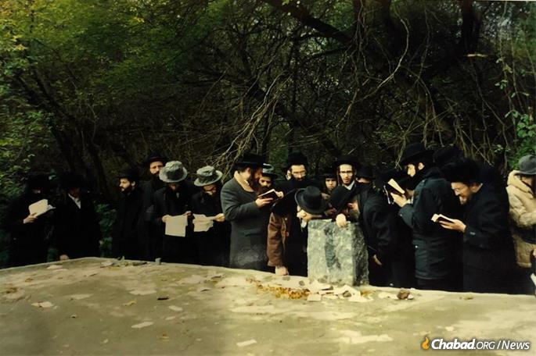
A group of Chassidim pray at Rabbi Levi Yitzchak's gravesite during Perestroika in the late 1980s.

As Chabad emissaries to Berdichev, Thaler and his wife, Chana, primarily work with the region’s living, breathing Jews, though the discovery helps put into focus their work and that of their colleagues throughout the former Soviet Union.
“When you’ve hit a person’s surface, you need to dig a little deeper,” Thaler considers. “You’ll be surprised by what you discover.”

A Pillar of Fire'
How indeed did these layers come to conceal this holy place?
The story begins on 25 Tishrei, 5570 (the evening of Oct. 4, 1809, N.S.), when the soul of Rabbi Levi Yitzchak of Berdichev ascended to Heaven, throwing the Jewish townsfolk into mourning. “As they escorted him to the cemetery they saw a pillar of fire,” records Shalom Guttman in his 1909 biography, Tiferet Beit Levi. Guttman also reports that the sage’s three sons were buried alongside him.

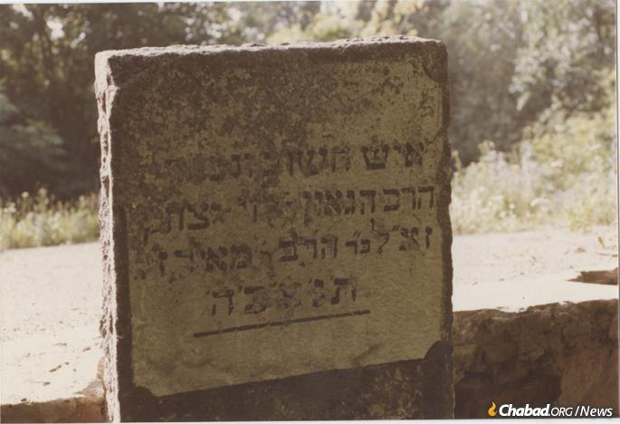
The headstone of Rabbi Levi Yitzchak of Berdichev erected by Chabad-Lubavitch activists Dovid Nachshon and Avi Taub as part of the first restoration work at the site in the late 1980s.

A Model of Genuine Humility
“Over the grave of the great Berdichever Rav was erected a little synagogue [shtibel], and on it was inscribed nothing. Not one word,” writes Mendel Osherovich in his 1948 Shtet Un Shtetlekh in Ukraine (Cities and Towns of Ukraine). “This was the wish ofthe deceased, who in his days had been a model of genuine humility.”
The Jews of Berdichev did not need a tombstone to tell them who lied buried there. “From generation to generation in Berdichev, they would relate that there, in that little synagogue in the cemetery, is the grave of Rabbi Levi Yitzchak. And during each time of danger, of great catastrophe, the Jews of Berdichev would go to his grave and cry and lament.”

The Loss of the Great Saint
It was precisely during these times that they felt the loss of the great saint who had defended them not only before man, “but even before G-d Himself.”
It would appear that this same little structure survived World War I; the brutal and bloody pogroms that colored the Russian Revolution and especially the Civil War; and into the dawn of the Bolshevik era.
And then came the Communists’ blatant, frontal and brutal assault on Jewish life and practice. Tragically, in the first decade of Bolshevik rule, this unrelenting onslaught was led by the Yevsektzia, the Jewish sections of the Communist Party.

Viscious Fanatics
Viciously, fanatically, they worked to uproot every vestige of the G-d of Abraham, Isaac and Jacob, confiscating synagogues, violently beating rabbis and paving over Jewish cemeteries.
The Yevsektzia was most powerful in traditionally Jewish areas, and there was no place more Jewish
than Berdichev.

A War Between Religious
Jews and the Police
“The conversion of the two-hundred-year-old Jewish cemetery of Berditcheff [sic] into a public park has resulted in a war between religious Jews and policemen and laborers employed in excavating the cemetery and transforming it into a park,” the Jewish Telegraphic Agency (JTA) reported on July 12, 1929. While the city’s rabbinate proclaimed that ancient Jewish remains were being desecrated, “the Communists declare that … only the skeletons of horses have been dug up.”
It does add, however, that a rumor had spread among workers that some of those who partook in the action had become paralyzed and a number of them refused to continue,
“What Will Be With the Grave of R’ Levi Yitzchak Berdichever?” screamed a July 23 Yiddish headline in Warsaw’s Unzer Express. The article, also a JTA dispatch, reports that in response to the uproar, Berdichev’s Yevsektzia had agreed to “make a concession to the protesting
Orthodox and to spare the grave of the popular Chassidic rabbi.”
There does appear to have been some confusion in the reporting, as Berdichev’s oldest cemetery was indeed destroyed and is today the city’s central Park Shevchenko. Perhaps due to the aforementioned workers’ fear, one grave remains—that of a legendary Berdichev rabbinical figure named Rav Liber the Great (d. 1771). Rabbi Levi Yitzchak, on the other hand, was buried in what was a relatively newer cemetery, destruction of which it seems the Yevsektzia did not get around to.

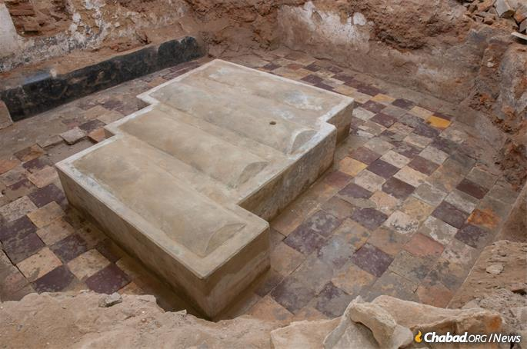
The original site was carefully capped by observant Jews hoping to make it less of a target for Communists, and is thus almost fully preserved. Thaler now plans to carefully restore the site. (Photo: Chabad of Berdichev)

In 1930, Stalin ordered the Yevsektzia disbanded, and by the end of the year Jewish Communists had lost their power in the city. (A high percentage of the outfits’ former members would be executed in Stalin’s terror of 1936-38.)
As Thaler understands it, some time after this episode and to head off the unthinkable destruction of Rabbi Levi Yitzchak’s grave, observant Jews in Berdichev themselves took down the brick mausoleum surrounding the grave and capped it with pavement and a headstone in order to make it less of a target.

The Nazis Violated the Cemetery
When the Nazis entered Berdichev on July 7, 1941, about a third of its Jewish population had fled. Over the next months, they would murder the remaining 30,000 Jews from Berdichev and surrounding villages. They also actively violated Berdichev’s Jewish cemetery, breaking the fences and carting headstones away for construction use.
Rabbi Levi Yitzchak’s grave, however, remained.

Thaler (left) and Wilhelm at the uncovered mausoleum and gravesite. Until now those coming to pray were in fact standing right over the graves of Rabbi Levi Yitzchak and his sons something that will now be rectified. (Photo: Chabad of Berdichev)

Sofya Nayer, a mathematics professor living in Fair Lawn, N.J., was born in Berdichev in 1946. Her parents had survived the region’s Holocaust by bullets, returning to their hometown after the war to build a family. But Nayer’s father had been badly injured fighting with the Red Army. Sick for years, he passed away in 1959 and was buried in Berdichev.
“My mother would take my two sisters and I to the cemetery to visit my father,” Nayer recalls. “And each time afterwards, she’d take us past all the broken stones to this big, flat grave, and say, ‘Here is buried a very famous person.’ She never told us it’s a big rabbi; she was afraid.”

The first post-war mausoleum was built in 1989. In the early 2000s an even bigger one was built around the original (seen here in the midst of construction). Unknown to all, the actual, original grave lay five feet underground waiting to be revealed.

A Not Unwarranted Fear
The fear Nayer’s mother felt was not unwarranted. Soviet persecution of Jewish religious practice—not to mention state-sanctioned anti-Semitism—was at full strength in the 1950s and ’60s, as the purposefully neglected and dilapidated Jewish cemetery testified.
Still, Nayer would recall her mother asking male passersby to say a prayer before they left, words she later came to recognize as Kel Maleh. Together with her husband, Nayer emigrated to the United States in the early 1980s, returning once in 1989 to visit her mother.

The First Restoration of Rabbi
Levi Yitzchak’s Gravesite
The two again went out to the Jewish cemetery, which had only further deteriorated. By this time, however, Lubavitch activists had done the first restoration of Rabbi Levi Yitzchak’s gravesite, cleaning it and placing a new headstone above.
Now Nayer knew the identity of the “famous man” her mother insisted on visiting, and she watched as her aging mother and Berdichev’s elderly Jews struggled, canes in hand
to reach Rabbi Levi Yitzchak.

A Brick Mausoleum was Again
Built Over the Resting Place
Not long thereafter, and with Nayer’s help, a road was laid and a brick mausoleum was again built over Rabbi Levi Yitzchak’s resting place, adding another layer. An even larger one (the one in use until now) was constructed in 2002. Little did they know that the true grave had been sealed underground for its own protection, waiting to be revealed.
“The rav and tzaddik of Berdichev once said that if he were faced with a choice, to be alone in Gan Eden or to go to gehinnom [purgatory] but together with other Jews, he would choose to go to gehinnom,” the Rebbe—Rabbi Menachem M. Schneerson, of righteous memory—recounted in Yiddish at a 10 Shevat gathering in 1953. “For the main purpose is to be together with other Jews.”

Remaining with His People
Through czarist edicts, Ukrainian pogroms, Communist repression and Nazi depravity, Rabbi Levi Yitzchak has remained with his people in Berdichev.
“This is the nature of a shepherd of Israel,” the Rebbe said. “His entire being is his role as a leader of the Jewish people, and so matters of Gan Eden are of no concern to him. What does matter is to be together with the Jewish people, for this is his purpose and mission….”
And so it is.

Reprinted from the July 27, 2020 dispatch of Chabad.Org News.
Reb Heshy (Harry) Trainer z”l

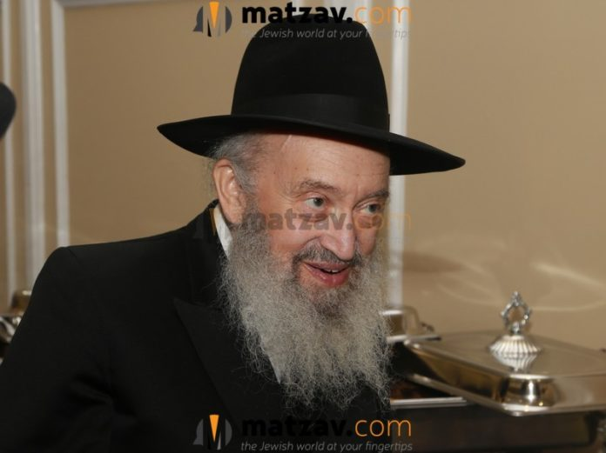

It is with great sadness that Matzav.com reports the passing of Reb Heshy (Harry) Trainer z”l, legendary photographer and owner of Trainer Studios. He was 95.
Reb Harry was known for the gorgeous pictures of great rabbonim, roshei yeshiva and admorim that he took over the course of his life.
Reb Harry was born in Williamsburg in the 1920s. His parents were both immigrants who had immigrated from Galicia several years earlier. Initially, the Trainers lived on the East Side, but by the time Harry was born, they had already moved to Williamsburg. Harry’s father was a Husyatiner chossid and came from the town of Skalut, while his mother came from a family of Belzer chassidim who lived in the town of Rava Ruska.
In his youth, Harry attended Yeshiva Torah Vodaas, beginning with first grade and continuing through post-high school.
At the time, Yidden who came to America from the Old Country met a new reality in the United States and in many ways were not familiar with the way things worked in America. Reb Harry once recalled that when he was in mesivta, he came to understand that much of the Pesach matzah being sold was problematic.
He and others would therefore bake their own shmurah matzah for the Seder in the basement of the old Torah Vodaas mesivta building on South 8th Street. He would also go to the machine matzah bakery and bake his own matzos to make sure that they were completed within eighteen minutes and that the machines were cleaned in between.
Already in Harry’s time, practically no one in Williamsburg sent their children to public school. Nevertheless, the norm was for a bochur to attend college. Because Torah Vodaas was not a college yeshiva, many bochurim left Torah Vodaas to go to college. There were no kollelim in those days, although there were many learned baalei batim from the old country who spent their every free minute learning in the shteiblach.

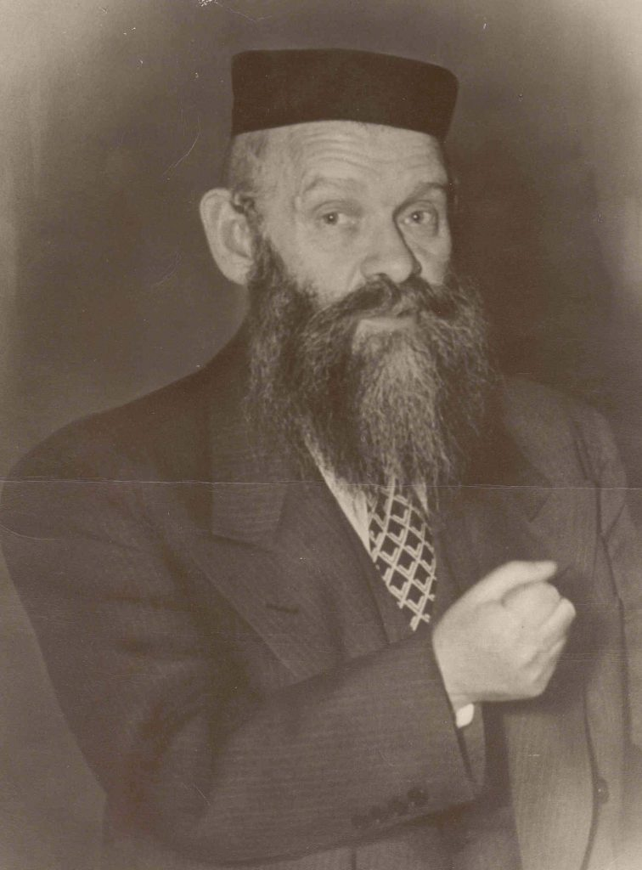
Rav Shraga Feivel Mendlowitz

At Torah Vodaas, the individual who made the greatest impression on him was Rav Shraga Feivel Mendlowitz. Harry saw his temimus in avodas Hashem, how sincere he was, how he so deeply wanted to serve Hashem, and how he loved Hashem and stood by his principles with such conviction and sincerity.
Reb Harry would tell a great story to illustrate this point.
The first wedding that he ever shot was the chasunah of the Bostoner Rebbe of Boston and Har Nof, Rav Levi Yitzchok Horowitz zt”l. He was a fellow talmid in Torah Vodaas and Harry had a camera.
Rav Shraga Feivel Mendlowitz, like many gedolim of that time, was very particular that no pictures should be taken of him. Harry knew this, but he just couldn’t resist. Harry took a chance, snapped the picture, and ran away.
In a couple of quick strides, Rav Shraga Feivel was there had caught up with Harry, held him by his shirt and jacket, and literally lifted Harry off the ground. What he said then in Yiddish remained indelibly etched in Harry’s memory: “If not for the fact that so many people are here, I would give you two fresk! Take out the film from your camera and tear it up!”
Naturally, Harry did what he was told. He was not, however, angry with Rav Shraga Feivel was there. In fact, Harry became even more impressed with how sincere he was about sticking to his principles.

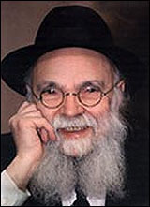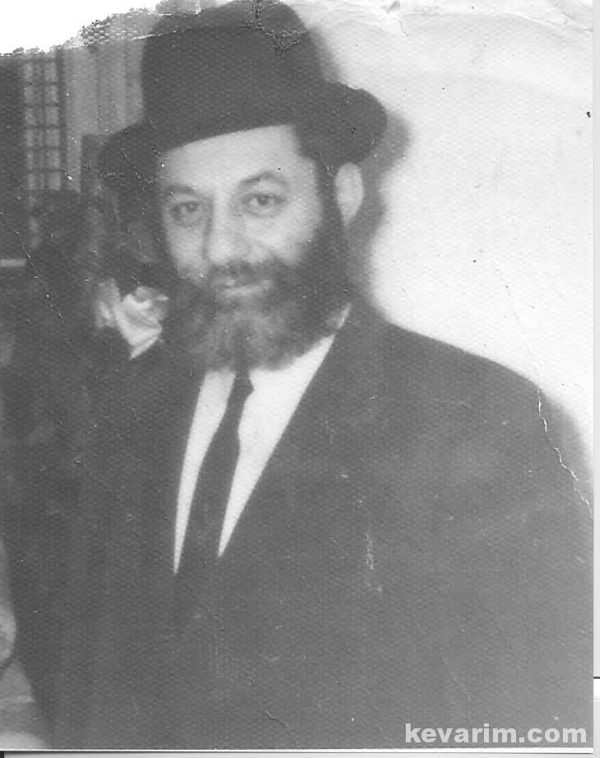
Rav Avrohom Pam Rav Dovid Bender

A few years later, however, Rav Shraga Feivel and some other gedolim began to change their stance on pictures. As cameras became more prevalent, with many more people owning them, it became nearly impossible to control them.
Harry remembered when Rav Shraga Feivel married off his daughter to Rav Shea Schiff and Harry was asked by the Schiffs to photograph the chasunah. Rav Shraga Feivel didn’t say a word about it. By then he had made peace with the situation and, indeed, some of the best pictures of Rav Shraga Feivel in Harry’s collection came from that chasunah.
There were two other mesivta rabbeim who made a very deep impression on Harry. One was a young rebbi named Rav Avrohom Pam. He was Harry’s rebbi in the first year of mesivta; he did not even have a beard back then. Harry was so impressed with him and became so attached to him.
Harry saw in him a person from their generation who so cared about Yiddishkeit and was so humble and caring. The beauty of his middos combined with how much he cared about mitzvos impressed Harry greatly.
His rebbi the next year, Rav Dovid Bender, also had a tremendous hashpaah on Harry. Rav Dovid was also an American who had recently returned from learning in the Mir in Europe. He spoke with such enthusiasm about Europe and the way Torah was learned there.
So how did Harry get into taking pictures?
Harry told the story numerous times: “There was a raffle going on in Torah Vodaas in the late 1930s. I bought a ticket for a penny. The first prize was a camera and I won. I began to take pictures with the camera. I enjoyed it and saw that I had a knack for capturing a good shot. From that basic camera, I graduated to a Brownie, which was the ‘in’ camera at the time. I began to do picture-taking as a hobby. This was all while I was still a bochur learning in yeshiva.”
At that time, there was no such thing as taking pictures of a wedding. The flash was not yet invented, and only outdoor pictures in daylight could be taken. Thus, after the yichud room, the chosson and kallah would be driven to a nearby picture studio that was outfitted with proper lighting. There they would have pictures taken and they would then return to the chasunah hall for the seudah.
In the late 1930s and early 1940s, the flash camera was invented, thereby enabling one to take pictures indoors. At that time, Harry’s oldest brother got married and Harry decided that he would take pictures of his wedding. Harry bought a flash camera for five and a half dollars, a tremendous amount of money in those days.
That chasunah was the first wedding that Harry shot. His hobby, however, was costing me a lot of money – between the price of the camera, the cost of film and developing. Harry realized that he needed to recoup some of his losses.
Word soon spread that a bochur named Trainer from Torah Vodaas could take pictures at weddings. No one wanted to go to a studio in the middle of the wedding if they could avoid it, and that is how Harry began to shoot chasunos.
Almost all of his pictures of gedolim were taken at weddings.
In order to pay for his expenses, Harry began selling pictures of the gedolim that he had taken at weddings. He charged eight cents per picture, a fair amount back then, and that enabled his to recoup his losses and eventually make a parnassah as well.
At the beginning, the Litvishe rabbonim, in general, did not say anything in opposition. Among the chassidim, around 50% covered their faces or studiously avoided Harry. It was very tough, because on the one hand, these rebbes were very makpid and didn’t want to be photographed. On the other hand, the chassanim were very intent on having a photograph of their rebbes at their chupah, and that was what Harry was hired to do. The conflicting interests were thus a great challenge for Harry.

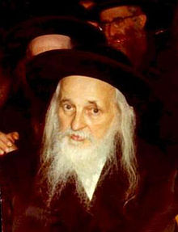
The Satmar Rebbe

Harry had a number of encounters with the Satmar Rebbe, Rav Yoel Teitelbaum. When the rebbe arrived in America in the early 1950s, he became an instant sensation. Everyone wanted to have him serve as mesader kiddushin at their chasunah. Indeed, in those days, he had a chasunah almost every night.
There Harry was, taking pictures at weddings attended by the Satmar Rebbe nearly every night of the week. He was extremely makpid not to have his picture taken, so Harry had to use innovative methods of taking his picture under the chupah, because the chassanim always insisted that Harry had better get a shot of him at their weddings.
After a while, the rebbe decided, “No more!” He made a policy that he would not attend a wedding if a photographer would be present. After a few months, Harry realized that his business was drastically dwindling. People wanted the rebbe to come to their chasunos, and if the price was not hiring Trainer, they didn’t hire Trainer and they made do without a photographer.
Harry decided to go to the Rebbe himself with a kvittel. In the kvittel, Harry explained to the Rebbe that his parnassah was in danger as a result of his policy and begged him to reconsider. He read the kvittel and sympathized with Harry’s plight, but he explained the Kabbalistic reason for why he couldn’t agree to have his picture taken. Harry replied that he understood, but added, “What should I do? I have to make a living.”
“Okay,” the Rebbe responded. “Let’s make an agreement. I will not object to a photographer being present at the wedding if you promise not to take pictures at the chupah.” In those days, however, the chupah was the main attraction for photographers and pictures were not taken during the seudah, so Harry could not agree. People simply did not want to hire a photographer if he would not take pictures at the chupah. Harry returned to the Rebbe and told him, “I still have no business.”
Again the Rebbe responded, “Okay, let’s make another agreement. You can take photographs at the chupah, but not while I am making the brachah.”
That was a condition that Harry could agree with, because, as it was, Harry was the person who ran the chupah at weddings. Harry would get the chosson, the kallah and the family members up under the chupah. Harry poured the wine and gave it to the mesader kiddushin along with the bentcher that had the brachos on it. So, after Harry would pour the Rebbe’s wine for him, he would recite the brachah and Harry would sit with folded hands, not taking any pictures. As soon as the Rebbe finished the brachah, the Rebbe faded into the background and that was Harry’s signal to resume taking pictures.
Harry would say that he was very impressed with the way the Rebbe handled the whole thing. Harry recalled, “He could have just stood his stance and said no. Instead, he showed how much he truly cared about my parnassah and therefore worked with me so that we could come to a solution that would satisfy both of us.”
Another story about the Satmar Rebbe told by Harry: “It was at a chasunah. I remember the chosson’s tish. The chosson was seated between the Satmar Rebbe on one side and the Klausenberger Rebbe on the other. There was a massive crowd pushing to get close to the rebbes, the two most prominent rebbes in America at the time.
“I, of course, was adept at pushing through crowds to get the best shots. This time, my pushing caught the eye of one of the Rebbe’s gabboim, who came over to me and said, ‘I am hereby giving you a warning. If you take a picture of the Rebbe, the chassidim will not only break your camera, but will break every bone in your body and throw you out the window!’ I was shaking in fear, but I stood my ground and did not leave.
“I had a responsibility and had to do the job. The gabbai returned to me saying, ‘What are you doing?’ I retorted, ‘I will take my chances. I am taking pictures.’ Looking me straight in the eye, he said, ‘Look, I did my hishtadlus. I warned you. If you won’t listen, can you at least wait a minute so that I can get into the picture and have a picture of myself with the Rebbe?’”
Another story about Harry and the Satmar Rebbe is a remarkable one that shows the rebbe’s greatness. One day, Harry received a call from the Rebbe’s gabbai. “The Rebbe wants you to take a picture of him,” he said. Harry almost fell to the floor. “The Rebbe WHAT?!” Harry exclaimed.
The gabbai explained: “There is going to be a massive demonstration in Manhattan Center against giyus banos, the Israeli government’s attempt to forcibly draft girls into the army. The Rebbe wants the demonstration to get as much publicity as possible, and he wants everyone to know that he was there and how strongly he feels about the issue. Because of that, he is willing to forgo his refusal to have pictures. We want you to come and take one shot, but one shot only.”
Harry went to the demonstration and got on the ladder, trembling from fear and hisragshus. The Rebbe looked him straight in the eye and motioned to him to shoot. Harry took the picture and, within a second, before he could even think of taking another one, he was off the ladder, thanks to the Chassidim. That is the only real, powerful, close-up face shot in existence today of the Satmar Rebbe.

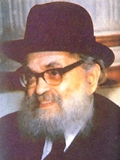
Rav Yaakov Kamenetsky

Rav Yaakov Kamenetsky was not at all opposed to having his picture taken. In addition to his greatness in other areas, Rav Yaakov had a remarkable sense of humor. Harry remembered once when he was arranging the chosson and kallah under the chupah, making sure that the microphone was in place, pouring the wine, and giving the bentcher to Rav Yaakov.
Afterwards, Harry picked up his camera, ready to shoot, and he waited for Rav Yaakov to begin. He didn’t. Everyone was wondering about the delay and Rav Yaakov, with a smile that could light up an entire room, gently asked, “Mr. Trainer, may I begin?”
If Harry was running the show, Harry should give him his cue!
Harry would frequently get calls from the gabboim of admorim to come over and take a passport picture. Harry remembered once going to the Klausenberger Rebbe’s home to take a passport picture and the Rebbe quipped that he was the first person that he has to stand up for… The Rebbe had been sitting in a chair with seforim shranks in the background. Harry told him that the regulation dictates that the picture has to have a white background and they should therefore move over to a blank wall. The Rebbe then quipped, “Mr. Trainer is the only person who I have to stand up for!”
There is a famous picture of the Skolya Rebbe, where you can see the famous shin formed from the crevices on his forehead that everyone talks about. Harry took that picture at a chasunah. The Skolya Rebbe was just about to put up his hand to cover his face, because he didn’t want Harry taking his picture, but Harry chapped it before he could cover his face.

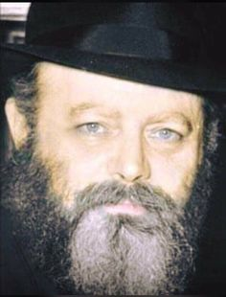
The Lubavitcher Rebbe, zt”l

Harry had several stories with the Lubavitcher Rebbe. Harry was hired to take pictures at many Lubavitcher weddings. In the Rebbe’s early years, he would go to every wedding, and not only would he stay at the chosson’s tish, but he would deliver a maamar. The Lubavitchers were different than the other chassidim. They loved pictures and they kept on encouraging Harry to take more pictures of the Rebbe.
Harry took one picture, feeling that it was enough, and he didn’t want to shter the maamar, but they kept motioning him to take more. Harry took a second, then a third, and they still wanted more. As Harry was getting ready to take a fourth picture, the Rebbe looked up and said in Yiddish, “I think that three pictures is already enough.” Harry was impressed that even while he was delivering an intricate maamar, he was keeping score.
Sometime later, Harry was at a Lubavitcher chupah and the Rebbe was being mesader kiddushin. It was a mob scene and they put tables around the chupah in order to keep the crowd away. The crowd then got up on the tables to get a better view. It was so full that Harry could not find an inch of space upon which he could stand. The chupah had started, and Harry knew that if he didn’t get up on the table in a matter of seconds, he would not have a picture of the chupah. That is what he was hired for, so he had to get up. Harry grabbed someone standing on the table by the sleeve and told him, “I only have a few seconds. You must let me in just to take one picture. Then I will come down!” The guy replied, “I am not budging!”
Harry was so desperate that he felt compelled to tell him that if he would not voluntarily make room for him, I he would be forced to pull him down and take his place and jump up on the table so that he could take that picture successfully. The fellow didn’t move, and Harry indeed had no choice but to pull him down and jump up. When Harry came down after taking the picture, that Yid looked at Harry and exclaimed in Yiddish, “You az ponim what you are!” He then continued, “I am making my own child’s chasunah in two months and I only want you to take the pictures!”
Harry would remember the early Agudah conventions, where he was always invited to attend, and he would come with a long telephoto lens that he would use to take close-ups even if he was standing very far away. In addition to taking pictures of the dais for the Agudah, Harry would take individual shots of the gedolim for his own personal gedolim picture business.
Harry was once asked what he says about today’s picture-saturated culture? He responded: “I am old-fashioned. In my days, photography was a real art. You learned how to set yourself up in the right place at the right angle. To use a baseball analogy, the goal was to hit a homerun on the first attempt. You tried to be a sharpshooter and get that great shot with one click of the camera.
“Today, the philosophy is like machine gun fire. You just spray bullets all over the place and hope that one of them hits the target. To prepare for a shot, anticipate a winner, and go for it is missing today. I also think that people are fed up from having so many pictures. People get hundreds of pictures of their wedding and they have to choose from all of them. It is crazy! What people need is fifty really good ones from which to choose.

Harry once said that being a photographer and having the opportunity to observe people up close at very important life cycle events such as weddings taught him a lot about how people should and shouldn’t conduct themselves. He said, “One of the main lessons I noticed is how important it is for everyone to realize what the ikkar is and what the taful is.
“There are weddings where the chosson and his parents are fully focused on the sanctity of the moment, the chasunah. The chosson is davening and his parents walk with trepidation and a tefillah to the chupah fully cognizant of what the ikkar is. Then there are chassanim and parents who even while they are under the chupah are telling the photographer to dim the lights. They are telling the musician not to forget to play the songs. They are so caught up in the tafel, in all of the less important things, that they forget about what is really the tachlis of the day. “One life lesson of my profession that I have learned is, ‘Ubilvad sheyechavein libo laShomayim,’ the main thing is that a person has to bear in mind that whatever he is doing should be l’sheim Shomayim. The chosson should realize that his l’sheim Shomayim is to prepare himself spiritually for this most important day.
The photographer, too, should do his job l’sheim Shomayim. When people mix up their roles, things don’t come out good. That is a lesson that I learned from my years in photography that I think everyone can apply to their own lives.”
Harry was a one-of-a-kind photographer and a one-of-a-kind vintage Yid. He will be sorely missed.
Yehi zichro boruch.

Reprinted from the May 17, 2020 website of Matzav.com

Story #1186
All In for the Daughter
From the desk of Yerachmiel Tilles
editor@ascentofsafed.com

In the venerable chasidic book, Toldos Yaakov, a woman from the community of Mezibush is quoted as having said: "The Jewish people have done well to have chosen G-d as their G-D, but He too has selected well by choosing Israel as His nation, for even Feivish, 'The Lowest of the Low,' consecrated His holy name."
Reb Nachman Kahana, the Spinker Bebbe in Bnei Brak (?-1976), explained her words with the following story: There once lived in the vicinity of Mezibush a fabulously wealthy man who had an only daughter. When the time came for her to be married, her father approached a local rosh yeshiva in search of a likely candidate. The rosh yeshiva suggested Reb Feivish, a gifted young student with a brilliant mind and equally admirable character traits.
The wealthy man, a learned man himself, spoke with the young man and was so impressed, he immediately asked the rosh yeshiva to propose the match to the young Feivish. To further entice Reb Feivel, the father guaranteed a substantial dowry and promised to support his son-in-law for the rest of his days so that he might be free to pursue the study of Torah.
It goes without saying that Feivish was pleased with these conditions and agreed to the match.
The wedding took place after several months and the young couple went to live next door to her parent's home. Feivish continued studying Torah while his father-in-law continued to manage his business, providing for the young couple as he had promised. To the wealthy man's delight, Feivish, being clever and sharp, found favor among the townspeople and they began coming to him with their various problems.

Many Years Passed and
Two Daughters Were Born
Many years passed and two daughters were born to Feivish and his wife.
The years claimed their toll on the rich man and he felt that he could no longer carry the burden of his business upon his shoulder.
One day, while discussing the future with his wife, she offered this suggestion: "My husband, you are already old. You cannot continue devoting the same attention to your business as in the past for you simply do not have the strength. Is it not true that your laborers take advantage of you and try to cheat you at every occasion? You simply cannot continue this way indefinitely. You have children and grandchildren to support, and we too, must be provided for in our old age. I suggest that you take our son-in-law into the business. Let him start with an hour a day until he gets acquainted with all its workings. He is a clever man and will eventually be able to considerably lighten your burden. And besides, he will eventually have to take over the business when, after 120 years, you depart from this world."
The man listened to his wife's words but thoroughly disagreed. "It is not fair to Feivish," he argued. "He agreed to marry our daughter on the condition that he would not be required to concern himself with business matters. It would be totally unfair to involve him in worldly affairs when he is so diligent and devoted to his study. That is, after all, much more important."

Discovered Her Mother Sobbing
The controversy raged back and forth. One day the daughter entered her parent's home to find her mother sitting and sobbing.
"Whatever is the matter, Mother? Is everyone well? What is wrong?"
The mother explained her feelings, describing her concern for the future of the family. She reviewed all her arguments while her daughter listened.
"But Mother," the daughter finally said, "you know that Feivish studies day and night, never wasting a minute. When could he possibly learn the business?"
The mother responded, "He doesn't have to assume complete responsibility at once. Let him but put in an hour a day to acquaint himself with the business."
The daughter, seeing her mother's deep concern in the matter, promised to speak to Feivish about it. The following day, when Feivish returned from the Beit Medrash (study hall), his wife greeted him despondently. Concerned, he asked her why she seemed so troubled. She told him of her conversation with her mother and begged him to begin taking an interest in her father's business, if only for an hour a day. At first Feivish was strongly opposed, but the mighty power of the evil inclination is overwhelmed him and he finally agreed.

Began Going to the Store for Just an Hour a Day
Feivish began going to the store for an hour a day, but even during this hour, he would immerse himself in a sefer (book) and study all the while.
The 'Accuser' was not satisfied with the state of things and laid further plans to tear Feivish away from Torah study.
"You scroundel! You dirty thief!" were the words that Feivish heard one day as he sat in the store, pouring over a sefer. An angry merchant had burst into the store and was now accusing his father-in-law of dishonest dealings.
"… and don't think that this is the first time you've cheated me! I pay you in full each time for all the merchandise that I order and then you go ahead and swindle me in the amount that you deliver!" accused the enraged customer.
The father-in-law opened the package thrust before him on the counter and saw that his customer's accusation was quite valid. He cross-examined his workers until he found the culprit who had been stealing the merchandise. He settled the matter with his disgruntled customer and fired his dishonest worker.

Feivish was Affected by the Realization of
His Father-in-Law’s Dishonest Employees
This scene had its effect on Feivish. He realized that the workers took advantage of his father-in-law, stealing whenever his back was turned. He decided that it was up to him to take a more active interest in the business to prevent such unpleasant scenes in the future. He started coming for two or three hours daily, becoming engrossed with the comings and goings of the laborers and customers. His father-in-law, relieved to shed some of his responsibility, relied more and more on Feivish as he saw the capable young man grasp all the facets of the business.
Feivish, seeing that the present laborers could not be trusted, dismissed all of them and hired others to replace them, reorganizing the whole business. Thus it happened that when the father-in-law passed away, Feivish was left totally involved in financial affairs. The Accuser had won the first round.
By now, Feivish was spending the whole day at the store. This left him virtually no time for Torah study. He set aside an hour in the mornings before prayers and another in the evenings, but the business soon encroached even upon these precious hours. He found that during business hours he had to tend to customers so that he was required to review his accounts in the evening.
Since Feivish stayed up till late at night over his accounts, he was too tired in the mornings to adhere to his schedule of one hour of study. His shacharit (morning) prayers became increasingly hurried until he stopped praying with a minyan (prayer quorum) altogether.

The Business Under Feivish Prospered and Expanded
The business prospered and Feivish soon found it necessary to expand. This naturally meant more responsibility and less free time. When Feivish was appointed the king's agent, the added burden left him with no time even for his prayers. On Shabbat he still managed to pray in a synagogue. But soon he stopped this too, being so worn out from his strenuous efforts of the week. He would spend the whole day in bed, just recovering his strength for the week to come. The Accuser had won again.
His position as official supplier to the king once presented an excellent business opportunity to Feivish. He was invited to the prime minister's home to sign a contract on a large order. Since he felt it unseemly to appear as he was, he trimmed his beard, acquired different clothing, and went to keep his appointment.
As he sat discussing business, the prime minister's wife entered with refreshments. Feivish did not wish to insult his hostess and tasted one of the cakes laid before him. By way of compliment, he casually asked her what they were made of, and was relieved to hear that they contained no treife (non-kosher) ingredients. And thereafter, when his affairs brought him to the prime minister's home again, he would partake of the refreshments without pangs of conscience. Little did he realize that the woman did, in fact, use lard and fats to enhance the flavor of her baking.

Descended into Completely Eating Treife
Once he had become lax in his eating habits, he felt no compunctions about eating treife, eventually bringing such food into his own home.
His wife, distressed by Feivish's downfall, was powerless to do anything. It pained and grieved her deeply to see the metamorphosis of her husband from a Torah scholar to an unobservant Jew, but she no longer had any influence upon him and was forced to remain silent. His GÂ·dless ways were apparent to the whole community and Feivish acquired the name, "Feivish, Lowest of the Low".
* * *
The years passed and Feivish prospered. The time arrived for him to marry off his older daughter. Although he realized that he was a sinner, Feivish desired the best for his daughter: a Torah scholar and an upright young man. But no one who knew Feivish or had even heard of him would be likely to consent to become his son-in-law. He decided to take a business trip, combining it with a search for a suitable young man. He took along with him his tallis and tefillin, though he had long ceased using them.

Feivish’s Travels Bring Him to Hungary
His travels brought Feivish to Hungary where he stopped at a village. When he entered the synagogue, he encountered a fine young student, whose very face bespoke his greatness. Upon inquiry, he learned that he was the son of the local rabbi and head of the Beit Din - the rabbinical court. After talking with the youth and becoming enamored of his fine qualities, Feivish desired him as a son-in-law.
Feivish returned home and summoned a penniless shadchan (matchmaker). He offered him a substantial sum to go to the village in Hungary and try to arrange a marriage for his daughter with the young man he had previously met, all the while concealing the current character of her father.. The shadchan accepted the project and immediately set forth.
When the shadchan reached the village, he went straight to the rabbi's home. Posing as a grain merchant, he said that business had brought him to Hungary where he was required to remain for several weeks. Since he was very particular in observance of Kashrut, he begged the rabbi to accept him as a paying guest. The rabbi, who barely subsisted upon his meager salary, agreed to the arrangement. The shadchan made himself very amenable during his stay. He possessed a glib tongue and would entertain the whole household with his amusing and interesting anecdotes.

He Approached the Rabbi with a Suggestion
One day he approached the rabbi with a suggestion. "I see that your son has already reached marriageable age."
"Yes, that is true. Indeed, he has had many offers for a shiduch, but they all require that we put up a large sum of money, which in our circumstances, we cannot possibly afford."
"Then I have just the prospect for you. You see, before I left my home town I was approached by a genuine Torah scholar, a man expert in Talmud and Jewish Law, who is extremely wealthy to the bargain. He told me that he sought for his accomplished daughter, a fine youth who would be willing to spend the rest of his days in Torah study. If I were to come across such a youth, I should feel free to represent him and suggest the match. After having lived here for a while, I feel I know you both, the honorable father and the learned son, well enough to feel that something might come of my humble suggestion.''
The rabbi listened to his guest's words and agreed to meet with the father. The shadchan immediately wrote to Feivish that the rabbi was amenable and that he was to come and make his acquaintance.

Arrives Loaded with Expensive Gifts for the Entire Family
Feivish's trip took several weeks but when he arrived he was loaded with expensive gifts for the entire family. Although his outward appearance did not make the most favorable impression, the rebbetzin assumed that this wealthy businessman certainly came in contact with high officials and must alter his appearance for their sake. When the rabbi himself spoke to Feivish, he was truly amazed at his erudition in Torah knowledge.
The couple now desired to see the daughter, but Feivish convinced them to first announce the engagement. If his daughter did not meet up with their expectations, when she came with her father on his next business trip, the engagement would automatically be declared void.
A grand feast, paid for by Feivish, of course, was made to celebrate the joyous occasion. Many poor people were invited and the chatan (bridegroom) delivered a brilliant speech. Feivish discussed several points, posing contradictions and resolving them with his vast knowledge. The chatan and his parents were very happy and eagerly awaited further developments.
Feivish took leave of his future mechutanim (relatives through marriage), again showering them with gifts. He promised to return soon with his daughter. When he did return with her, she was approved by the rabbi and his family. Feivish then suggested that they celebrate the wedding right away.

Offers to Have His Daughter
Married in His Mechutan’s Hometown
"Why must you be bothered by such a lengthy trip to our city. It is both tiring and expensive. How, too, do you propose to leave your city without its leader? Let us celebrate the wedding here and now, and then I will take the young couple back with me to their new home."
The rabbi agreed and the wedding took place. Hundreds of people attended from the chatan's side but the kallah (bride) and her father were the only ones to represent their side of the family. Feivish explained that they had few relations and that distance prevented their friends from attending.
After the seven days of celebration following the wedding, Feivish and the young couple packed their things and set out for home.
When they finally reached their destination, they were greeted by many servants who rushed to take in their things and make them comfortable. The young husband was not accustomed to the splendor and wealth that was apparent all around him. They first entered a large courtyard lit up by many lanterns, surrounded by orchards and gardens from whence emanated a mixture of heavenly fragrances. The rugs and tapestries that adorned the rooms of the mansion within stunned the youth who had never seen such wealth in all his days.

Feivish Begged to Speak to His Son-in-Law
The chatan and kallah were taken to their room to refresh themselves. Just as they had made themselves comfortable, a knock was heard at the door. It was Feivish, who begged to speak several words with his new son-in-law.
"I think it is only fair to inform you of certain things before you become a member of my household. I am known in these parts as "Feivish, Lowest of the Low": this is because I transgress all the commandments of the Torah. I wish you to hear it first from me before you hear it from outsiders. You may accuse me of having deceived you, but first let me state my case.
"Even though I myself am no longer an observant Jew, I desire a pious and scholarly husband for my daughter. I will give you your own home complete with new furniture and dishes and you need have no contact with me at all. I agree to continue to support you for the rest of your days. If however, you still wish to back out, you must give your wife a divorce immediately and renounce all claims against me. Either way, you may keep all the gifts I have given to you until now. But whatever you decide. I want that decision to be made by morning."
The poor young man was thoroughly shaken up. What a disgrace for his eminent father and for himself as well, to be thus connected with a man known as "The Lowest of the Low"! His decision was clear; he would divorce his wife the very next day and return home.

His Mind was Filled with Conflicting Thoughts
When he had time to reflect, his mind was filled with conflicting thoughts.
"Does it not say 'He who divorces his first wife - the very altar sheds tears for him.' How can I return home and tell everyone that my father-in-law is an unobservant Jew. Who will believe me after the wonderful impression he made upon my whole village? They will all whisper that it is my fault alone that the marriage did not succeed. And it won't be easy for me to find myself another wife after this."
Opposing arguments now rushed into his mind. "Perhaps this is a plot fostered by the evil inclination to ruin me. Just as my father-in-law was seduced into abandoning the tenets of Judaism, so might I be led astray."
Suddenly he was reminded of his new wife. Why must she be punished for her father's sins. She was a good woman and had every right to live a Torah-true life.
He confronted his wife with this question : "Would you then be satisfied with leading a Torah life in contrast to the life you have led under your father's roof ?"

The New Wife Confesses that
She Hated Her Previous Life
"My dear husband," said the young woman earnestly, tears streaming down her cheeks, "Do you not realize that it is not you alone that I married, but all that you stand for! How I have hated this life I lead here! How I have yearned to live a Torah life. Never fear - I will not hinder you from your studies but will do all in my power to encourage you and help you."
The entire night had passed while the young man had considered and weighed all the aspects of his situation. Early the next morning, a knock was again heard at the door. The young husband told the waiting Feivish that he had decided to remain. Feivish then took his son-in- law and showed him his new lodgings and told him that he would have furniture delivered that very day. The young man then went to the Beit Medrash (study hall) join a minyan for the morning prayers.
The people there greeted the newcomer and, noticing his Hungarian manner of dress, asked if he had come to stay. The young man then explained that he had married Feivish's daughter. Everyone was shocked to hear this and hastened to warn him about his father-in-law's irreligious ways, lest he be influenced by them.
He listened to their warnings politely and then went home to study.

The Holy Baal Shem Tov Lived Not Far from Feivish
The holy Baal Shem Tov lived not far from Feivish and the young son-in-law began to frequent the rebbe's Beit Medrash. In a short time, he spent several days each week studying there.
* * *
Two years passed and Feivish's second daughter became of a marriageable age. Feivish reasoned that his chances for getting a scholarly husband for her were even slimmer than before, for his first son-in-law had surely written home about him. He would now be notorious even in Hungary. He decided therefore to travel to a distant part in Russia and begin his search there.
Eventually, he arrived at a certain village and entered its Beit Medrash. There he found the rabbi, a follower of the Baal Shem Tov, seated at a table surrounded by his students, engrossed in Torah study. Impressed by the scene, Feivish made inquiries about this rabbi. When he learned that he had a son who was likewise a pious scholar, he was overjoyed. He hurried home and summoned the shadchan to him once again. This time however, the shadchan was loath to perform the deceptive mission and it required a doubling of the previous fee to persuade him.
The shadchan arrived at his destination and went to the Beit Medrash. The rabbi was again seated with his students. The shadchan sat down and joined them at their study. Eventually he brought the talk around to the Baal Shem Tov, about whom he knew many fascinating stories. His audience listened to him spellbound, their admiration and affection towards the capable storyteller growing by the minute. When the shadchan felt that the chassidim knew him well enough, he approached the rabbi's young son with his proposal for a shiduch.

The Shadchan Makes His Pitch
The young man listened respectfully and then referred him to his mother. The rebbetzin also listened with interest but told him that it was her husband, the rabbi, who made all such decisions. After much pleading on the shadchan's part, she finally agreed to personally approach her husband in this matter. She relayed to the rabbi all the information that the shadchan had told her, of Feivish's wealth and of his scholarly son-in- law, husband to Feivish's first daughter. The rabbi did indeed recall seeing the young man by the Baal Shem Tov but he refused to commit himself without first seeing Feivish.
The shadchan duly summoned Feivish to come and discuss the matter with the rabbi. But as soon as the rabbi beheld Feivish's face, he intuitively felt that it was the face of a sinner. Loath to discuss the matter, he asked Feivish to leave the next day.
That evening, the rabbi prayed that it be revealed to him in a dream what course of action he was to take. That night he had a dream in which he was told that even though Feivish himself was a sinner, his daughter was the predestined wife for his son. The rabbi was not to do anything to prevent this match for it was heaven-ordained and would come to pass in any event. The rabbi immediately awoke and hurried to Feivish's room with his answer.

The Rabbi Knock on Feivish’s Door
Feivish had been lying in bed when suddenly he heard footsteps coming towards his room. He hurriedly donned a robe, and went over to his table to pore over a gemarra (Talmud), pretending that he had been studying all evening. The rabbi knocked and was told to enter.
"You have nothing to hide from me," the rabbi told his startled guest. "I know just what kind of a man you are and all your sins have been revealed to me. However, I agree to go through with the match for I have been informed that it is so willed in heaven."
Feivish was relieved with this news, as well as by the fact that he need not maintain his pretenses any longer. He therefore decided to hold the wedding in his city. He set a date for the event and returned home.

Feivish’s Family was Overjoyed by the Good News
Feivish's family was overjoyed to hear the good news, most of all the first son-in-law. He would now have a companion with whom he could study. It was he who made all the arrangements for the forthcoming wedding making sure, of course, that all the food would be of the highest degree of kashrut.
The week of the wedding arrived. The rabbi and his students arrived in the city before Shabbos. Their arrival made a big stir in the community, but when the townspeople learned that the visiting rebbe was to be Feivish's mechutan, they simply shook their heads in bewilderment. They tried to forewarn him of Feivish's true nature but the rabbi's mind was made up.
The wedding day arrived and all rejoiced -- Feivish, on having succeeded in again acquiring a scholarly son-in-law, the rabbi, on having married off his son so painlessly, and the first son-in-law on having acquired a pious brother-in-law.
During the festivities, the rabbi stood up and proposed a toast. "To your true repentance, mechutan."
"No, rabbi." answered Reb Feivish, "Such a time has not arrived as yet."
"When then will you repent?"

Wants Three Days Notice to Repent
"Ah, if only I knew when I was to die, I would repent three days before my death."
"Let me have your promise on that," said the rabbi, and he leaned over to grasp Feivish's hand firmly. The week of festivities over, the rabbi returned home with his talmidim (students) and the new husband assumed his new responsibilities. Feivish provided a home complete with new furnishings and utensils for the couple, and life settled down to normal. The two brothers-in-law now went together to the Baal Shem Tov where they studied and received guidance.
* * *
The years passed and the rebbe, the father of his second son-in-law, departed from this world but Feivish lived on, steeped in his evil ways. One Shabbos night he returned home from a wild party he had attended and threw himself down upon his bed. Suddenly the door of his chamber opened slowly and a man dressed all in white entered. Feivish was shocked to realize that it was the father of his second son-in-law.
"I have come from Heaven to remind you of the promise you made at your daughter's wedding. In three days time you will die. The time has come for you to repent your wicked ways."

The Mechutan Disappears as Silently as He had Come
The rabbi disappeared as silently as he had come. Feivish sat up in bed all shaken. Is it possible to repent in three days time, he wondered, what I have transgressed during thirty years?
Suddenly he fell into a fit. He screamed and struck his head against the wall and no one could restrain him. A doctor was quickly summoned but Feivish did not let him get near. Finally the two sons-in-law were called. When they appeared, Feivish calmed down somewhat and told them what had happened.
"What am I to do? How can I possibly repent all my sins? Maybe you can take me to the Baal Shem Tov? Right now! If anyone can still help me, it is he."
The two young men immediately ordered the carriage prepared and were soon speeding towards the Baal Shem Tov.
It was already after midnight and their only concern was how to get in to see the holy Baal Shem Tov at this late hour. But as the moment they arrived, the Rebbe's attendant hurried out to them and asked:
"Has Reb Feivish arrived?"
As soon as they entered the study, Feivish threw himself down at the Baal Shem Tov's feet and burst into uncontrollable sobbing, his life's story emerging between his racking cries.

The Baal Shem Tov Give Feivish
Instructions on How to Repent
"You can still repent, Feivish," said the Rebbe. "Now listen. You must fast for the next three days and spend the entire time in the Beit Medrash in prayer and repentance. When the people come to pray in the morning and evening, you are to throw yourself down at their feet and exclaim, 'I am Feivish the Sinner who has transgressed all the commandments of the Torah. I regret it all and have accepted upon myself the burden of repentance as specified by the Baal Shem Tov. In addition to this, you are to throw yourself down at the feet of anyone who enters the Beit Medrash during the day and repeat what I have just told you."
"Is that all, rebbe? How can these actions atone for thirty years of heavy sinning?"
"You just do as I have instructed and all will turn out well."
Feivish set out immediately for the Beit Medrash to begin his program of tshuvah ('repentance'). He recited Tehilim (Psalms) all day and night, he confessed his sins before everyone who entered the shul, and he wept and fasted all the while. By the third day he was at the end of his strength.

The Accuser Becomes Upset by Feivish’s Tshuvah
These developments irked and inflamed the Accuser. The man whom he had ensnared in his nets for thirty years was now making amends for them in three days time! It was just not fair! All of his work was being nullified. He raised a riot in heaven at the injustice of such instant tshuvah and the heavenly court ruled that Satan might descend to have another try at corrupting Feivish. If Satan could succeed in forcing Feivish to taste a bit of treife food again, his repentance would not be accepted.
On Tuesday afternoon a distinguished-looking person entered the Beit Medrash. Feivish rushed over, and throwing himself down at his feet, made his usual confession.
"What kind of silly behavior is this for a grown man?" asked the stranger.
Feivish explained his situation and said that the Baal Shem Tov had instructed him to thus prostrate himself at every newcomer's feet. The man sat himself at a table and opened a volume of Talmud. He began learning out loud, pretending that he could barely understand the text. Feivish politely interrupted him.
"Please forgive my impertinence, but that is not the way one should understand that particular passage."
"If you are indeed a learned man, than why must you abase yourself in such a manner? Does it not say that if a scholar sins let him study two pages of Talmud and he will be strengthened by Torah?"

Greatly Weakened by His Three-Day Fast
Meanwhile a minyan had gathered in the Beit Medrash to pray mincha (the afternoon prayer). Feivish, greatly weakened by his three-day fast, struggled to stand up and go over to them, but the stranger tried to detain him.
"Does it not also say 'You shall guard your lives exceedingly.' If you continue fasting any longer you may not last the day. How then will you propose to repent the sin of suicide on top of all your other transgressions?"
Feivish hurried nevertheless to fulfill the Besht's instructions and threw himself down before the men who had assembled. Then he returned to the stranger, who had meanwhile taken out a package of food.
Feivish was literally dying for just a taste of fresh bread. The stranger offered to share his meal. Feivish wavered. Suddenly he noticed that a drop of candlewax, which was made from animal fats, had fallen into the stranger's soup.
"I wouldn't touch that soup, it's treife!" he shouted. The stranger then tried to make him taste some challah. But since Feivish had not washed his hands he refused to eat the bread.

Warns Feivish that He on the Threshold of Starvation
"Here you are on the very threshold of starvation and you still stand on ceremony? Come with me, I will help you wash your hands."
The stranger took Feivish to the sink but somehow there was no water in the faucets. He then led the weakened but resisting Feivish to the mikveh (ritual bath) where there was sure to be water. But here too, the man was disappointed. Poor Feivish summoned up his last ounce of strength to wrench himself away from his persuasive captor and jumped into the empty mikveh. As he was falling he felt the Baal Shem Tov's hands on him and he heard his voice.
"Feivish, it was such a self-sacrifice that we had hoped of you. Now all your sins are atoned for. Rest now in peace."
It was concerning this Feivish that they said, "Feivish the Lowly sanctified G-d's holy name in public."
Source: Freely adapted by Yerachmiel Tilles from a story in Tales of the Baal Shem Tov (vol. 2) by Y.Y. Klapholtz (English translation by Sheindel Weinbach), as posted on the www.baalshemtov.com website of Tzvi-Meir HaCohain (Howard M. Cohn, Patent Attorney).
Biographical note: Rabbi Yisrael ben Eliezer [of blessed memory: 18 Elul 5458- 6 Sivan 5520 (Aug. 1698 - May 1760 C.E.)], the Baal Shem Tov ["Master of the Good Name"-often referred to as "the Besht" for short], a unique and seminal figure in Jewish history, revealed his identity as an exceptionally holy person, on his 36th birthday, 18 Elul 5494 (1734 C.E.), and made the until-then underground Chasidic movement public. He wrote no books, although many works claim to contain his teachings. One available in English is the excellent annotated translation of Tzava'at Harivash, published by Kehos.
Connections (2):
1) ELUL, the last thirty days before Rosh Hashana is the month of tshuvah.
2) Early next week, Sun. night- Monday, is the 322nd anniversary of the birthday of the Baal Shem Tov.

Reprinted from the Parshat Ki Savo 5780 email of KabbalaOnline.org, a project of Ascent of Safed.

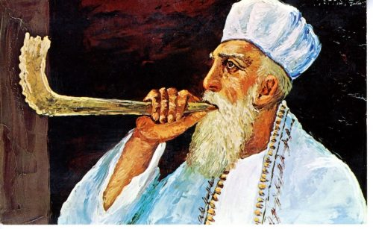
A 1908 Rosh Hashanah card

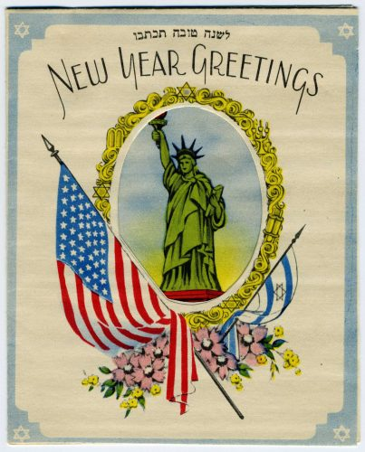
A 1940’s Rosh Hashanah card
Reprinted from the website of the Jewish Museum of Maryland
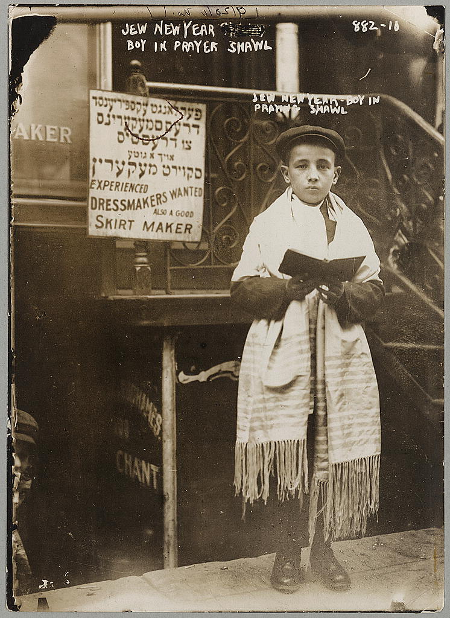
Jewish boy in prayer shawl in preparation of the Jewish New Year
(circa – early 1900s) from the Smithsonian Library Jewish photo collection.

